3D View by tools - Header
Detailed Table of content 1
Introduction 22
Header 22
All Modes - View Menu 23
All Modes - Navigation Menu 30
All Modes, all Object types - Show / Hide 35
Object Mode - Select menu 36
Object Mode - Object menu 44
Edit Mode - Transform Menu 61
Edit Mode - Mesh Object - Mesh Menu 68
Edit Mode - Curve + Surface Object - Curve + Surface Menu 98
Edit Mode - Metaball Object - Metaball Menu 103
Edit Mode - Text Object - Text Menu 104
Edit Mode - Armature Object - Armature Menu 105
Edit Mode - Lattice Object - Lattice Menu 113
Pose Mode - Armature Object - Pose Menu 114
Sculpt Mode - Sculpt Menu 124
Sculpt Mode - Brush Menu 124
Sculpt Mode - Hide/Mask Menu 124
Vertex paint Mode - Paint Menu 126
Weight Paint Mode - Select Menu 128
Weight Paint Mode - Weights Menu 131
Texture Paint Mode - Select Menu 132
Particle Mode - Select Menu 134
Particle Mode - Particle Menu 136
Header Tool - Mode Drop-down Box 137
Header Tool - 3D Manipulator Widget 138
Header Tool - Proportional Editing 139
Header Tool - Transform Snapping 140
Header Tool - Viewport Shading 141
Header Tool - Pivot Point 142
Header Tool - Manipulate Center Points 143
Header Tool - Mesh Object - Edit Mode - Mesh Select Mode 143
Header Tool - Mesh Object - Edit Mode - Limit Selection to Visible 144
Header Tool - Mesh Object - Face selection masking for Painting 144
Header Tool - Mesh Object - Vertex selection masking for Painting 145
Header Tool - Particle Edit - Select modes 145
Header Tool - Reset 3D View 146
Header Tool - Align View Buttons 146

Detailed Table of content

3D View by tools - Properties Sidebar
Detailed Table of content 1
Introduction 22
Header 22
All Modes - View Menu 23
Toggle Full screen Area 23
Toggle Maximize Area 23
Toggle Quad view 24
Duplicate Area into New Window 24
View All 24
Center Cursor and View All 24
View All all Regions 24
View Selected 25
View Selected All Regions 25
View Global / Local 25
Render Border 25
Clear Render Border 26
Clipping 26
Clear All Restrict Render 26
Restrict Render Unselected 27
Set Restrict Render 27
Align View to Active 27
Align View 27
Align Active Camera to View 27
Align Active Camera to Selected 27
Center View to Cursor 28
View Lock to Active 28
View Lock Center 28
View Lock Clear 28
View Persp/Ortho 28
Top, Bottom, etc. 28
View Camera Center 28
Active Camera 29
Set Active Object as Camera 29
OpenGL Render Animation 29
OpenGL Render Image 29
Tool Shelf 30
Properties 30
All Modes - Navigation Menu 30
Scale 31
Last Operator Resize 31
Vector 31
Constraint Axis 31
Orientation 31
Proportional Editing 31
Proportional Editing Falloff 31
Proportional Size 31
Edit Grease Pencil 31
Edit Texture Space 31
Rotate 31
Last Operator Translate 31
Angle 31
Constraint Axis 32
Orientation 32
Proportional Editing 32
Proportional Editing Falloff 32
Proportional Size 32
Edit Grease Pencil 32
Translate 32
Last Operator Translate 32
Vector 32
Constraint Axis 32
Orientation 32
Proportional Editing 32
Proportional Editing Falloff 33
Proportional Size 33
Edit Grease Pencil 33
Edit Texture Space 33
Playback Animation 33
View Navigation 33
Walk Navigation 33
Fly Navigation 33
Center View to Mouse 33
Dolly View 33
Zoom Camera 1:1 34
Zoom In 34
Zoom Out 34
Zoom Border 34
Pan Left 34
Pan Right 34
Pan Up 34
Pan Down 34
Roll Right 35
Roll Left 35
Orbit Opposite 35
Orbit Left 35
Orbit Right 35
Orbit Up 35
Orbit Down 35
All Modes, all Object types - Show / Hide 35
Show Hidden 35
Hide Selected 36
Hide Unselected 36
Last Operator Show Hidden 36
Object Mode - Select menu 36
Less 36
More 36
Child Extended 37
Parent extended 37
Child 37
Parent 37
Last Operator Select Hierarchy 37
Direction 37
Extended 37
All by Type 37
Last Operator Select By Type 38
Extend 38
Type 38
All by Layer 38
Last Operator Select by Layer 38
Match 38
Extend 38
Layer 38
By Pattern 38
Pattern 39
Case Sensitive 39
Extend 39
Last Operator Select Pattern 39
Pattern 39
Case Sensitive 39
Extend 39
Linked 39
Object Data 39
Material 39
Texture 39
Dupligroup 40
Particle System 40
Library 40
Library (Object Data) 40
Last Operator Select Linked 40
Extend 40
Type 40
Grouped 40
Last Operator Select Grouped 40
Extend 40
Type 40
Camera 40
Last Operator Select Camera 41
Extend 41
Mirror 41
Last Operator Select Mirror 41
Extend 41
Random 41
Last Operator Select Random 41
Percent 41
Random Seed 41
Action 41
Inverse 41
(De)Select All 41
Last Operator (De)Select All 41
Action 41
Invert 41
Deselect 42
Select 42
Toggle 42
Circle Select 42
Border Select 42
Lasso Select 42
Stroke Select 43
Object Mode - Object menu 44
Convert to 44
Curve from Mesh/Text 44
Mesh from Curve/Meta/Surf/Text 44
Last Operator Convert to 44
Show/Hide 44
Game 45
Subdivide 45
Last Operator Subdivision Set 45
Level 45
Relative 45
Quick Effects 45
Quick Fur 45
Quick Explode 45
Quick Smoke 46
Quick Fluid 46
Constraints 46
Add Constraints ( With Targets) 46
Last Operator Add Constraints (with Target) 47
Type 47
Copy Constraints to Selected Objects 47
Clear Object Constraints 47
Clear Track 47
Last Operator Clear track 48
Type 48
Clear Track - Keep Transformation 48
Last Operator Clear track 48
Type 48
Make Dupli Face 48
Delete 48
Last Operator Delete 48
Delete Globally 48
Delete Global 48
Last Operator Delete 49
Delete Globally 49
Duplicate Linked 49
Last Operator Duplicate Linked 49
Duplicate Objects 49
Linked 49
Translate 49
Constraint Axis 49
Orientation 49
Proportional Editing 49
Proportional Editing Falloff 50
Proportional Size 50
Edit Grease Pencil 50
Edit Texture Space 50
Duplicate Objects 50
Last Operator Duplicate 50
Duplicate Objects 50
Linked 50
Translate 50
Constraint Axis 50
Orientation 50
Proportional Editing 51
Proportional Editing Falloff 51
Proportional Size 51
Edit Grease Pencil 51
Edit Texture Space 51
Copy 51
Paste 51
Last Operator Paste Selection from Buffer 51
Select 51
Active Layer 51
Apply 52
Location, Rotation, Scale and Rotation&Scale 52
Last Operator Apply Object Transform. 52
Location 52
Rotation 52
Scale 52
Apply Properties 52
Location, Rotation, Scale and All Transforms to Deltas 52
Last Operator Transforms to Deltas 52
Mode 52
Reset Values 53
Animated Transform to Deltas 53
Clear 53
Location 53
Last Operator Clear Location 53
Clear Delta 53
Rotation 53
Last Operator Clear Rotation 53
Clear Delta 53
Scale 53
Last Operator Clear Scale 53
Clear Delta 53
Origin 53
Transform 54
To Sphere 54
Last Operator To Sphere 54
Factor 54
Proportional Editing 54
Proportional Editing Falloff 54
Proportional Size 54
Edit Grease Pencil 54
Shear 55
Last Operator Shear 55
Factor 55
Proportional Editing 55
Proportional Editing Falloff 55
Proportional Size 55
Edit Grease Pencil 55
Bend 55
Push/Pull 56
Last Operator Shear 56
Factor 56
Proportional Editing 56
Proportional Editing Falloff 56
Proportional Size 56
Move Texture Space 56
Last Operator Translate 57
Vector 57
Constraint Axis 57
Orientation 57
Proportional Editing 57
Proportional Editing Falloff 57
Proportional Size 57
Edit Grease Pencil 57
Edit Texture Space 57
Scale Texture Space 57
Last Operator Resize Texture 58
Vector 58
Constraint Axis 58
Orientation 58
Proportional Editing 58
Proportional Editing Falloff 58
Proportional Size 58
Edit Grease Pencil 58
Edit Texture Space 58
Align to Transform Orientation 58
Last Operator Transform 59
Values 59
Constraint Axis 59
Orientation 59
Proportional Editing 59
Proportional Editing Falloff 59
Proportional Size 59
Edit Grease Pencil 59
Randomize Transform 59
Last Operator Randomize Transform 60
Random Seed 60
Transform Delta 60
Randomize Location checkbox 60
Location edit boxes 60
Randomize Rotation checkbox 60
Rotation edit boxes 60
Randomize Scale checkbox 60
Scale Even 60
Scale edit boxes 60
Align Objects 60
Last Operator Align Objects 60
High Quality 60
Align Mode 60
Relative To 60
Align 61
Undo History 61
Redo 61
Undo 61
Edit Mode - Transform Menu 61
To Sphere 61
Last Operator To Sphere 62
Factor 62
Proportional Editing 62
Proportional Editing Falloff 62
Proportional Size 62
Edit Grease Pencil 62
Shear 62
Last Operator Shear 62
Factor 62
Proportional Editing 62
Proportional Editing Falloff 63
Proportional Size 63
Edit Grease Pencil 63
Bend 63
Push/Pull 63
Last Operator Push/Pull 63
Factor 63
Proportional Editing 63
Proportional Editing Falloff 63
Proportional Size 64
Warp 64
Last Operator Warp 64
Warp Angle 64
Offset Angle 64
Min 64
Max 64
Randomize 64
Last Operator Randomize 64
Amount 64
Uniform 64
Normal 64
Random Seed 64
Move Texture Space 65
Last Operator Translate 65
Vector 65
Constraint Axis 65
Orientation 65
Proportional Editing 65
Proportional Editing Falloff 65
Proportional Size 65
Edit Grease Pencil 65
Edit Texture Space 65
Scale Texture Space 66
Last Operator Resize Texture 66
Vector 66
Constraint Axis 66
Orientation 66
Proportional Editing 66
Proportional Editing Falloff 66
Proportional Size 66
Edit Grease Pencil 66
Edit Texture Space 67
Skin Resize 67
Last Operator Skin Resize 67
Vector 67
Constraint Axis 67
Orientation 67
Proportional Editing 67
Proportional Editing Falloff 67
Proportional Size 67
Set Dimensions 68
Last Operator Set Dimensions 68
New Dimensions 68
Align Bones 68
Edit Mode - Mesh Object - Mesh Menu 68
Smart Delete 69
Show / Hide 69
Sort Elements 69
View Z Axis 70
View Y Axis 70
Cursor Distance 70
Material 70
Selected 70
Randomize 70
Reverse 70
Last Operator Sort Mesh Elements 70
Type 71
Vertices, Edges or Faces 71
Reverse Checkbox 71
Seed Edit box (Randomize only) 71
Noise 71
Last Operator Noise 71
Factor 71
Symmetrize 71
Last Operator Symmetrize 71
Direction 72
Threshold 72
Subdivide 72
Last Operator Subdivision Set 72
Level 72
Relative 72
Clean Up 72
Delete Loose 72
Last Operator Delete Loose 73
Vertices 73
Edges 73
Faces 73
Decimate Geometry 73
Last Operator Decimate Geometry 73
Ratio 73
Vertex Group 73
Weight 73
Invert 73
Symmetry 73
Degenerate Dissolve 73
Make Planar Faces 74
Last Operator Make Planar Faces 74
Factor 74
Iterations 74
Split Non-Planar Faces 74
Last Operator Split Non-Planar Faces 74
Max Angle 74
Split Concave Faces 74
Fill Holes 74
Last Operator Fill Holes 74
Sides 74
Faces 75
Fill 75
Last Operator Fill 75
Beauty 75
Grid Fill 75
Last Operator Grid Fill 75
Span 75
Offset 75
Simple Blending 75
Beautify Faces 76
Last Operator Beautify Faces 76
Max Angle 76
Solidify 76
Last Operator Solidify 76
Thickness 76
Intersect 76
Last Operator Intersect 76
Source 76
Separate Mode 76
Merge Threshold 77
Intersect ( Boolean ) 77
Last Operator Intersect (Boolean) 77
Boolean 77
Swap 77
Merge Threshold 77
Wire Frame 78
Last Operator Wire Frame 78
Boundary 78
Offset Even 78
Offset Relative 78
Replace 78
Thickness 78
Offset 78
Crease 78
Crease Weight 78
Mark Freestyle Face 78
Clear Freestyle Face 78
Poke Faces 79
Last Operator Poke Faces 79
Poke Offset 79
Offset Relative 79
Poke Center 79
Triangulate Faces 79
Last Operator Triangulate Faces 79
Quad Method 79
Shortest diagonal 79
Fixed Alternate 79
Fixed 79
Beauty 79
Polygon Method 79
Clip 80
Beauty 80
Tris to Quads 80
Last Operator Tris to Quads 80
Max Face Angle 80
Max Shape Angle 80
Compare UV's 80
Compare VCols 80
Compare Seam 80
Compare Sharp 80
Compare Materials 80
Split by Edges 80
Rotate UV's 81
Last Operator Rotate UV's 81
Reverse UV's 81
Rotate Colors 81
Last Operator Rotate Colors 81
Counter Clockwise 81
Reverse Colors 81
Edges 82
Subdivide Edge ring 82
Last Operator Subdivide Edge ring 82
Number of Cuts 82
Interpolation 82
Smoothness 82
Profile Factor 82
Profile Shape 82
Un-Subdivide 82
Last Operator Un-Subdivide 83
Iterations 83
Edge Crease 83
Last Operator Edge Crease 83
Factor 83
Edge Bevel Weight 83
Last Operator Edge Bevel Weight 83
Factor 83
Mark Sharp 84
Last Operator Mark Sharp 84
Clear 84
Vertices 84
Clear Sharp 84
Last Operator Mark Sharp 84
Clear 84
Vertices 84
Mark Freestyle Edge 84
Last Operator Mark Freestyle Edge 84
Clear 84
Clear Freestyle Edge 85
Last Operator Mark Freestyle Edge 85
Clear 85
Rotate Edge CW 85
Last Operator Rotate Selected Edge 85
Counter Clockwise 85
Edge Split 85
Vertices 85
Rip 86
Last Operator Rip 86
Vector 86
Constraint Axis 86
Orientation 86
Proportional Editing 86
Proportional Editing Falloff 86
Proportional Size 86
Edit Grease Pencil 86
Edit Texture Space 86
Rip Fill 87
Last Operator Rip Fill 87
Vector 87
Constraint Axis 87
Orientation 87
Proportional Editing 87
Proportional Editing Falloff 87
Proportional Size 87
Edit Grease Pencil 87
Edit Texture Space 87
Extend Vertices 88
Last Operator Extend Vertices 88
Vector 88
Constraint Axis 88
Orientation 88
Proportional Editing 88
Proportional Editing Falloff 88
Proportional Size 88
Edit Grease Pencil 88
Edit Texture Space 88
Split 89
Connect Vertex Path 89
Connect Vertices 89
Convex Hull 89
Last Operator Convex Hull 89
Delete Unused 89
Use existing Faces 90
Make Holes 90
Join Triangles 90
Max Face Angle 90
Max Shape Angle 90
Compare UV's 90
Compare Vcols 90
Compare Seam 90
Compare Sharp 90
Compare Materials 90
Blend from Shape 90
Last Operator Blend from Shape 90
Drop-down box 90
Blend edit box 90
Add 91
Shape Propagate 91
Hooks 91
Hook to New Object 91
Hook to Selected Object 91
Last Operator Hook to Selected Object 91
Active Bone 91
Hook to Selected Object Bone 91
Assign to Hook 91
Remove Hook 92
Select Hook 92
Reset Hook 92
Recenter Hook 92
Vertex Groups 92
Assign to New Group 92
Assign to active Group 93
Remove from Active Group 93
Remove from All 93
Set Active Group 93
Remove Active Group 93
Remove All Groups 93
Mesh Select Mode 93
Last Operator Select Mode 93
Extend 93
Expand 93
Type 94
Action 94
Delete 94
Vertices 94
Edges 94
Faces 94
Only Edges and Faces 94
Only Faces 94
Last Operator Delete 94
Type 95
Edge Loops 95
Last Operator Delete Edge Loop 95
Face Split 95
Duplicate 95
Last Operator Duplicate 95
Duplicate Objects 95
Linked 95
Translate 95
Constraint Axis 95
Orientation 95
Proportional Editing 96
Proportional Editing Falloff 96
Proportional Size 96
Edit Grease Pencil 96
Edit Texture Space 96
Snap to Symmetry 96
Last Operator Snap to Symmetry 96
Direction 96
Threshold 96
Factor 96
Center 96
Mirror Vertex Group 96
Last Operator Mirror Vertex Group 97
Mirror Weights 97
Flip Group Names 97
All Groups 97
Topology Mirror 97
Transform 97
Edit Mode - Curve + Surface Object - Curve + Surface Menu 98
Show/Hide 98
Hooks 98
Hook to New Object 98
Hook to Selected Object 98
Last Operator Hook to Selected Object 99
Active Bone 99
Hook to Selected Object Bone 99
Assign to Hook 99
Remove Hook 99
Select Hook 99
Reset Hook 99
Recenter Hook 99
Mean Tilt 99
Tilt 100
Clear Tilt 100
Set Goal Weight 100
Last Operator Set Goal Weight 100
Weight 100
Smooth Curve Weight 100
Smooth Curve Radius 100
Smooth Curve Tilt 100
Add Vertex 100
Last Operator Add Vertex 101
Location 101
Make Segment 101
Separate 101
Split 101
Delete 101
Last Operator Delete 101
Type 101
Duplicate 101
Last Operator Duplicate 102
Duplicate Objects 102
Linked 102
Translate 102
Constraint Axis 102
Orientation 102
Proportional Editing 102
Proportional Editing Falloff 102
Proportional Size 102
Edit Grease Pencil 102
Edit Texture Space 102
Transform 102
Edit Mode - Metaball Object - Metaball Menu 103
Show/Hide 103
Duplicate 103
Last Operator Duplicate 103
Duplicate Meta elements 103
Translate 103
Constraint Axis 103
Orientation 103
Proportional Editing 103
Proportional Editing Falloff 104
Proportional Size 104
Edit Grease Pencil 104
Edit Texture Space 104
Delete 104
Transform 104
Edit Mode - Text Object - Text Menu 104
Delete 104
Last Operator Move Select 105
Type 105
Last Operator Delete 105
Type 105
Special Characters 105
Edit Mode - Armature Object - Armature Menu 105
Bone Settings 106
Last Operator Collection Boolean Set 106
Draw Wire 106
Deform 106
Multiply Vertex Group with Envelope 107
Inherit Rotation 107
Inherit Scale 107
Lock 108
Show/Hide 108
Change Bone Layers 108
Last Operator Change Bone Layers 108
Layer 108
Change Armature Layers 108
Last Operator Change Armature Layers 108
Layer 108
Flip Names 109
AutoName Top/Bottom 109
AutoName Front/Back 109
AutoName Left/Right 109
Symmetrize 109
Last Operator Symmetrize 110
Direction 110
Delete Selected Bone(s) 110
Duplicate 110
Last Operator Duplicate 110
Duplicate Selected Bone(s) 110
Translate 110
Constraint Axis 110
Orientation 110
Proportional Editing 110
Proportional Editing Falloff 111
Proportional Size 111
Edit Grease Pencil 111
Edit Texture Space 111
Recalculate Roll 111
Last Operator Recalculate Roll 111
Type 111
Flip Axis 111
Shortest Rotation 111
Bone Roll 112
Set Roll 112
Last Operator Transform 112
Clear Roll 112
Last Operator Clear Roll 112
Roll 112
Transform 112
Edit Mode - Lattice Object - Lattice Menu 113
Flip 113
Mirror Vertex Group 113
Last Operator Mirror Vertex Group 113
Mirror Weights 113
Flip Group Names 113
All Groups 113
Topology Mirror 113
Transform 113
Pose Mode - Armature Object - Pose Menu 114
Bone Settings 114
Last Operator Collection Boolean Set 114
Draw Wire 114
Deform 115
Multiply Vertex Group with Envelope 115
Inherit Rotation 116
Inherit Scale 116
Show/Hide 116
Change Bone Layers 116
Last Operator Change Bone Layers 116
Layer 116
Change Armature Layers 116
Last Operator Change Armature Layers 117
Layer 117
Flip Quats 117
Flip Names 117
AutoName Top/Bottom 117
AutoName Front/Back 117
AutoName Left/Right 118
Constraints 118
Add (With Targets) 118
Copy Constraints to selected Bones 118
Clear Pose Constraints 119
Inverse Kinematics 119
Add IK to Bone 119
Last Operator Add IK to Bone 119
With Targets 119
Remove IK 119
Bone Groups 120
Assign to New Group 120
Assign to Group 120
Last operator Add Selected to Bone Group 120
Bone Group Index 120
Remove selected from Bone Groups 120
Remove Bone Group 120
Pose Library 120
Browse Poses 121
Last Operator Pose lib Browse Poses 121
Pose 121
Add Pose 121
Add New 121
Add New (Current Frame) 121
Replace Existing 121
Last Operator Pose Lib Add Pose 121
Frame 121
Pose Name 121
Rename Pose 121
Last Operator Pose Lib Rename Pose 122
New Pose Name 122
Pose 122
Remove Pose 122
Last Operator Pose Lib Remove Pose 122
Pose 122
Paste X-Flipped Pose 122
Paste Pose 122
Last Operator Paste Pose 122
Flipped on X-Axis 122
On Selected Only 122
Copy Pose 122
Apply 122
Apply Pose as Rest Pose 123
Apply Visual Transform to Pose 123
Clear Transform 123
All 123
Location 123
Rotation 123
Scale 123
Reset Unkeyed 123
Last Operator Clear User Transforms 123
Only Selected 123
Transform 124
Sculpt Mode - Sculpt Menu 124
Subdivide 124
Last Operator Subdivision Set 124
Sculpt Mode - Brush Menu 124
Reset Brush 124
Sculpt Mode - Hide/Mask Menu 124
Lasso Mask 125
Box Mask 125
Clear Mask 125
Fill Mask 125
Invert Mask 125
Hide Masked 125
Show Bounding Box 126
Hide Bounding Box 126
Show All 126
Vertex paint Mode - Paint Menu 126
Bright / Contrast 126
Last Operator Vertex Paint Bright/Contrast 126
Brightness 126
Contrast 126
Hue Saturation Value 126
Last Operator Vertex Paint Hue Saturation Value 126
Hue 126
Saturation 126
Value 127
Levels 127
Last Operator Vertex Paint Levels 127
Offset 127
Gain 127
Invert 127
Vertex Color from Weight 127
Dirty Vertex Colors 127
Last Operator Dirty Vertex Colors 128
Blur strength 128
Blur Iterations 128
Highlight Angle 128
Dirt Angle 128
Dirt only 128
Smooth Vertex Colors 128
Set Vertex Colors 128
Weight Paint Mode - Select Menu 128
Linked 129
Linked Pick Select 129
Linked Pick Deselect 129
Ungrouped Verts 129
Last Operator Select Ungrouped 129
Extend 129
Inverse 129
(De)Select All 129
Last Operator (De)Select All 129
Action 129
Invert 129
Deselect 129
Select 130
Toggle 130
Circle Select 130
Border Select 130
Lasso Select 130
Weight Paint Mode - Weights Menu 131
Set Weight 131
Assign from Bone Envelopes 131
Assign Automatic from Bones 131
Last Operator Weight from Bones 131
Type 131
Texture Paint Mode - Select Menu 132
Linked 132
Linked Pick Select 132
Linked Pick Deselect 132
Inverse 132
(De)Select All 132
Last Operator (De)Select All 132
Action 132
Invert 132
Deselect 132
Select 133
Toggle 133
Circle Select 133
Border Select 133
Lasso Select 133
Particle Mode - Select Menu 134
Less 134
More 134
Linked 134
Deselect Linked 134
Select Tips 134
Last Operator Select Tips 134
Action 134
Select Roots 134
Last Operator Select Roots 135
Action 135
Random 135
Last Operator Select Random 135
Percent 135
Random Seed 135
Action 135
Inverse 135
(De)Select All 135
Last Operator (De)Select All 135
Action 135
Invert 135
Deselect 135
Select 135
Toggle 135
Border Select 136
Lasso Select 136
Particle Mode - Particle Menu 136
Show/Hide 136
Weight Set 137
Rekey 137
Unify Length 137
Delete 137
Remove Doubles 137
Mirror 137
Header Tool - Mode Drop-down Box 137
Object Mode 137
Edit Mode 137
Sculpt Mode 137
Vertex Paint 138
Weight Paint 138
Texture Paint 138
Edit Strokes 138
Particle Edit 138
Header Tool - 3D Manipulator Widget 138
3D Manipulator 138
Transformation manipulator Translate, Rotate and Scale 138
Last Operator Translate, Rotate and Resize 139
Transform Orientation 139
View 139
Gimbal 139
Normal 139
Local 139
Global 139
Header Tool - Proportional Editing 139
Changing the Proportional influence radius 140
Usage: 140
Header Tool - Transform Snapping 140
Transform Snapping 140
Transform Snapping 141
Snap Element 141
Volume 141
Snapping 141
Edge 141
Vertex 141
Increment 141
Absolute Grid alignment while translating 141
Header Tool - Viewport Shading 141
Rendered 141
Material 142
Texture 142
Solid 142
Wireframe 142
Bounding Box 142
Header Tool - Pivot Point 142
Active Element 142
Median Point 142
Individual Origins 143
3D Cursor 143
Bounding Box Center 143
Header Tool - Manipulate Center Points 143
Header Tool - Mesh Object - Edit Mode - Mesh Select Mode 143
Header Tool - Mesh Object - Edit Mode - Limit Selection to Visible 144
Header Tool - Mesh Object - Face selection masking for Painting 144
Face selection masking for Painting 144
Header Tool - Mesh Object - Vertex selection masking for Painting 145
Vertex selection masking for Painting 145
Header Tool - Particle Edit - Select modes 145
Path 145
Point 145
Tip 145
Header Tool - Reset 3D View 146
Header Tool - Align View Buttons 146
Top, Bottom, etc. 146
View Persp/Ortho 147
Align View to active Camera 147
Set Active Camera 147

Introduction


The 3D View is made of several areas.

Yellow is the Tool Shelf.
Blue is the Header or Menu bar. It can be at the top or the bottom.

Green is the Viewport. Here you will see and work with your 3D data.

Red is the Properties Sidebar.

The content of the Tool Shelf , the Header and the Properties Sidebar can vary. It depends of the type of the objects and the modes that you are in.

This chapter here is about the Header.

Header

The Header contains various menus, navigation elements and tools for the 3d view. This content vary, dependant of mode and object type. The navigation widget for example is not available in Sculpt Mode. The Object menu just in Object mode and so on.

The header not only provides tools and menus. It is also the place where you will see specific informations when you perform an operation. When you move an object for example, then the menus hides, and you will see the actual transformation values in the header in real time.

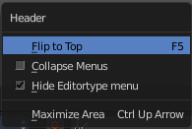
The header has also some right click functionality. Or that you can show or hide a editor type menu where you can switch to other editor types. For this general header functionality, like to show the editor type menu, collapse menus, etc. please have a look at the chapter 2.2 Layouts.

All Modes - View Menu

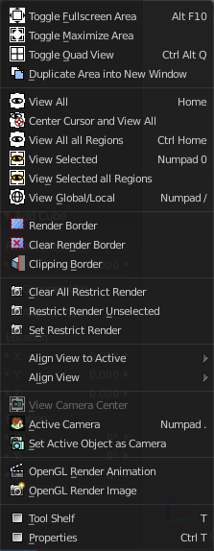
The View menu contains all View related tools. The range goes from tools to maximize the current window across align view tools up to rendering related tools for the viewport like Render Border.

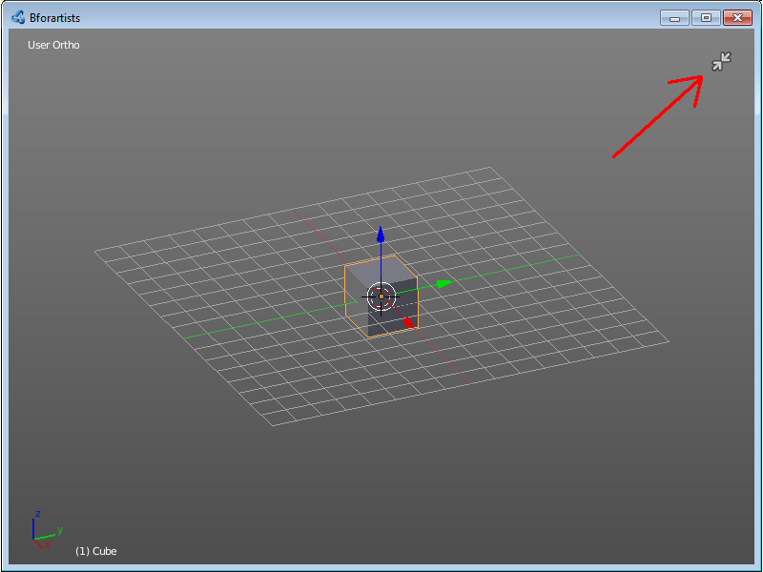
Toggle Full screen Area
Displays the editor maximized without menus.
To return from the full screen view press hotkey Alt F10, or use the little button that appears up right when you move the mouse in this corner.

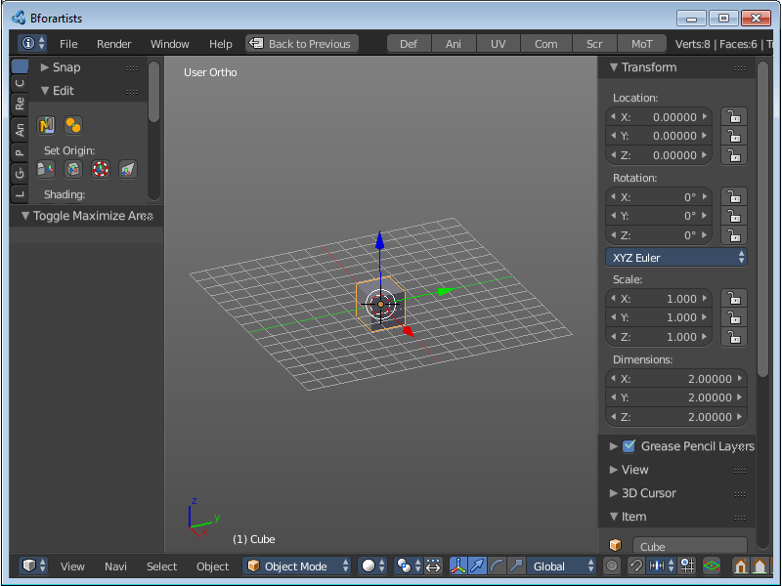
Toggle Maximize Area
Displays the editor maximized with menus.
To return to split view press hotkey Ctrl Up Arrow, or reuse the menu item in the View menu.

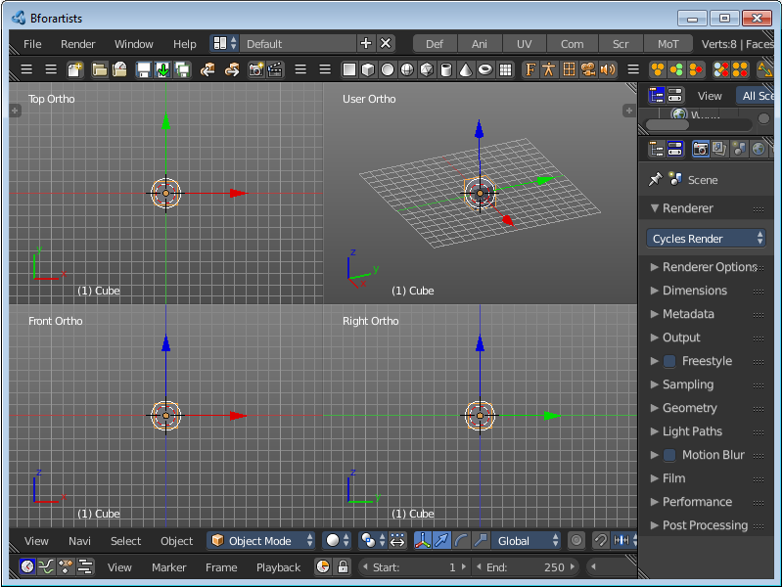
Toggle Quad view
Displays the 3D View divided into four screen parts.
To return to single view reuse the menu item in the View menu.

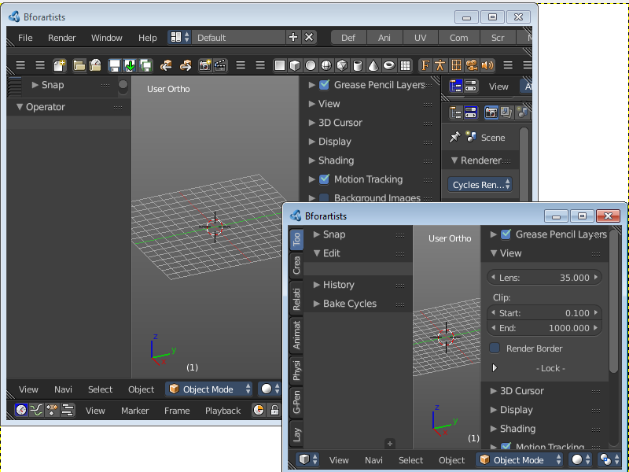
Duplicate Area into New Window
Duplicate Area into New Window makes the selected editor window floating. You can then drag it around at the monitor.
A separated window cannot be merged into the main window again. You have to close it when not longer needed.

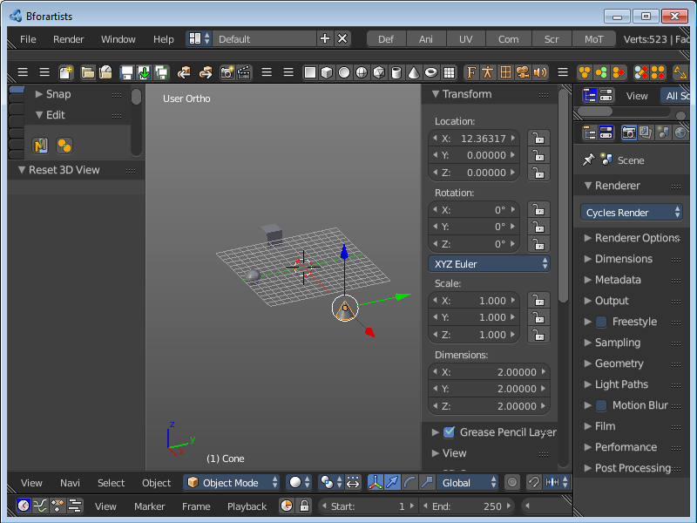
View All
View all zooms in or out until all objects in the scene are displayed fitting in the viewport.

Center Cursor and View All
Center Cursor and View all centres the 3D Cursor at 0/0/0, and zooms in or out until all objects in the scene are displayed fitting in the viewport.

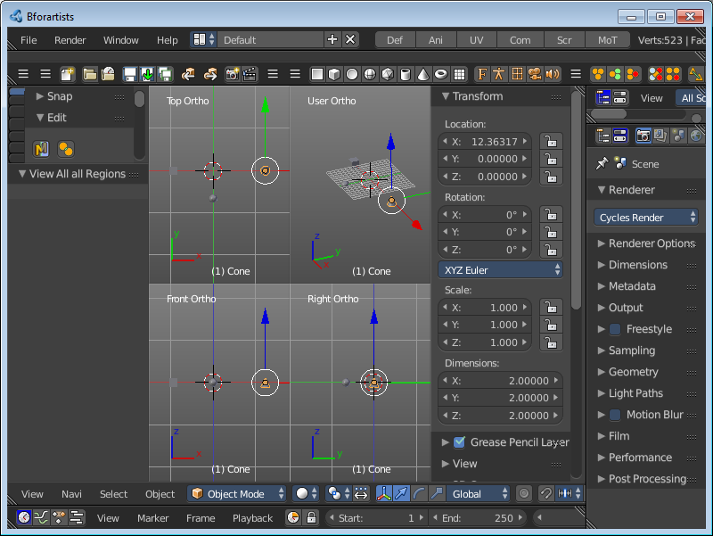
View All all Regions
View All all Regions works just in Quad View. It zooms in or out until all objects in the scene are displayed fitting in the four divided parts of the viewport.

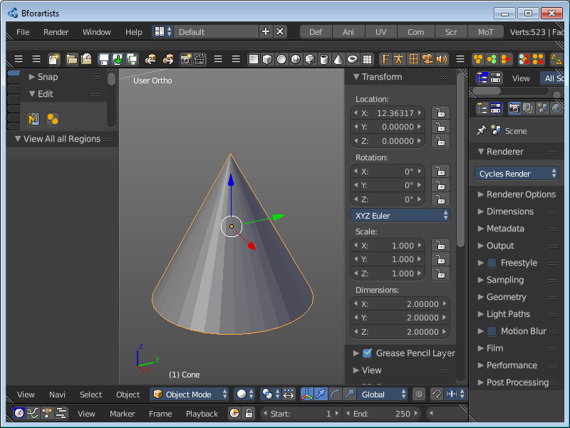
View Selected
View Selected zooms in or out until the Selection is displayed fitting in the viewport.

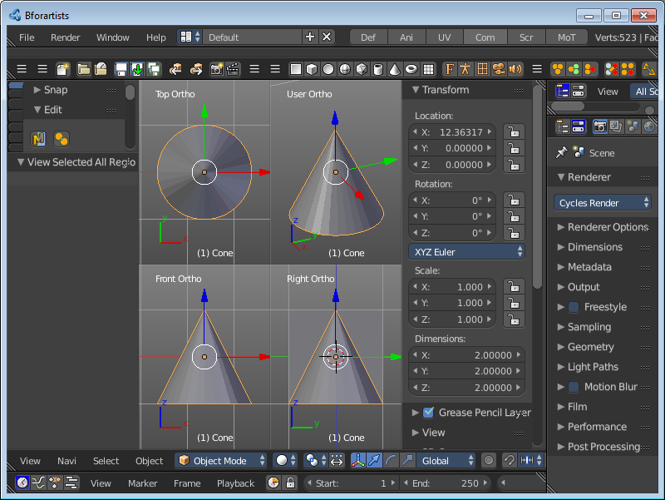
View Selected All Regions
View Selected all Regions works just in Quad View. It zooms in or out until the Selection in the scene are displayed fitting in the four divided parts of the viewport.

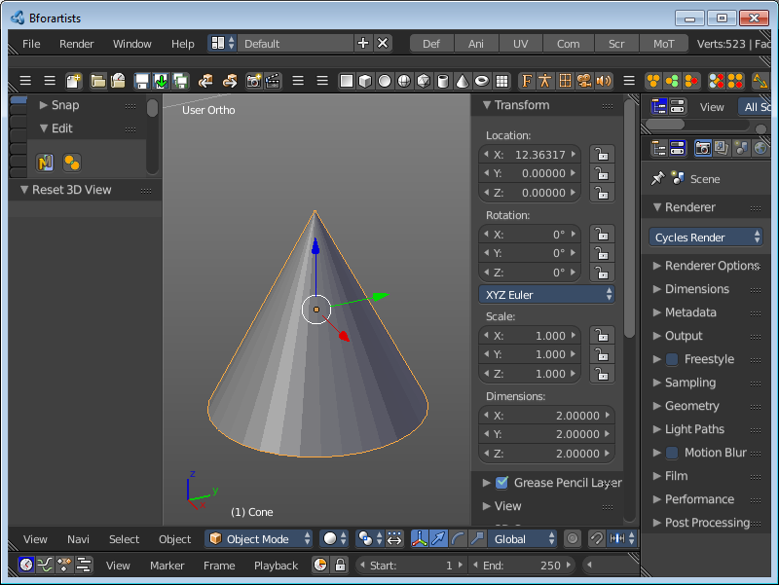
View Global / Local
View Global / Local zooms in or out until the Selection is displayed fitting in the viewport. And hides all other objects but the Selection.

Render Border
With the Render Border you can drag a rectangle at the viewport to define a portion of the screen to render. The benefit here is to have much faster preview renderings. You just render what you want to judge, and not the whole image.
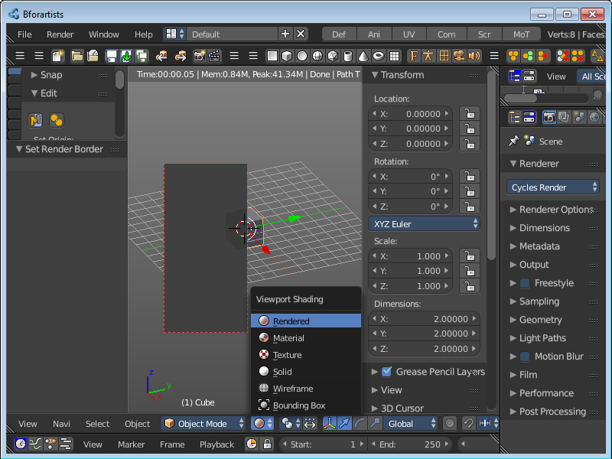
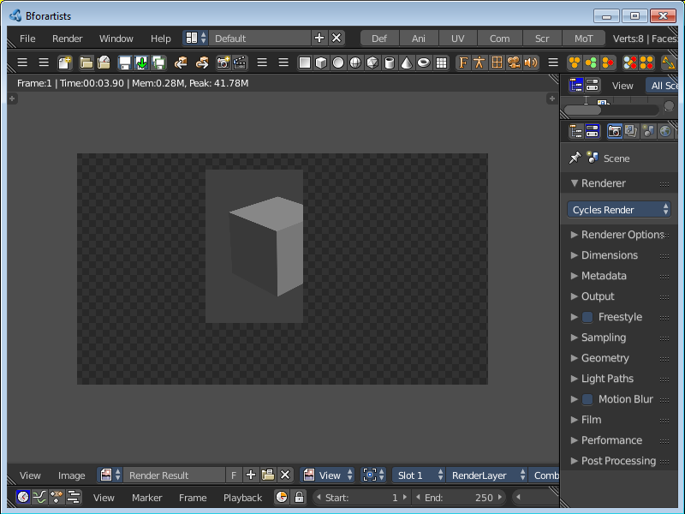
It has two use cases. The one is with the rendering through the camera. Just what is marked gets rendered. The other is directly in the viewport, with the Viewport shading method Rendered.

Clear Render Border
Removes the Render Border from the viewport.

Clipping
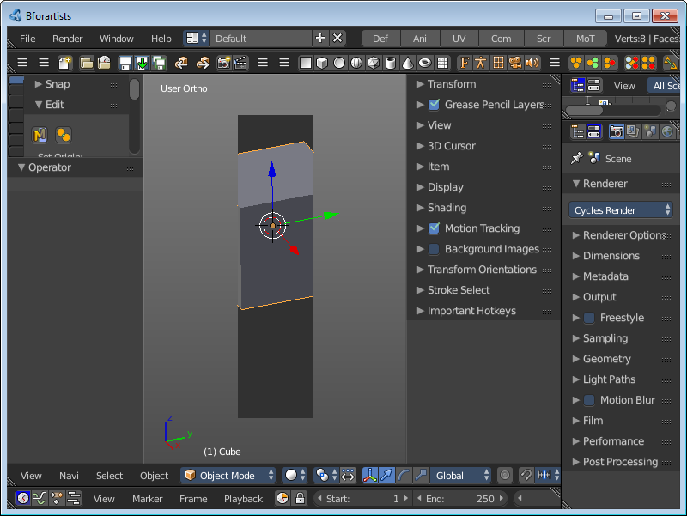
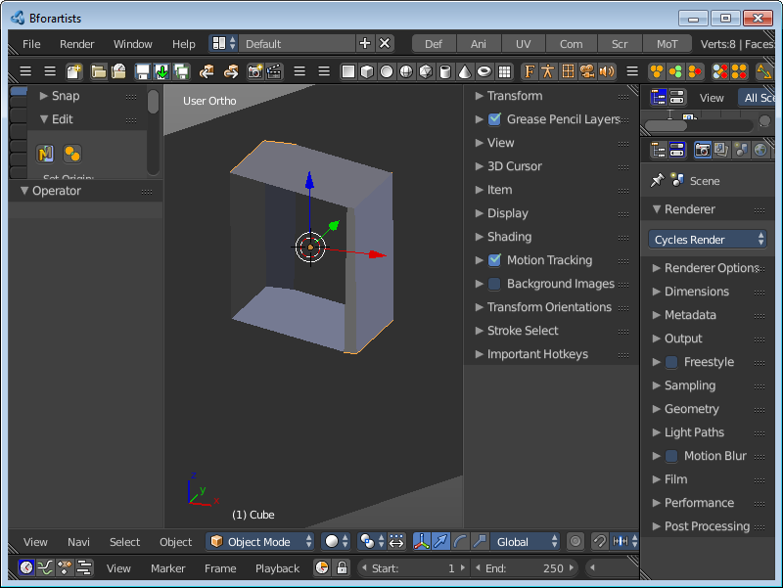
With clipping you can draw a rectangle that excludes the display of everything outside of this rectangle. That way you can look inside the geometry when you rotate the viewport. To clear the clipping use the tool again.

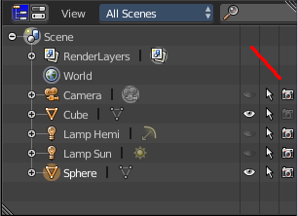
Clear All Restrict Render
Sets all Objects in the scene to be rendered. Have a look in the outliner, the camera row at the right.
This menu option just appears when there is a render able object in the viewport.

Restrict Render Unselected
Sets all unselected Objects in the scene to be rendered. The selected object(s) will be excluded from rendering now. Have a look in the outliner, the camera row at the right.
This menu option just appears when there is a render able object in the viewport

Set Restrict Render
Sets the selected Objects in the scene to be rendered. The unselected objects will be excluded from rendering now. Have a look in the outliner, the camera row at the right.
This menu option just appears when there is a render able object in the viewport

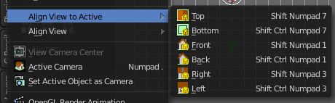
Align View to Active
Align View to Active is a menu where you can choose between different view align methods. The view gets aligned relative to the rotation of the currently active object. Not in World coordinates. The menu items should be self explaining. So we won't list them one by one.

Align View
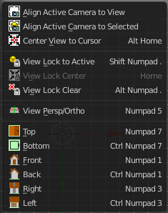
Align View is a menu where you can choose between different view align methods. The view gets aligned at the world coordinates. Here we also find a few more align methods.

Align Active Camera to View
Aligns the active camera to the current view. This means you can navigate with the viewport camera, select the render camera, and align it with this tool, so that the render camera has the same position and angle than the viewport camera.

Align Active Camera to Selected
Aligns the active camera to the current selected object. This means you can navigate with the viewport camera, select the render camera, and align it with this tool, so that the render camera has the same position and angle than the selected object.

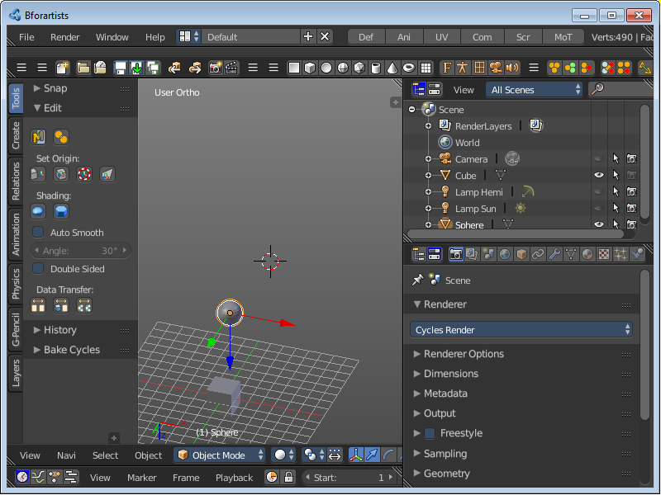
Center View to Cursor
Centres the view at the 3D cursor position.

View Lock to Active
Locks the view to the currently active object.

View Lock Center
Centres the view to the currently active and locked object. This tool is just active when you have performed a View Lock to Active before.

View Lock Clear
Removes the View Lock to Active from the object.

View Persp/Ortho
Toggles between perspectivic and orthographic view. Perspectivic view acts like a real camera with the perspectivic distortions. Orthographic view acts like a mathematical display of an object, without distortions.
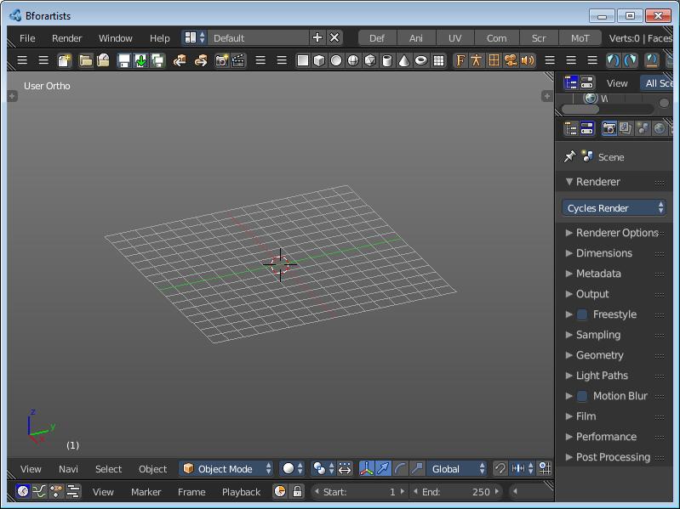
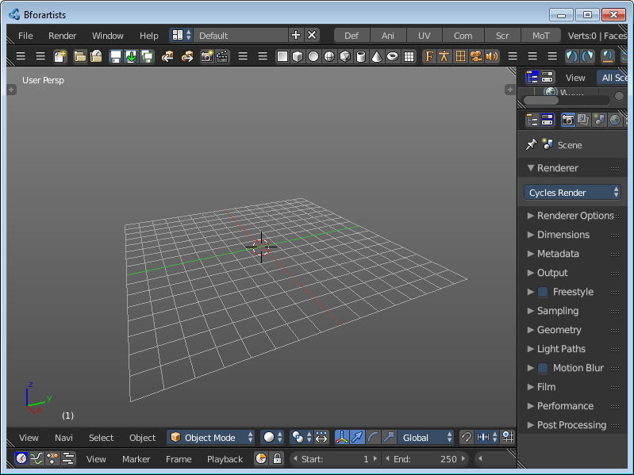

Top, Bottom, etc.
Switches to Top view, Bottom View, etc.

View Camera Center
This tool is of use when you are in camera view. It can be that the passepartout around the actual camera view field does not fit into the viewport. It can be too big or too small. It's already enough to resize the Tool shelf at the left or the Properties Sidebar at the right. And then it doesn't fit anymore.
View Camera center fits the camera view into the viewport.
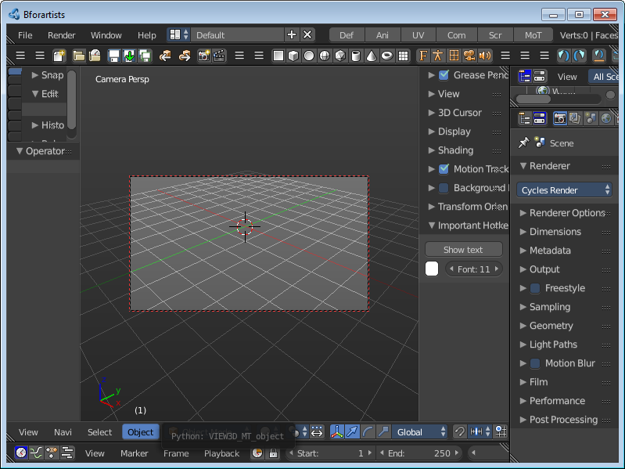
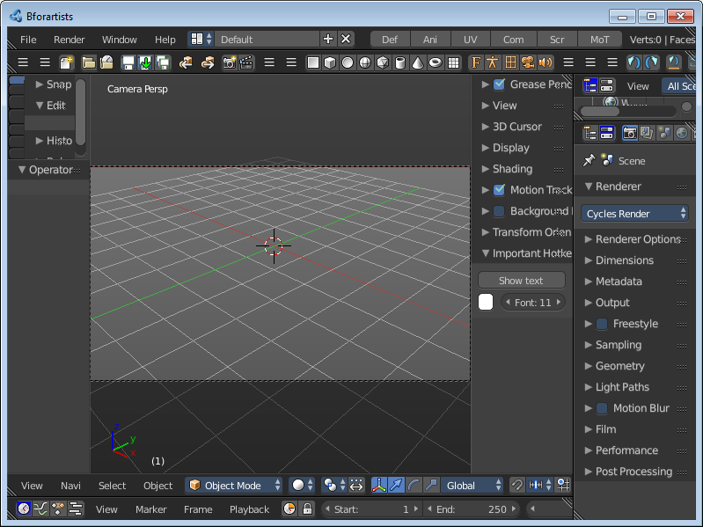

Active Camera
Switches to Camera view and back to Viewport Camera.

Set Active Object as Camera
With this tool you can set any object to be the active camera where you render from.

OpenGL Render Animation
Renders an animation, using the Viewport OpenGL renderer. This can be useful for preview renderings.
Note
Note that this menu item is a double menu entry. The same menu item exists in the Render menu in the Info Header. But this is required when you work with more than one 3D view. When you use the entry in the Render menu, then it picks an arbitrary 3D view. When you use the menu entry in the 3D view, then it renders from this 3D view.

OpenGL Render Image
Renders an Image, using the Viewport OpenGL renderer. This can be useful for preview renderings.
Note
Note that this menu item is a double menu entry. The same menu item exists in the Render menu in the Info Header. But this is required when you work with more than one 3D view. When you use the entry in the Render menu, then it picks an arbitrary 3D view. When you use the menu entry in the 3D view, then it renders from this 3D view.

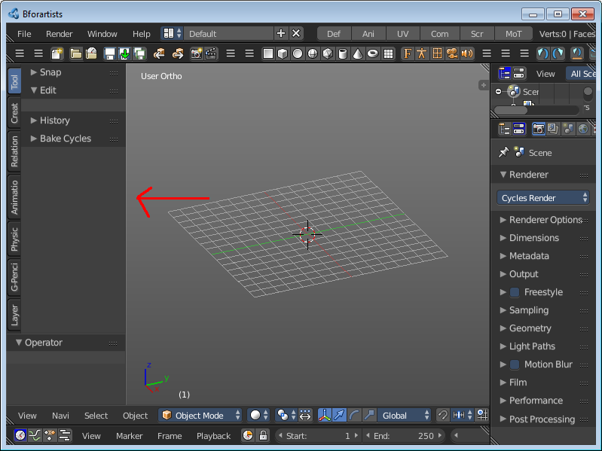
Tool Shelf
Opens or closes the Tool Shelf at the left side of the 3D Viewport.

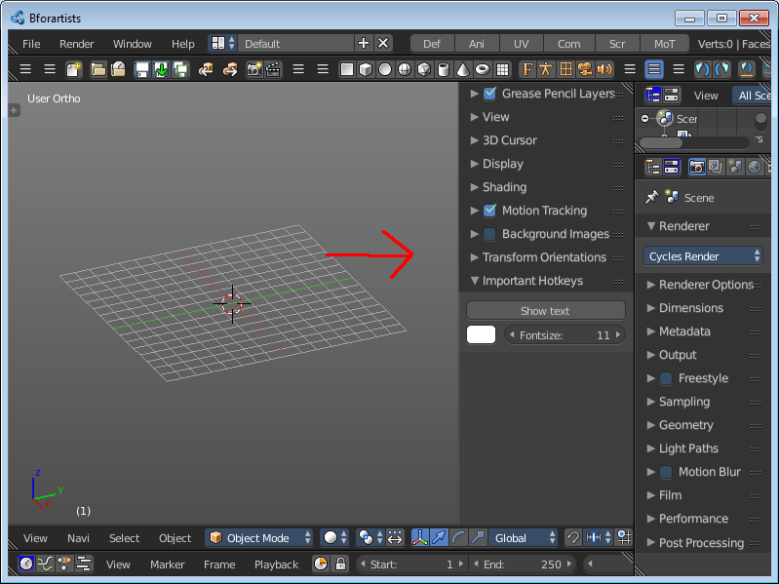
Properties
Opens or closes the Properties sidebar at the right side of the 3D Viewport.

All Modes - Navigation Menu
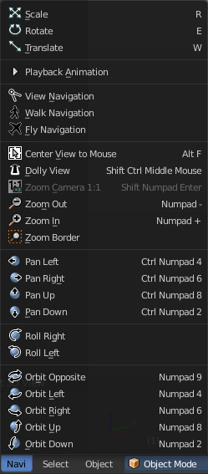
The Navigation menu provides you with all tools around viewport navigation.

Scale
Scales the selected object in the viewport by moving the mouse.

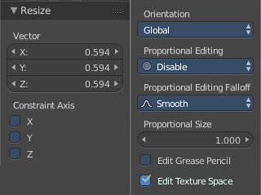
Last Operator Resize

Vector
Here you can adjust the position values for the three values

Constraint Axis
Here you can limit the position relative to the source object.

Orientation

Orientation is a drop-down box where you can choose the type of orientation for the mirroring action.

Proportional Editing

Proportional Editing is a drop-down box where you can choose to use proportional editing. When you choose one of the active methods then the neighbour geometry gets influenced by Shrink/Fatten too in a proportional way.

Proportional Editing Falloff

Proportional Editing Falloff is a drop-down box where you can choose a method for the falloff for the proportional editing.

Proportional Size
Proportional size is a edit box where you can adjust the strength of the Proportional falloff.

Edit Grease Pencil
Edit Grease Pencil edits the selected Grease Pencil strokes.

Edit Texture Space
With Confirm on Release checked the action gets performed when you release the mouse button.

Rotate
Rotates the selected object in the viewport by moving the mouse.

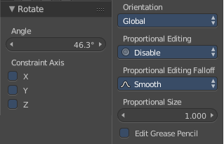
Last Operator Translate

Angle
Here you can adjust the rotation angle.

Constraint Axis
Here you can limit the position relative to the source object.

Orientation
Orientation is a drop-down box where you can choose the type of orientation for the mirroring action.

Proportional Editing
Proportional Editing is a drop-down box where you can choose to use proportional editing. When you choose one of the active methods then the neighbour geometry gets influenced by Shrink/Fatten too in a proportional way.

Proportional Editing Falloff
Proportional Editing Falloff is a drop-down box where you can choose a method for the falloff for the proportional editing.

Proportional Size
Proportional size is a edit box where you can adjust the strength of the Proportional falloff.

Edit Grease Pencil
Edit Grease Pencil edits the selected Grease Pencil strokes.


Translate
Moves the selected object in the viewport by moving the mouse.

Last Operator Translate

Vector
Here you can adjust the position values for the three values

Constraint Axis
Here you can limit the position relative to the source object.

Orientation
Orientation is a drop-down box where you can choose the type of orientation for the mirroring action.

Proportional Editing
Proportional Editing is a drop-down box where you can choose to use proportional editing. When you choose one of the active methods then the neighbour geometry gets influenced by Shrink/Fatten too in a proportional way.

Proportional Editing Falloff
Proportional Editing Falloff is a drop-down box where you can choose a method for the falloff for the proportional editing.

Proportional Size
Proportional size is a edit box where you can adjust the strength of the Proportional falloff.

Edit Grease Pencil
Edit Grease Pencil edits the selected Grease Pencil strokes.

Edit Texture Space
With Confirm on Release checked the action gets performed when you release the mouse button.

Playback Animation
Plays back an existing animation.

View Navigation
Switches to View Navigation Mode. In this view mode the view gets rotated moved and scaled from the Camera view point.

Walk Navigation
Switches to Walk Navigation. In this view mode the camera acts like a player in a first person shooter. Gravity will pull you down, The ground grid is the ground. And you can move around with wasd keys.

Fly Navigation
Switches to Fly navigation. In this view mode the camera acts like an air plane.

Center View to Mouse
Centres the view to the current mouse position.

Dolly View
Dolly View is a special zoom mode.
Be careful with this navigation method, you can easily trap yourself to not zoom able anymore!

Zoom Camera 1:1
Zooms the camera fitting to match the render output size by factor 1:1

Zoom In
Zooms into the viewport. Works also in camera view.

Zoom Out
Zooms out of the viewport. Works also in camera view.

Zoom Border
Draws a rectangle and zooms then to fit the size of this rectangle.
Zooming in is done with drawing the rectangle with left mouse button. Zooming out is done with drawing the rectangle with middle mouse button.

Pan Left
Pans the viewpoint to the left. The scene moves to the right.

Pan Right
Pans the viewpoint to the right. The scene moves to the left.

Pan Up
Pans the viewpoint upwards. The scene moves down.

Pan Down
Pans the viewpoint downwards. The scene moves up.

Roll Right
Rolls the viewport clockwise.

Roll Left
Rolls the viewport counter clockwise.

Orbit Opposite
Rotates the view by 180 degree.

Orbit Left
Orbits to the left.

Orbit Right
Orbits to the right.

Orbit Up
Orbits upwards.

Orbit Down
Orbits downwards.

All Modes, all Object types - Show / Hide

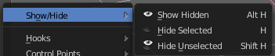
The Show/Hide menu is available for all object types and in all modes. It is usually in the object related menu to find. In Object mode it's the Object menu, for a curve object in edit mode it is the Curve menu. It always contains three menu items. Show Hidden, Hide Selected and Hide Unselected.

Show Hidden
Makes all objects in the scene visible again.

Hide Selected
Hides the selected objects.

Hide Unselected
Hides the not selected objects. The selected object stays visible.

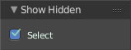
Last Operator Show Hidden
Here you can define if the selected or the unselected objects gets hidden.

Object Mode - Select menu

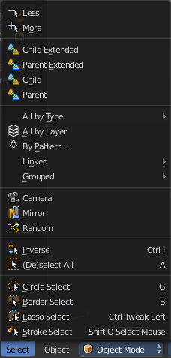
The select menu in Object mode is for all object types equal. It provides you with several selection methods.

Less
Less requires to have a parent or child relationship. It reduces the selection.

More
More requires to have a parent or child relationship. It expands the selection.

Child Extended
Child Extended requires to have a parent or child relationship. It selects the child object(s) of the currently selected object(s). But keeps the active object in the selection, even when it's not currently selected.

Parent extended
Parent extended requires to have a parent or child relationship. It selects the parent object of the currently selected object(s). But keeps the active object in the selection, even when it's not currently selected.

Child
Child requires to have a parent or child relationship. It selects the child object(s) of the currently selected object(s).

Parent
Parent requires to have a parent or child relationship. It selects the parent object of the currently selected object(s).

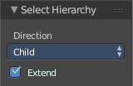
Last Operator Select Hierarchy
Child Extended, Parent Extended, Child and Parent share the same Last Operator. Called Select Hierarchy.

Direction
Direction is a drop-down box where you can adjust if child or parent objects gets selected.

Extended
This checkbox defines if the selection is extended or not. Extended means that it keeps the active object in the selection, even when it's not currently selected.

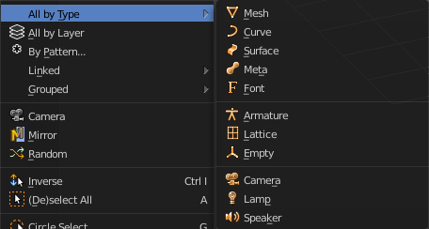
All by Type
All by Type is a menu where you can choose between the different object types to select.
The menu items are pretty self explaining. So we won't cover every single menu item here.

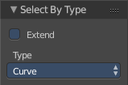
Last Operator Select By Type

Extend
With this option activated the selection does not clear before performing the selection operation, but extends. This means when you have a mesh object selected, and want to select all objects by type curve, then the mesh object is still selected. Without Extend just the curve objects are selected. The mesh object gets deselected.

Type
Type is a drop-down box where you can choose the object type to select again.

All by Layer
Selects all object in the defined layer.
You need to define the layer in the last operator panel. It's not enough to switch to let's say layer three, then perform the tool. The default value is Layer 1.

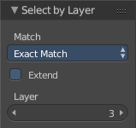
Last Operator Select by Layer

Match
Match is a drop-down box where you can choose if you want to select the objects that just exists at the current layer only. This is the option Exact Match. Or if you want to select objects too that exists at more than one layer. This is the option Shared Layers.

Extend
Extends existing selection instead of deselecting everything first.

Layer
The edit box where you can define the layer where you want to select the objects at.

By Pattern
Selects all objects whose name matches the entered string. For missing parts you need to add an asterix.
For example, you have four cubes in the scene. Cube, Cube.001, Cube.002 and mycube3. Then the term " Cube " will just select the first cube. While the term " Cube* " will select the first three. And " *cube* " will select all four.
Supported wild-cards:
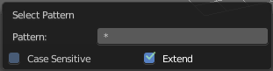
* matches everything
? matches any single character
[abc] matches characters in “abc”
[!abc] match any character not in “abc”
The tool operates immediately at entering the string.

Pattern
Here you can type in your string.

Case Sensitive
When ticked then the string comparison happens by taking upper and lower letters into account.

Extend
Extends existing selection instead of deselecting everything first.

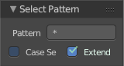
Last Operator Select Pattern
The Last Operator Select Pattern contains the same menu items than the pop-up.

Pattern
Here you can type in your string.

Case Sensitive
When ticked then the string comparison happens by taking upper and lower letters into account.

Extend
Extends existing selection instead of deselecting everything first.

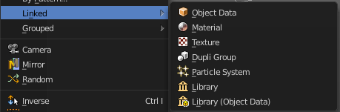
Linked
Linked is a menu where you can select different types.
Here you can select all objects that shares a common data-block with the active object. Select Linked uses the active object as a basis to select all others.

Object Data
Selects every object that is linked to the same Object Data.

Material
Selects every object that is linked to the same material data-block.

Texture
Selects every object that is linked to the same texture data-block.

Dupligroup
Selects all objects that use the same Group for duplication.

Particle System
Selects all objects that use the same Particle System.

Library
Selects all objects that are in the same Library

Library (Object Data)
Selects all objects that are in the same Library and limited to object data.

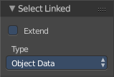
Last Operator Select Linked

Extend
Extends existing selection instead of deselecting everything first.

Type
Type is a drop-down list where you can choose the Linked type again.

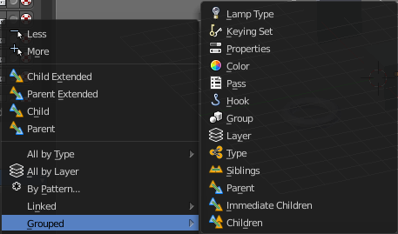
Grouped
Grouped is a menu where you can select different types of objects within the group. It requires to have a group selected.
The menu items are pretty self explaining. So we won't go into detail here.

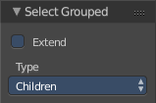
Last Operator Select Grouped

Extend
Extends existing selection instead of deselecting everything first.

Type
Type is a drop-down list where you can choose the Linked type again.

Camera
Selects the active camera.

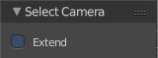
Last Operator Select Camera

Extend
Extends existing selection instead of deselecting everything first.

Mirror
Select the mirrored parts of an object. For example for L.Sword it selects R.Sword.

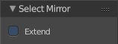
Last Operator Select Mirror

Extend
Extends existing selection instead of deselecting everything first.

Random
Selects random objects.

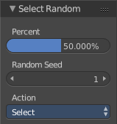
Last Operator Select Random

Percent
The Percentage of objects that should be selected randomly.

Random Seed
The Seed for the random number generator.

Action
Action is a drop-down box where you can choose if you want to select or to deselect random.

Inverse
Inverts the current selection.

(De)Select All
Toggles between select all and deselect all.

Last Operator (De)Select All

Action
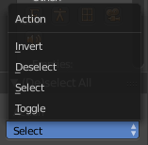
Action is a drop-down box where you can choose between different methods.

Invert
Inverts the selection.

Deselect
Deselects all.

Select
Selects all.

Toggle
Toggles between select all and deselect all.

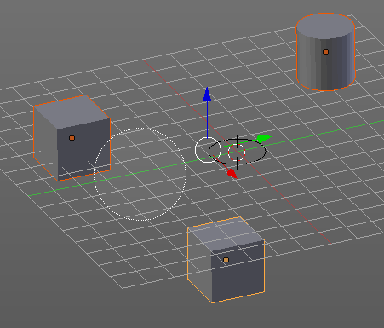
Circle Select
Circle select enters the Circle Select mode. This is a special select mode where you can select elements by moving with the mouse over it. It adds to selection by default.
To subtract from selection hold down Shift key. To exit the Circle select click with the right mouse button.
The pencil radius of the circle select tool can be adjusted with the scroll wheel.

Note
You cannot navigate while you are in Circle Select mode. You have to leave the Circle Select mode, do the navigation, then re-enter the Circle Select mode.

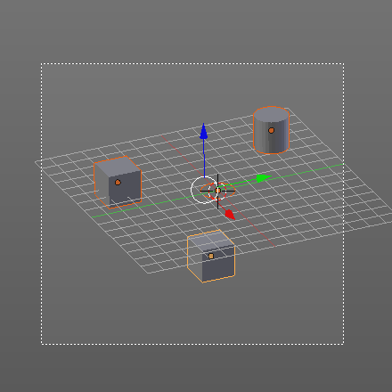
Border Select
Border select enters the Border Select mode. This is a special select mode where you can select elements by dragging a rectangle. And what's inside of the rectangle gets selected then. It adds to selection by default.
To subtract from selection hold down Shift key.
The selection gets applied when you release the mouse. You leave the mode automatically when you release the mouse.

Lasso Select
Lasso select enters the Lasso Select mode. This is a special select mode where you can select elements by dragging a form around what you want to select. And what's inside of the rectangle gets selected then. It adds to selection by default.
To subtract from selection hold down Shift key.
The selection gets applied when you release the mouse. You leave the mode automatically when you release the mouse.

Note
You can of course also start with clicking at the menu item. But this tool is by design a hotkey only tool. Hold down Ctrl , and select with left mouse button.

Stroke Select
Stroke select enters the Stroke Select mode. This is a special select mode where you can select elements by moving with the mouse over it. It is somehow similar to the Circle select tool. But has no pencil size. At the contrary, here you can navigate while you are in stroke select mode.
It adds to selection by default. To subtract from selection right click to change to deselect mode. This can also be done in the Properties sidebar in the Stroke Select panel. To return to add to selection right click again. Or untick the menu item in the Stroke Select Panel.
Note
This tool is by design a hotkey only tool. Hold down the key combo Shift Q, and paint with left mouse button.

Stroke Select is an add-on, and can be uninstalled if wanted. But note that the functionality is not longer available then.
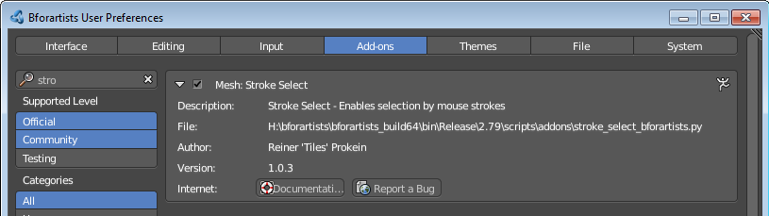

Object Mode - Object menu
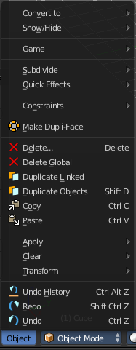
The object menu in Object mode provides you with tools to work at Object level.

It contains things like undo redo, copy and paste, delete and other general tools. But also some object specific tools, like the Convert to menu.

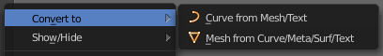
Convert to
Convert to is a menu to convert curves object types to mesh objects, and mesh object types to curves.

Curve from Mesh/Text
Converts a selected Mesh or Text Object to a Curve Object.

Mesh from Curve/Meta/Surf/Text
Converts a selected Curve, Metaball, Surface or Text Object to a Mesh Object.

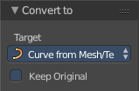
Last Operator Convert to
Target is a drop-down box where you can again choose between the two convert methods.
Keep Original
With this option ticked the original object gets kept. And a new object gets created.

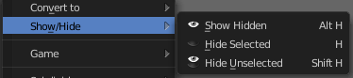
Show/Hide
Show/Hide is a menu. Here you can show or hide objects in the viewport. See chapter All Modes, all Object types - Show / Hide

Game
Game is a menu that is related to the Blender Game Engine. Bforartists does not give any support for the Game Engine. Please head over to the Blender Manual when you want to learn more about this menu.

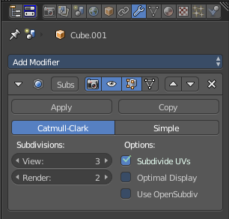
Subdivide
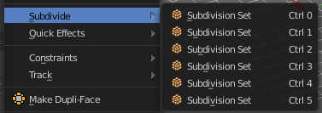
Subdivide is a menu where you can quickly add and change a subdivision surface modifier with a predefined resolution in a quick way. Especially when you use the hotkey for it. The subdivision surface modifier panel can then as usual be found in the Properties editor in the Modifier tab.

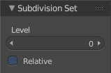
Last Operator Subdivision Set

Level
Here you can set the level of subdivisions

Relative
Applies the sub surf level as an offset to the already existing sub surf level.

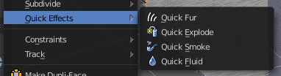
Quick Effects
Quick effects is a menu with some predefined basic Particle effects. You need to have a mesh object selected.

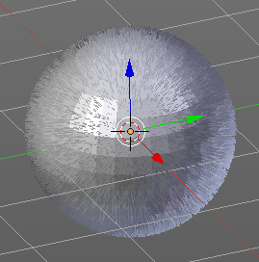
Quick Fur
Adds a particle system with Fur settings.

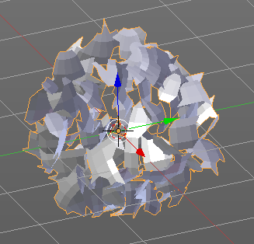
Quick Explode
Adds a particle system that lets the selected object explode into pieces.
Hit play to play the animation.

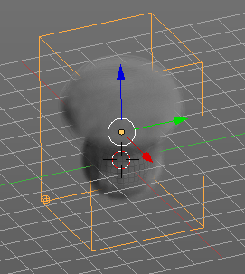
Quick Smoke
Adds a particle system with a simple smoke.
Hit play to play the animation.

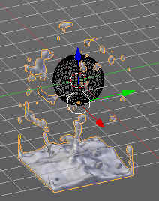
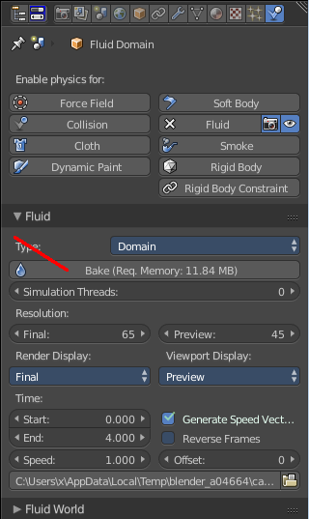
Quick Fluid
Adds a particle system with Fluid settings.
This feature does not completely work out of the box. You need to bake the animation first. This can be done in the Properties Editor, Particles Tab, Fluid Panel.

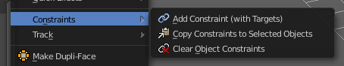
Constraints
Constraints is a menu around Constraints functionality. Constraints provides you with various limitation methods connected to a target object. For example, you can limit the X position of an object to the X position of the target object. And when you move the target object, then the object will change its X position too.

Add Constraints ( With Targets)
Add Constraints ( With Targets) calls a menu where you can choose the constraints type. It's the same content than in the Constraints tab in the Properties editor.
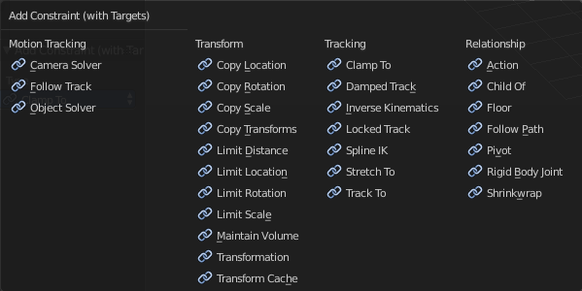
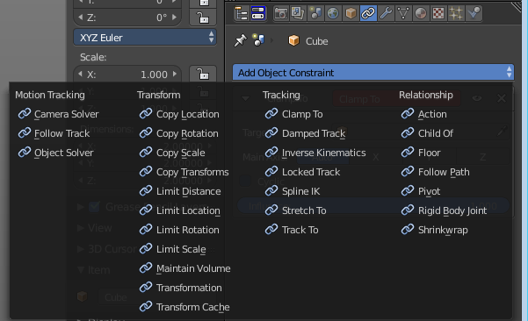

We will not explain every single constraint type here. Please have a look at the constraint types in the manual part for the Properties editor.
Usage:
Select the target object. Hold down Shift key. Now select the object where you want to add the constraints to. Both should be selected. Then choose the constraints type in the menu that you want to add.
As a result a constraints panel gets created in the Constraints tab in the Properties editor. Here you can tweak the settings then further if required. In our example we wanted to limit the X axis. So we added a Copy Location constraint, and unticked Y and Z axis.
In the 3D view a black dotted line indicates the relationship.
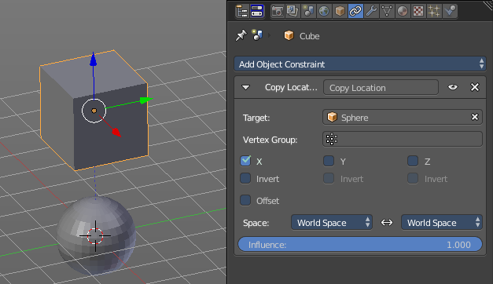

Last Operator Add Constraints (with Target)

Type
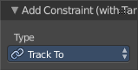
Type is a drop-down box where you can choose the constraints type again.

Copy Constraints to Selected Objects
Copy Constraints to Selected Objects copies a constraint from one object to another.
Usage:
Select the object where you want to copy the constraint to. Hold down Shift and select the object with the constraint. Both should be selected. Then click at Copy Constraints to Selected Objects. This copies the constraint to the object.

Clear Object Constraints
Removes all constraints from the object.

Clear Track
This menu item is just relevant when you have a Track constraint applied. It removes the track constraint.

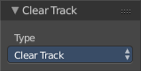
Last Operator Clear track

Type
Type is a drop-down box where you can choose between Clear Track and Clear Track Keep Transformation.

Clear Track - Keep Transformation
This menu item is just relevant when you have a Track constraint applied. Removes the track constraint. But keeps the current position.

Last Operator Clear track

Type
Type is a drop-down box where you can choose between Clear Track and Clear Track Keep Transformation.

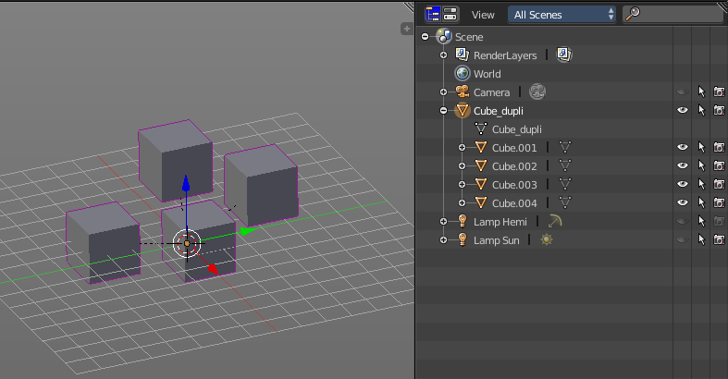
Make Dupli Face
Make Dupli Face is a relict from the past, when there was no instancing or parenting feature available in Blender. When you turn an object into a Dupli Face object, then this object becomes an instancing container for this object. All objects in this container just exists once in ram when you duplicate it. No matter how often you duplicate it. This allows to plant whole forests without to run into a memory problem. Since the tree object just loads once into ram. And gets just drawn at different screen positions then.

Delete
Delete deletes the selected object(s)

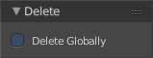
Last Operator Delete

Delete Globally
When ticked then the delete operation deletes global, in all scenes.

Delete Global
It can be that you have more than one scene open. Delete deletes the selected object(s) in all scenes.

Last Operator Delete

Delete Globally
When ticked then the delete operation deletes global, in all scenes.

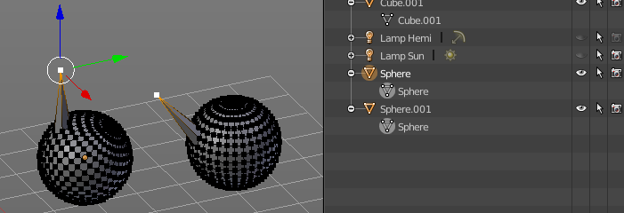
Duplicate Linked
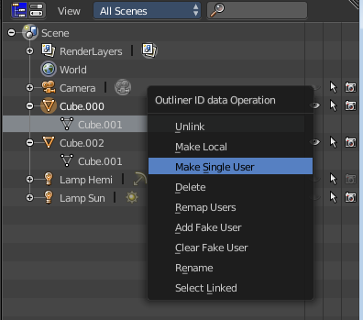
Duplicates selected objects. The instance has its own transforms. But the duplicate shares some data with the first instance. This means when you for example edit the mesh of one of the instances, then the other instance gets modified too. As you can see this in the screen shot. Here you can also see that the mesh name is the same.
If you want to make changes to an object in the new linked duplicate independently of the original object, then you will have to manually make the object a “single-user” . This can be done for example in the Outliner, in the right click menu of the object.
You are automatically in grab mode, and so you can easily move the object out of position. which is sometimes wanted, since you can position the duplicate then. But sometimes this is unwanted. A right click after releasing the mouse lets the object snap back into its creation position.

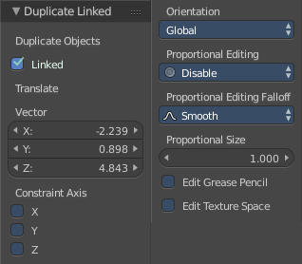
Last Operator Duplicate Linked

Duplicate Objects

Linked
With this option ticked the duplication happens with linked data.

Translate
The Position of the duplicated object

Constraint Axis
Here you can limit the position relative to the source object.

Orientation
Orientation is a drop-down box where you can choose the type of orientation for the mirroring action.

Proportional Editing
Proportional Editing is a drop-down box where you can choose to use proportional editing. When you choose one of the active methods then the neighbour geometry gets influenced by Shrink/Fatten too in a proportional way.

Proportional Editing Falloff
Proportional Editing Falloff is a drop-down box where you can choose a method for the falloff for the proportional editing.

Proportional Size
Proportional size is a edit box where you can adjust the strength of the Proportional falloff.

Edit Grease Pencil
Edit Grease Pencil edits the selected Grease Pencil strokes.

Edit Texture Space
With Confirm on Release checked the action gets performed when you release the mouse button.

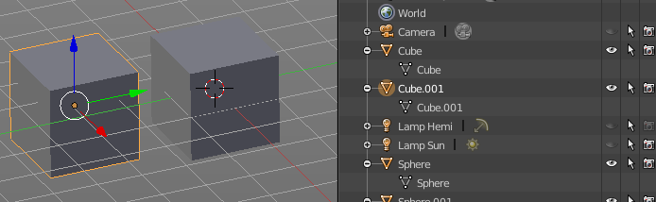
Duplicate Objects
Duplicates selected objects. The copy is completely independent. All containing data gets duplicated too. And you can edit the object instances completely independent. then.
You are automatically in grab mode, and so you can easily move the object out of position. Which is sometimes wanted, since you can position the duplicate then. But sometimes this is unwanted. A right click after releasing the mouse lets the object snap back into its creation position.
When you drag the duplicate around you will see the position values in the header.

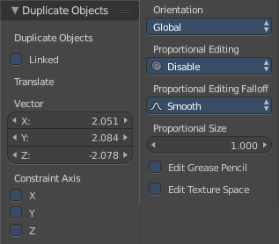
Last Operator Duplicate

Duplicate Objects

Linked
With this option ticked the duplication happens with linked data.

Translate
The Position of the duplicated object.

Constraint Axis
Here you can limit the position relative to the source object.

Orientation
Orientation is a drop-down box where you can choose the type of orientation for the mirroring action.

Proportional Editing
Proportional Editing is a drop-down box where you can choose to use proportional editing. When you choose one of the active methods then the neighbour geometry gets influenced by Shrink/Fatten too in a proportional way.

Proportional Editing Falloff
Proportional Editing Falloff is a drop-down box where you can choose a method for the falloff for the proportional editing.

Proportional Size
Proportional size is a edit box where you can adjust the strength of the Proportional falloff.

Edit Grease Pencil
Edit Grease Pencil edits the selected Grease Pencil strokes.

Edit Texture Space
With Confirm on Release checked the action gets performed when you release the mouse button.

Copy
Copies the selected object(s)

Paste
Pastes copied object(s).

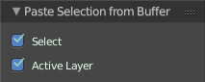
Last Operator Paste Selection from Buffer

Select
Select pasted object(s).

Active Layer
Paste the object into the active layer.

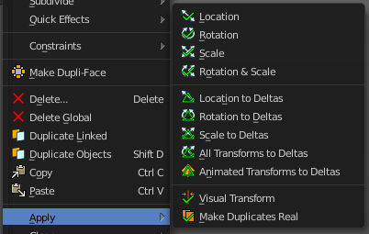
Apply
Apply is a menu where you can apply transforms in various combinations. For example, when you create a cube, then move it to let's say 3, then apply the location, then the origin gets set to 0. The position is "applied". Of special Interest is apply scale, since it resets the scale factor to 1.
Apply just works with single user objects. And it does not apply to pose position, animation curves or constraints. These tools should be used before rigging and animation.

Location, Rotation, Scale and Rotation&Scale
This applies the location, rotation and scale of the object.

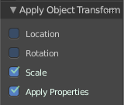
Last Operator Apply Object Transform.

Location
Applies the position, and resets origin to 0

Rotation
Applies the rotation.

Scale
Applies the Scale.

Apply Properties
Properties such as Curve Vertex Radius. Font Size and bone envelope gets applied.

Location, Rotation, Scale and All Transforms to Deltas
Transforms are absolute to the world coordinates. Delta Transforms are relative to the current transformation.
The delta transform values can be found in the Object properties, in the Delta Transform Panel.
Example use case:
Keyframe a object rotation from 0 to 90 degrees. Rotate the object by 45 degrees. When you play the animation it will still rotate from 0 to 90 degrees.
Now keyframe a delta rotation from 0 to 90 degrees and rotate the object by 45 degrees. When you playback the animation it will rotate from 45 to 135 degrees now. (a 90 degree difference from the current state)

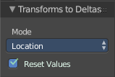
Last Operator Transforms to Deltas

Mode
Mode is a drop-down box where you can choose the transform mode again.

Reset Values
Clears the transform values after transferring to Deltas.

Animated Transform to Deltas
Converts the “normal” transformation animations to Delta transforms. This tool requires to have key frames at the object.

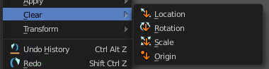
Clear
Clear Transform is a menu where you can clear the transform for location, rotation, scale and Origin. Clear means in this conjunction that the values gets reset. When you have for example a cube at X 5, and clear the location, then the cube gets positioned at position X 0.

Location
Resets the location of the selected object(s).

Last Operator Clear Location

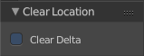
Clear Delta
With Clear Delta ticked it clears the delta transform instead of the transform.

Rotation
Resets the rotation of the selected object(s).

Last Operator Clear Rotation

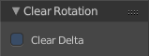
Clear Delta
With Clear Delta ticked it clears the delta transform instead of the transform.

Scale
Resets the scaling of the selected object(s).

Last Operator Clear Scale

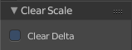
Clear Delta
With Clear Delta ticked it clears the delta transform instead of the transform.

Origin
Clear Origin requires to have a parent child relationship selected. It sets the child object to the position of the parent object.

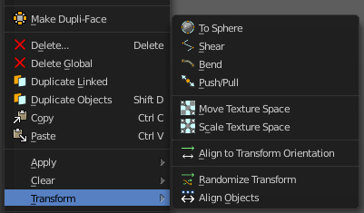
Transform
Transform is a menu that contains some special transform functionality.

To Sphere
In Object mode this tool requires to have more than one object selected. It tries to transform the object positions to a sphere shape, using the center of the selected objects as a center point for the operation.
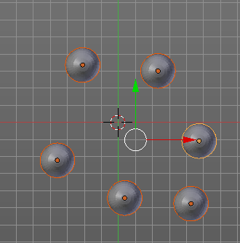
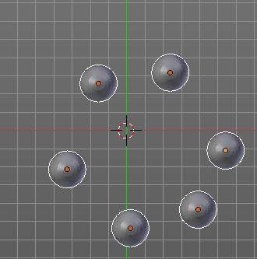

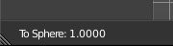
While the operation you will see in the header the strength value for the spherical shape.

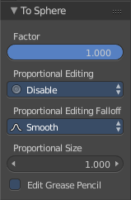
Last Operator To Sphere

Factor
A edit box where you can adjust the strength of influence of the tool.

Proportional Editing
Proportional Editing is a drop-down box where you can choose to use proportional editing. When you choose one of the active methods then the neighbour geometry gets influenced by Shrink/Fatten too in a proportional way.

Proportional Editing Falloff
Proportional Editing Falloff is a drop-down box where you can choose a method for the falloff for the proportional editing.

Proportional Size
Proportional size is a edit box where you can adjust the strength of the Proportional falloff.

Edit Grease Pencil
Edit Grease Pencil edits the selected Grease Pencil strokes.

Shear
In Object mode this tool requires to have more than one object selected. It shears the object positions relative to the center of the selection.
While the operation you can press x or y to change the direction of shearing.
While the operation you will see the strength value in the header.

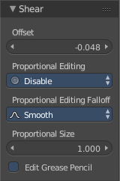
Last Operator Shear

Factor
A edit box where you can adjust the strength of influence of the tool.

Proportional Editing
Proportional Editing is a drop-down box where you can choose to use proportional editing. When you choose one of the active methods then the neighbour geometry gets influenced by Shrink/Fatten too in a proportional way.

Proportional Editing Falloff
Proportional Editing Falloff is a drop-down box where you can choose a method for the falloff for the proportional editing.

Proportional Size
Proportional size is a edit box where you can adjust the strength of the Proportional falloff.

Edit Grease Pencil
Edit Grease Pencil edits the selected Grease Pencil strokes.

Bend
Bends the selected objects between 3D cursor and mouse.
HOTKEY ONLY TOOL!
You might want to add/use a hotkey here, since the operation calculates from the mouse position starting point. And the menu item might not be at the wanted position.
While the operation you will see in the header the strength value for the bend. Holding down Alt turns off Clamp.
The Last operator for Bend is greyed out. Undo is not supported.

Push/Pull
In Object mode this tool requires to have more than one object selected. It pushes or pulls the object positions relative to the center of the selection.

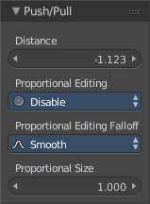
Last Operator Shear

Factor
A edit box where you can adjust the strength of influence of the tool.

Proportional Editing
Proportional Editing is a drop-down box where you can choose to use proportional editing. When you choose one of the active methods then the neighbour geometry gets influenced by Shrink/Fatten too in a proportional way.

Proportional Editing Falloff
Proportional Editing Falloff is a drop-down box where you can choose a method for the falloff for the proportional editing.

Proportional Size
Proportional size is a edit box where you can adjust the strength of the Proportional falloff.

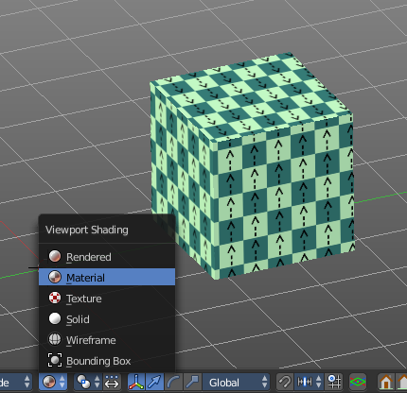
Move Texture Space
This tool relies at the move tool. With the difference that it moves the texture space instead of the object. It has also a very special use case, and just works with a material with a Texture Coordinate / Generated node. And requires to have the shading at Material or Rendered to see a result in the viewport.
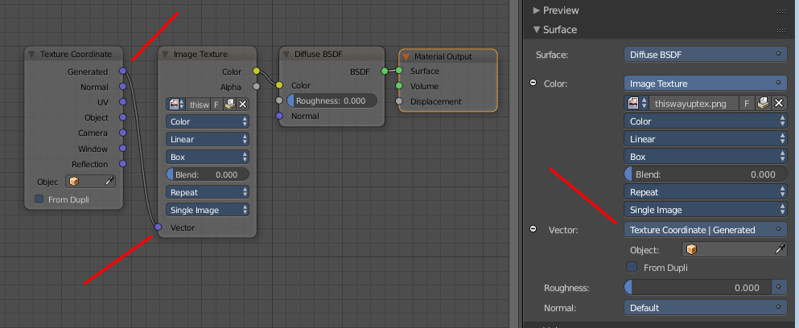

Last Operator Translate

Vector
Here you can adjust the position values for the three axis.

Constraint Axis
Here you can limit the position relative to the source object.

Orientation
Orientation is a drop-down box where you can choose the type of orientation for the mirroring action.

Proportional Editing
Proportional Editing is a drop-down box where you can choose to use proportional editing. When you choose one of the active methods then the neighbour geometry gets influenced by Shrink/Fatten too in a proportional way.

Proportional Editing Falloff
Proportional Editing Falloff is a drop-down box where you can choose a method for the falloff for the proportional editing.

Proportional Size
Proportional size is a edit box where you can adjust the strength of the Proportional falloff.

Edit Grease Pencil
Edit Grease Pencil edits the selected Grease Pencil strokes.

Edit Texture Space
With Confirm on Release checked the action gets performed when you release the mouse button.

Scale Texture Space
This tool relies at the scale tool. With the difference that it scales the texture space instead of the object. It has also a very special use case, and just works with a material with a Texture Coordinate / Generated node. And requires to have the shading at Material or Rendered to see a result in the viewport.

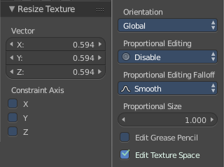
Last Operator Resize Texture

Vector
Here you can adjust the position values for the three values

Constraint Axis
Here you can limit the position relative to the source object.

Orientation
Orientation is a drop-down box where you can choose the type of orientation for the mirroring action.

Proportional Editing
Proportional Editing is a drop-down box where you can choose to use proportional editing. When you choose one of the active methods then the neighbour geometry gets influenced by Shrink/Fatten too in a proportional way.

Proportional Editing Falloff
Proportional Editing Falloff is a drop-down box where you can choose a method for the falloff for the proportional editing.

Proportional Size
Proportional size is a edit box where you can adjust the strength of the Proportional falloff.

Edit Grease Pencil
Edit Grease Pencil edits the selected Grease Pencil strokes.

Edit Texture Space
With Confirm on Release checked the action gets performed when you release the mouse button.

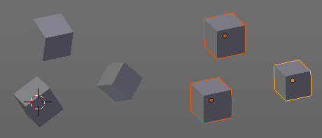
Align to Transform Orientation
Rotates the selected objects so that their local orientation matches the active transform orientation in the Transform orientation panel or the Orientation selection in the Transform Operator panels.
For example when you have a few cubes that are rotated differently, then perform align to transform orientation with Global coordinates, then the cubes rotations gets set back to 0/0/0

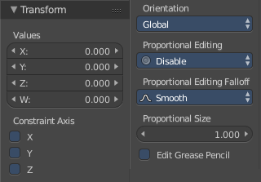
Last Operator Transform
Align Transform Orientation is a subset of the Transform tool. And so it comes with the full set.

Values
The transform values for the single axis.

Constraint Axis
Here you can limit the transform of single axis.

Orientation
Orientation is a drop-down box where you can choose the type of orientation for the mirroring action.

Proportional Editing
Proportional Editing is a drop-down box where you can choose to use proportional editing. When you choose one of the active methods then the neighbour geometry gets influenced by Shrink/Fatten too in a proportional way.

Proportional Editing Falloff
Proportional Editing Falloff is a drop-down box where you can choose a method for the falloff for the proportional editing.

Proportional Size
Proportional size is a edit box where you can adjust the strength of the Proportional falloff.

Edit Grease Pencil
Edit Grease Pencil edits the selected Grease Pencil strokes.

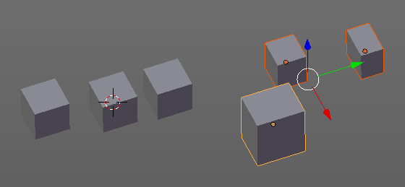
Randomize Transform
This tool allows to randomize position rotation and scale of selected objects. Each object gets threaten individually by a random value.
It starts with zeroed values. You need to adjust the values in the last operator.

Last Operator Randomize Transform

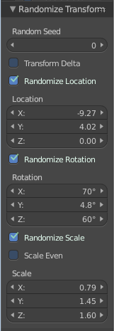
Random Seed
Here you can adjust the random seed value.

Transform Delta
Randomize Delta transform values instead of the regular transform values.

Randomize Location checkbox
With this checkbox ticked the location of the selected objects gets randomized.

Location edit boxes
Here you can adjust the strength of the transform for the single axis.

Randomize Rotation checkbox
With this checkbox ticked the rotation of the selected objects gets randomized.

Rotation edit boxes
Here you can adjust the strength of the transform for the single axis.

Randomize Scale checkbox
With this checkbox ticked the scale of the selected objects gets randomized.

Scale Even
Use the same scale values for all axis.

Scale edit boxes
Here you can adjust the strength of the transform for the single axis.

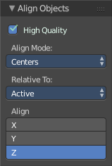
Align Objects
Align Objects allows you to align the selected objects in various ways. You need to adjust the settings in the Last operator panel. The align operation happens in world coordinates.

Last Operator Align Objects

High Quality
When ticked the calculation gets performed in a higher precision.

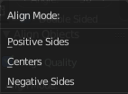
Align Mode
Align Mode is a drop-down box where you can choose between different align modes.

Relative To
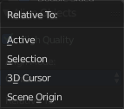
Relative to is a drop-down box. Here you adjust in what method the alignment happens. Relative to the active object, to the center of selection, to the 3D cursor or to the scene origin.

Align
Here you can turn on or off the single axis for the align operation.

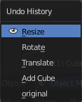
Undo History
Undo History reveals a list of the last actions. And allows you to go back to a specific action.

Redo
Redo the previous action. This is no repeat. It just redoes what was previously undone.

Undo
Undo the previous action.

Edit Mode - Transform Menu
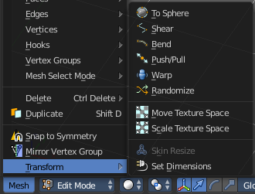
The transform menu in edit mode is available for most object types that has an edit mode. Exception is the text object in edit mode. The transform menu in edit mode is usually located in the object type related menu. For a mesh object it's the mesh menu. For a curve object it's the curve menu.

Transform is a menu that contains some special transform functionality.
For armatures we have some tools fewer, and one more. Align Bones.
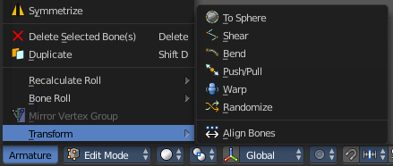

To Sphere
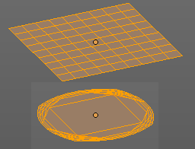
In Edit mode this tool tries to form a sphere from the selected vertices.
While the operation you will see in the header the strength value for the spherical shape.

Last Operator To Sphere

Factor
A edit box where you can adjust the strength of influence of the tool.

Proportional Editing
Proportional Editing is a drop-down box where you can choose to use proportional editing. When you choose one of the active methods then the neighbour geometry gets influenced by Shrink/Fatten too in a proportional way.

Proportional Editing Falloff
Proportional Editing Falloff is a drop-down box where you can choose a method for the falloff for the proportional editing.

Proportional Size
Proportional size is a edit box where you can adjust the strength of the Proportional falloff.

Edit Grease Pencil
Edit Grease Pencil edits the selected Grease Pencil strokes.

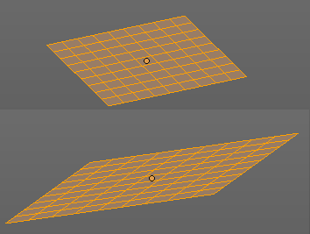
Shear
Shears the selection relative to the center of the selection. Press x or y to change the shear axis while operation.
While the operation you will see in the header the strength value for the shear.

Last Operator Shear

Factor
A edit box where you can adjust the strength of influence of the tool.

Proportional Editing
Proportional Editing is a drop-down box where you can choose to use proportional editing. When you choose one of the active methods then the neighbour geometry gets influenced by Shrink/Fatten too in a proportional way.

Proportional Editing Falloff
Proportional Editing Falloff is a drop-down box where you can choose a method for the falloff for the proportional editing.

Proportional Size
Proportional size is a edit box where you can adjust the strength of the Proportional falloff.

Edit Grease Pencil
Edit Grease Pencil edits the selected Grease Pencil strokes.

Bend
Bends the selected objects between 3D cursor and mouse.
HOTKEY ONLY TOOL! You might want to add/use a hotkey here, since the operation calculates from the mouse position starting point. And the menu item might not be at the wanted position.
While the operation you will see in the header the strength value for the bend. Holding down Alt turns off Clamp.
The Last operator for Bend is greyed out. Undo is not supported.

Push/Pull
In Object mode this tool requires to have more than one object selected. It pushes or pulls the object positions relative to the center of the selection.

Last Operator Push/Pull

Factor
A edit box where you can adjust the strength of influence of the tool.

Proportional Editing
Proportional Editing is a drop-down box where you can choose to use proportional editing. When you choose one of the active methods then the neighbour geometry gets influenced by Shrink/Fatten too in a proportional way.

Proportional Editing Falloff
Proportional Editing Falloff is a drop-down box where you can choose a method for the falloff for the proportional editing.

Proportional Size
Proportional size is a edit box where you can adjust the strength of the Proportional falloff.

Warp
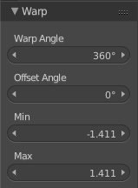
Edit Mode only! Warps the selected vertices around the 3D cursor.

Last Operator Warp

Warp Angle
The amount to wrap around the 3D cursor.

Offset Angle
Angle to use as the basis for warping

Min
The minimum amount

Max
The maximum amount

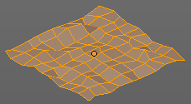
Randomize
Edit Mode Only! Randomizes the positions of the selected vertices.

Last Operator Randomize

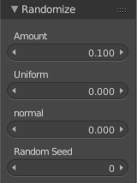
Amount
The distance to offset.

Uniform
Increase for uniform offset distance.

Normal
Align Offset direction to normals.

Random Seed
The seed for the random number generator.

Move Texture Space
This tool relies at the move tool. With the difference that it moves the texture space instead of the object. It has also a very special use case, and just works with a material with a Texture Coordinate / Generated node. And requires to have the shading at Material or Rendered to see a result in the viewport.

Last Operator Translate

Vector
Here you can adjust the position values for the three axis.

Constraint Axis
Here you can limit the position relative to the source object.

Orientation
Orientation is a drop-down box where you can choose the type of orientation for the mirroring action.

Proportional Editing
Proportional Editing is a drop-down box where you can choose to use proportional editing. When you choose one of the active methods then the neighbour geometry gets influenced by Shrink/Fatten too in a proportional way.

Proportional Editing Falloff
Proportional Editing Falloff is a drop-down box where you can choose a method for the falloff for the proportional editing.

Proportional Size
Proportional size is a edit box where you can adjust the strength of the Proportional falloff.

Edit Grease Pencil
Edit Grease Pencil edits the selected Grease Pencil strokes.

Edit Texture Space
With Confirm on Release checked the action gets performed when you release the mouse button.

Scale Texture Space
This tool relies at the scale tool. With the difference that it scales the texture space instead of the object. It has also a very special use case, and just works with a material with a Texture Coordinate / Generated node. And requires to have the shading at Material or Rendered to see a result in the viewport.

Last Operator Resize Texture

Vector
Here you can adjust the position values for the three values

Constraint Axis
Here you can limit the position relative to the source object.

Orientation
Orientation is a drop-down box where you can choose the type of orientation for the mirroring action.

Proportional Editing
Proportional Editing is a drop-down box where you can choose to use proportional editing. When you choose one of the active methods then the neighbour geometry gets influenced by Shrink/Fatten too in a proportional way.

Proportional Editing Falloff
Proportional Editing Falloff is a drop-down box where you can choose a method for the falloff for the proportional editing.

Proportional Size
Proportional size is a edit box where you can adjust the strength of the Proportional falloff.

Edit Grease Pencil
Edit Grease Pencil edits the selected Grease Pencil strokes.

Edit Texture Space
With Confirm on Release checked the action gets performed when you release the mouse button.

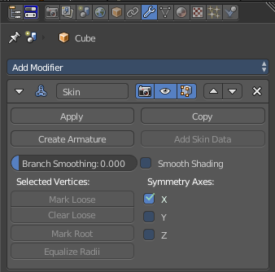
Skin Resize
This tool requires to have a skin modifier at the mesh. It scales the thickness of the skin.
While the operation you will see in the header the strength value for the skin.

Last Operator Skin Resize

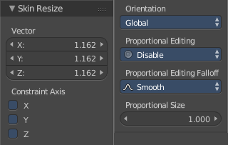
Vector
Here you can adjust the position values for the three values.

Constraint Axis
Here you can limit the position relative to the source object.

Orientation
Orientation is a drop-down box where you can choose the type of orientation for the mirroring action.

Proportional Editing
Proportional Editing is a drop-down box where you can choose to use proportional editing. When you choose one of the active methods then the neighbour geometry gets influenced by Shrink/Fatten too in a proportional way.

Proportional Editing Falloff
Proportional Editing Falloff is a drop-down box where you can choose a method for the falloff for the proportional editing.

Proportional Size
Proportional size is a edit box where you can adjust the strength of the Proportional falloff.

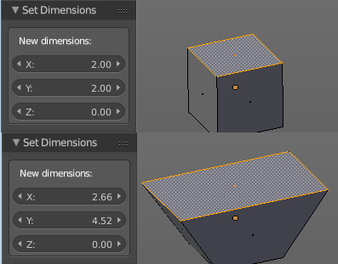
Set Dimensions
Edit Mode Only!
Normally all scale operations in Bforartists are relative to the current selection and dimensions. Set dimensions allows to scale mesh selections in absolute world values. No matter how the initial values are. The new values gets set in the Last Operator.
Set dimensions is an add-on. You can turn it off in the add-ons section of the user preferences when you want.

Last Operator Set Dimensions

New Dimensions
When you activate the tool then you will see the world coordinates of the selection. Here you can change the values to other world coordinates.

Align Bones
Armature only.
Align bones aligns the selected bones.

Edit Mode - Mesh Object - Mesh Menu
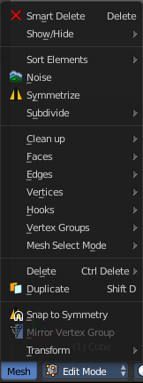
The Mesh Menu in Edit Mode contains the tools to manipulate the mesh geometry in Edit mode. It just exists for Mesh Objects.

Lots of functionality that could also belong here can also be found in the Tool Shelf. The difference is that the tools in the tool shelf are easier to access. And so it contains the most used tools for the daily work. While the Mesh menu contains the not so often used tools. Or tools where you use the hotkey anyway. Delete for example.

Smart Delete
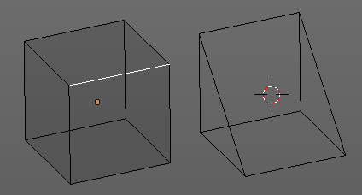
Smart delete deletes what is selected in an intelligent way. When you for example delete an edge then the edge gets deleted. But it also deletes the vertices connected to this edge. It performs a Dissolve operation under the hood.
There is a bit below a Delete menu where you can choose different methods for deleting if required. And the Dissolve tools can be found in the Tool Shelf in the Tools tab.

Show / Hide
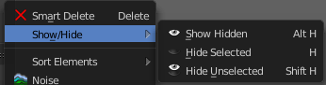
Show / hide is a menu that contains the Show Hide tools. Here you can show or hide your current selection in the viewport. See chapter All Modes, all Object types - Show / Hide

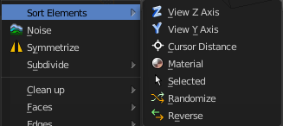
Sort Elements
Sort Elements is a menu with different sorting methods. It allows you to reorder the mesh indices of the selected mesh elements by various methods.

Hint
You can enable the viewing of mesh indices by typing in bpy.app.debug = True in the Python console in the scripting layout. This reveals a checkbox in the Mesh Display panel in the Info Options subsection. And when you tick this checkbox, then the vertices or edges or faces gets displayed with their indices value.
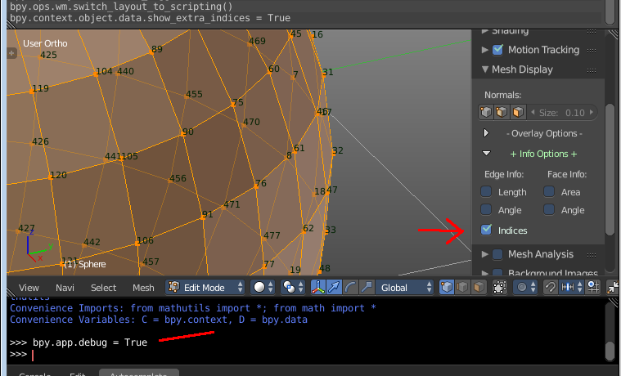

View Z Axis
Sorts along the active view’s Z axis, from farthest to nearest. You can use Reverse if you want it the other way.

View Y Axis
Sorts along the active view’s Y axis, from farthest to nearest. You can use Reverse if you want it the other way.

Cursor Distance
Sorts from nearest to farthest away from the 3D cursor position.

Material
Faces only! Sorts faces by their lowest material index up to highest material index. Order of faces inside each of those material groups remains unchanged.

Note that the Reverse option only reverses the order of the materials. And the order of the faces inside them.

Selected
Moves all selected elements to the beginning without affecting their relative orders. Attention, this option will also affect unselected element indices!

Randomize
Randomizes the indices of selected elements. This option does not affect the unselected elements.

Reverse
Reverses the order of the selected elements.

Last Operator Sort Mesh Elements
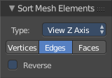
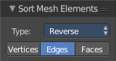
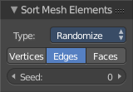
Sort Elements always brings up the same last operator. But with a small difference for Randomize and Reverse. Reverse has no checkbox. And Randomize has a Seed checkbox.

Type
This is a drop-down box where you can choose the sort method again.

Vertices, Edges or Faces
Here you can adjust if the sort will affect the vertices, edges or faces.

Reverse Checkbox
Reverses the sorting.

Seed Edit box (Randomize only)
The seed option allows you to get another randomization – the same seed over the same mesh/set of selected elements will always give the same result!

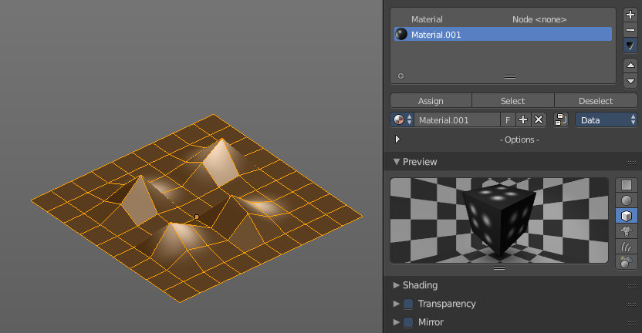
Noise
Noise is a displacement tool where you can use a texture to displace the geometry. It just works with the Blender Internal renderer, and you need to have a texture and a material assigned.
The strength can be adjusted in the Last Operator.

Last Operator Noise

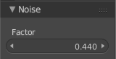
Factor
Here you can adjust the strength of the displacement.

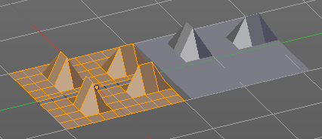
Symmetrize
The Symmetrize tool mirrors the selected geometry symmetrical along a world axis.

Last Operator Symmetrize
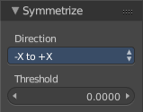

Direction
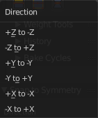
Direction is a drop down box where you can define the mirroring direction.

Threshold
Here you can adjust a distance after which the mirroring should happen, relative to the mirror axis. 0 means it mirrors the geometry directly at the axis.

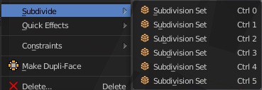
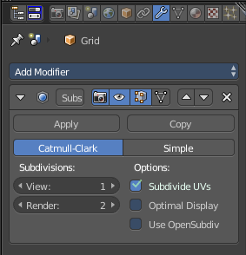
Subdivide
Subdivide is a menu where you can quickly set the subdivision level of the selection.
What it does is to add a SDS modifier in the Properties Editor if required. And set the SDS level to the needed value.
Crtrl 0 sets SDS to level 0. Ctrl 1 sets SDS level to 1 , and so on.
SDS happens at Object mode level. Even when you apply it in the Edit Mode! And it happens at the whole object.

Last Operator Subdivision Set

Level
Here you can adjust the SDS level.

Relative
Applies the Subsurf Level as an offset relative to the current level.

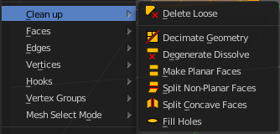
Clean Up
Clean Up is a menu that contains various functionality to clean up your geometry.

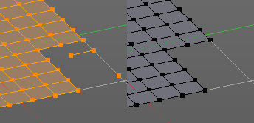
Delete Loose
Delete loose deletes not connected geometry. Vertices, Edges, and Faces. The tool starts with deleting Vertices and Edges. But you can tick Faces in the Last Operator too, and then it also removes not connected Faces.

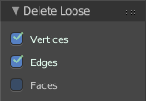
Last Operator Delete Loose

Vertices
Delete Vertices

Edges
Delete Edges

Faces
Delete Faces

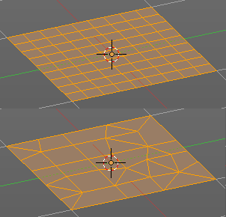
Decimate Geometry
Decimate Geometry decimates the currently selected geometry. It starts with a Ratio of 1. Which means no decimation. The lower the ratio the more decimation you will get. The Decimate Modifier works with Tris!

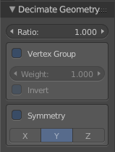
Last Operator Decimate Geometry

Ratio
Here you can adjust the strength of decimation

Vertex Group
Use active Vertex Group as an influence. You need to have a Vertex Group.

Weight
Here you can adjust the Vertex Group Strength.

Invert
Invert Vertex Group Influence

Symmetry
Here you can make the decimation geometry symmetric along a chosen world axis.

Degenerate Dissolve
Removes zero size Faces and Edges.

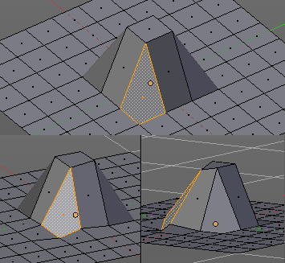
Make Planar Faces
Make Planar Faces tries to make the selected faces planar. Quads or N-Gons for example can have vertices that are not planar.

Last Operator Make Planar Faces

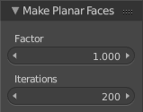
Factor
Here you adjust how strong the influence should be.

Iterations
Here you adjust how often it should repeat in the try to find a solution.

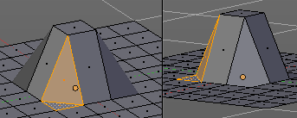
Split Non-Planar Faces
Split Non Planar Faces splits up non planar Quads and N-Gons to end in planar faces.

Last Operator Split Non-Planar Faces

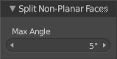
Max Angle
Here you can limit the action to a maximum angle.

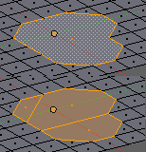
Split Concave Faces
Splits concave faces to make the geometry more stable. This tool is thought for N-Gons.

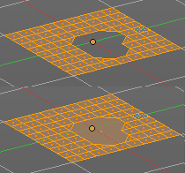
Fill Holes
Fill holes closes holes in the mesh geometry.
Fill holes can just calculate one face size at one time. So when you have several holes in the mesh, let's say one is a tri, and one is a quad, then you need to calculate twice.

Last Operator Fill Holes

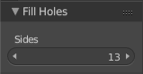
Sides
Here you can define what face size will be filled.

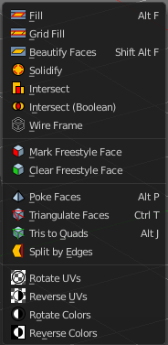
Faces
Faces is a menu where you can find some Faces related tools.

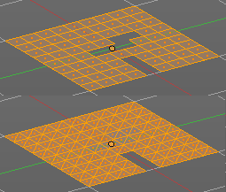
Fill
Fills holes and triangulates the geometry.

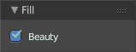
Last Operator Fill

Beauty
Use best triangulation division.

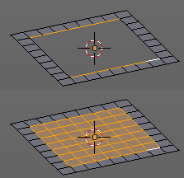
Grid Fill
Grid Fill allows you to fill two edge loops with quad geometry that follows the surrounding geometry.
Usage: select two opposite edge loops. Then perform the tool.

Last Operator Grid Fill

Span
Number of sides.

Offset
Here you can define a offset.

Simple Blending
Uses a simple interpolation. Faster but less accurate.

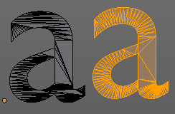
Beautify Faces
Beautify faces tries to optimize triangulations.

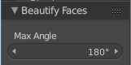
Last Operator Beautify Faces

Max Angle
Here you can set an angle limit.

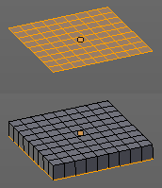
Solidify
Gives the selected faces a thickness, and makes it solid.
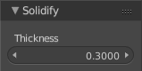
There is also a Solidify modifier available.

Last Operator Solidify

Thickness
Here you can adjust the thickness. You can scale also into the negative range.

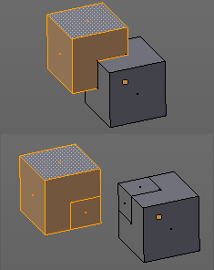
Intersect
Intersect creates edges where geometry intersects.
This operation happens in Edit mode, and so all parts must be in the same mesh.

Last Operator Intersect

Source
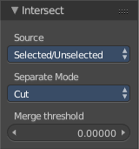
Source is a drop-down box where you can choose at which mesh part you want to operate.
Selected/Unselected works between the selected and unselected geometry.
Self Intersect works on the overlapping geometry of the mesh.

Separate Mode
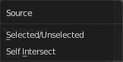
Separate mode is a drop-down box where you can choose the separation mode.
All splits the geometry at the new edge.
Cut keeps each side of the intersection separate without splitting the faces in half.
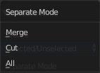
Merge merges all the geometry from the intersection.

Merge Threshold
Here you can adjust the merge threshold. Increase it when some geometry is not calculated. But keep it small for fast calculation

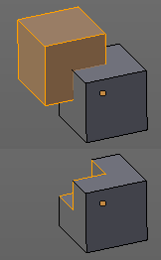
Intersect ( Boolean )
Intersect (Boolean) performs a boolean operation between the selected and unselected mesh parts.
This operation happens in Edit mode, and so all parts must be in the same mesh.

Last Operator Intersect (Boolean)

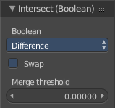
Boolean
Here you can choose the boolean method.

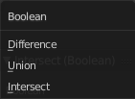

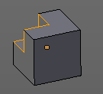
Difference subtracts the source geometry from the target geometry.

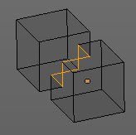
Union unions the source geometry with the target geometry. Geometry inside the source and target geometry gets removed.

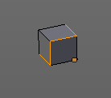
Intersect removes all geometry but the overlapping geometry.

Swap
Inverts source and target geometry.

Merge Threshold
Here you can adjust the tolerance for the boolean operation. Increase it when some geometry is not calculated. But keep it small for fast calculation.

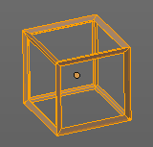
Wire Frame
Wireframe grabs the edges of the faces and turns them into tubes.

Last Operator Wire Frame

Boundary
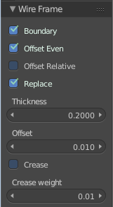
Inset Face Boundaries.

Offset Even
Scales the offset to give more even thickness.

Offset Relative
Scales the offset by surrounding geometry.

Replace
Removes the source geometry.

Thickness
Here you can adjust he thickness of the tubes.

Offset
Here you can adjust the offset of the tubes.

Crease
Crease adds close edges so that you have sharp corners when you use Subdivision Surface.

Crease Weight
Here you can adjust the crease weight.

Mark Freestyle Face
Mark selected Faces for exclusion from Freestyle Feature edge detection. Freestyle is a cartoon renderer that is also included in Bforartists.

Clear Freestyle Face
Unmark selected Faces for exclusion from Freestyle Feature edge detection. Freestyle is a cartoon renderer that is also included in Bforartists.

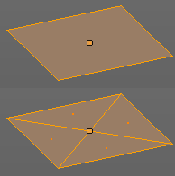
Poke Faces
Splits the selected faces to create a triangulated geometry.

Last Operator Poke Faces

Poke Offset
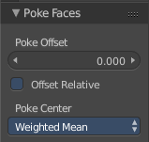
Normally the center vertice of the poke operation is planar with the rest. Here you can adjust an offset.

Offset Relative
Scale the offset by surrounding geometry.
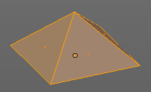

Poke Center
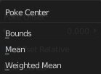
Poke Center is a drop-down box where you can choose what the center of the poke operation should be. You can choose between weighted mean, mean and bounds.

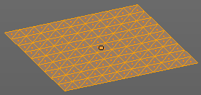
Triangulate Faces
Triangulate Faces triangulates the faces of the selected geometry.

Last Operator Triangulate Faces

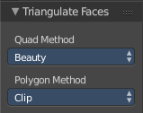
Quad Method
Here you can choose how quads should be triangulated.

Shortest diagonal
Splits the quads based on their distance between vertices.

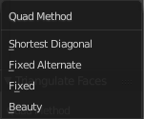
Fixed Alternate
Splits the quads on the second and fourth vertice.

Fixed
Splits the quads on the first and third vertice.

Beauty
Tries to optimize the triangulation.

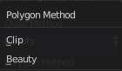
Polygon Method
Here you can choose how N-Gons should be triangulated.

Clip
Splits the polygons with an ear clipping algorithm.

Beauty
Tries to optimize the triangulation.

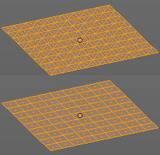
Tris to Quads
Tris to quads tries to convert triangulated geometry back to a quad geometry by removing the edges inside of the quads.

Last Operator Tris to Quads

Max Face Angle
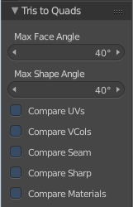
Here you can adjust the threshold to adjacent triangles.

Max Shape Angle
Here you can adjust the shape angle limit.

Compare UV's
Takes the UV patches for the calculation into account. Border geometry will not be calculated.

Compare VCols
Takes the Vertex colors for the calculation into account. Border geometry will not be calculated.

Compare Seam
Takes the Vertex colors for the calculation into account. Border geometry will not be calculated.

Compare Sharp
Takes the as sharp marked edges for the calculation into account. Border geometry will not be calculated.

Compare Materials
Takes the Materials colors for the calculation into account. Border geometry will not be calculated.

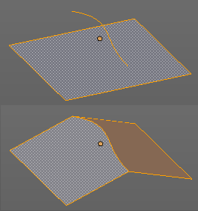
Split by Edges
This tool incorporates loose wire edges into selected faces.
You need a loose edge geometry to get it to work. By converting a curve to a Mesh geometry for example. You need to join the edge into the mesh where you want to use it. The operation happens in Edit mode.
In edit mode select the edge and the face where you want it to join. And then perform the tool.

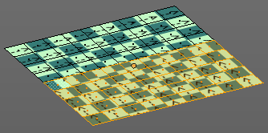
Rotate UV's
Rotates the UV space for the selected geometry by 90 degrees. This tool requires to have a working UV mapping.

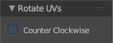
Last Operator Rotate UV's
The tool rotates clockwise by default. With this option ticked the rotation happens counter clockwise.

Reverse UV's
Reverses the UV Space for the selected geometry. This tool requires to have a working UV mapping.

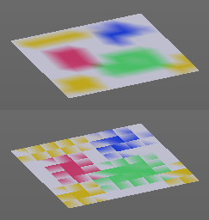
Rotate Colors
Rotates the vertex colors for the selected geometry. This tool requires to have vertex colors painted at the mesh.
Note that there is no way to display vertex colors in Edit mode. So you need to switch to Vertex paint mode to see the result.

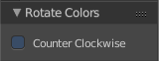
Last Operator Rotate Colors

Counter Clockwise
The tool rotates clockwise by default. With this option ticked the rotation happens counter clockwise.

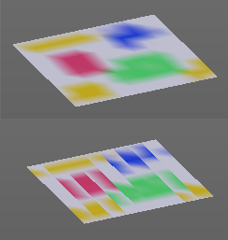
Reverse Colors
Reverses the vertex colors.
Note that there is no way to display vertex colors in Edit mode. So you need to switch to Vertex paint mode to see the result.

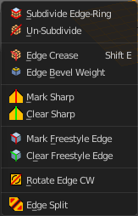
Edges
Edges is a menu where you can find some Edges related tools.

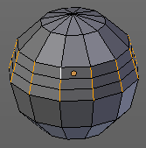
Subdivide Edge ring
Subdivides the selected edge ring(s).

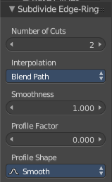
Last Operator Subdivide Edge ring

Number of Cuts
Here you can adjust the number of cuts for the subdivision.

Interpolation
Here you can chose a interpolation method for the new geometry.
Linear ends in a equal division and a flat result. Blend Surface interpolates the surrounding geometry. And can end in a curvy result.

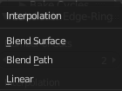
Smoothness
The Smoothness factor for the interpolation.

Profile Factor
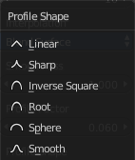
The profile strength

Profile Shape
A drop-down box where you can define a profile for the generated geometry.

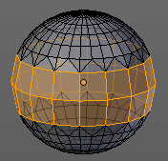
Un-Subdivide
Decimates the geometry by trying to make one quad out of four quads. But can also end in Tris where this is not possible.

Last Operator Un-Subdivide

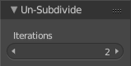
Iterations
Number of iterations. This means how deep the calculation should go. One level of SDS, two levels, three levels, etc. . Down to the point where you cannot decimate any geometry anymore.

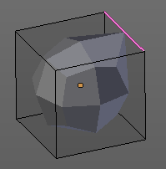
Edge Crease
When you use a Subdivision Surface Modifier, then you can define the sharpness of selected edges with this tool. Crease edges will be marked colored in edit mode.
You will see a value in the header that indicates the current strength when you activate the tool. Move with the mouse to increase or decrease the value. Or type in a value while you are in this mode. You can also scale into negative range.
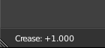
A negative crease value will subtract from the current active crease value in case it exists already from a former crease operation. A Crease value of -1 removes the crease from this edge.

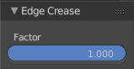
Last Operator Edge Crease

Factor
Here you can adjust the crease factor.

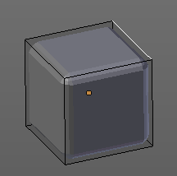
Edge Bevel Weight
This tool adjusts the edge bevel weight for selected edges when you use the Bevel modifier at the mesh.
You will see a value in the header that indicates the current strength when you activate the tool. Move with the mouse to increase or decrease the value. Or type in a value while you are in this mode. You can also scale into negative range.
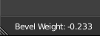
A negative Edge Bevel Weight value will subtract from the current active crease value in case it exists already from a former crease operation. A Edge Bevel Weight value of -1 removes the weight from this edge.

Last Operator Edge Bevel Weight

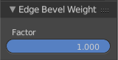
Factor
Here you can adjust the Edge Bevel Weight factor.

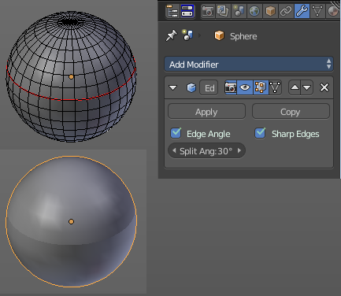
Mark Sharp
Mark Sharp is a tool that you need for the Edge Split modifier. Marked edges are displayed and rendered as sharp edges.

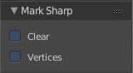
Last Operator Mark Sharp

Clear
Clears selected edges instead of marking it

Vertices
Calculate by the selected vertices instead of edges to mark the edges.

Clear Sharp
Clears formerly as sharp marked selected edges

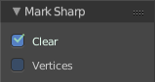
Last Operator Mark Sharp

Clear
Clears selected edges instead of marking it.

Vertices
Calculate by the selected vertices instead of edges to mark the edges.

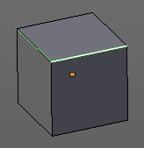
Mark Freestyle Edge
Freestyle is a comic renderer that is included in Bforartists. Mark Freestyle Edges marks the selected edges as Freestyle feature edges.

Last Operator Mark Freestyle Edge

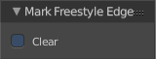
Clear
Unmarks the selected edges as Freestyle feature edges.

Clear Freestyle Edge
Freestyle is a comic renderer that is included in Bforartists. Clear Freestyle Edges unmarks the selected edges as Freestyle feature edges.

Last Operator Mark Freestyle Edge

Clear
Unmarks the selected edges as Freestyle feature edges.

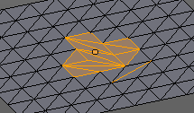
Rotate Edge CW
Rotate Edge rotates the selected edge clockwise.
This feature is useful when you have a triangulated quad mesh, and need to have some edges point into another direction as they currently do.
Rotate Edge CW rotates clockwise by default. But you can also rotate counter clockwise.

Last Operator Rotate Selected Edge

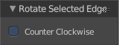
Counter Clockwise
Rotate selected edges counter clockwise

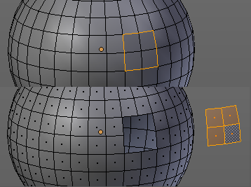
Edge Split
Edge split splits the selected edges. It creates two edges out of one.
This tool works similar to the Rip tool. But with selected edges instead of selected vertices. And this tool has no further settings.

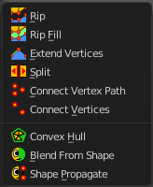
Vertices
Vertices is a menu that contains vertices related tools.

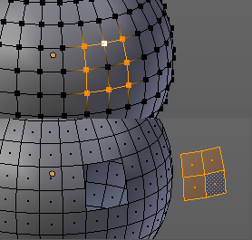
Rip
Rip splits the edges between the selected vertices. It creates two edges out of one.
This tool works similar to the Edge Split tool. But with selected edges instead of selected vertices. It also selects the outer edges so that you immediately move them. And it provides some options in the Last operator.

Last Operator Rip
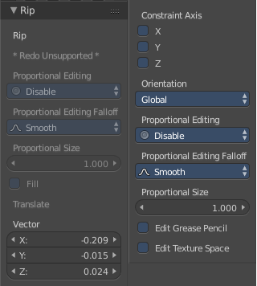
There are some greyed out parts. We will ignore them since it is most probably a bug, and we cannot edit them anyway.

Vector
Here you can adjust the position values for the three values

Constraint Axis
Here you can limit the position relative to the source object.

Orientation
Orientation is a drop-down box where you can choose the type of orientation for the mirroring action.

Proportional Editing
Proportional Editing is a drop-down box where you can choose to use proportional editing. When you choose one of the active methods then the neighbour geometry gets influenced by Shrink/Fatten too in a proportional way.

Proportional Editing Falloff
Proportional Editing Falloff is a drop-down box where you can choose a method for the falloff for the proportional editing.

Proportional Size
Proportional size is a edit box where you can adjust the strength of the Proportional falloff.

Edit Grease Pencil
Edit Grease Pencil edits the selected Grease Pencil strokes.

Edit Texture Space
With Confirm on Release checked the action gets performed when you release the mouse button.

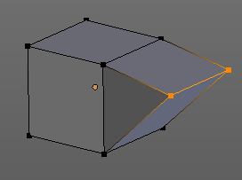
Rip Fill
Rip Fill works similar to the Rip tool. It splits the edges between the selected vertices. It creates two edges out of one. But it fills the gap between the new edges when you move the geometry.
This tool works similar to the Edge Split tool. But with selected edges instead of selected vertices. It also selects the outer edges so that you immediately move them. And it provides some options in the Last operator.

Last Operator Rip Fill
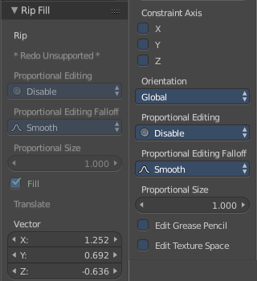
There are some greyed out parts. We will ignore them since it is most probably a bug, and we cannot edit them anyway.

Vector
Here you can adjust the position values for the three values

Constraint Axis
Here you can limit the position relative to the source object.

Orientation
Orientation is a drop-down box where you can choose the type of orientation for the mirroring action.

Proportional Editing
Proportional Editing is a drop-down box where you can choose to use proportional editing. When you choose one of the active methods then the neighbour geometry gets influenced by Shrink/Fatten too in a proportional way.

Proportional Editing Falloff
Proportional Editing Falloff is a drop-down box where you can choose a method for the falloff for the proportional editing.

Proportional Size
Proportional size is a edit box where you can adjust the strength of the Proportional falloff.

Edit Grease Pencil
Edit Grease Pencil edits the selected Grease Pencil strokes.

Edit Texture Space
With Confirm on Release checked the action gets performed when you release the mouse button.

Extend Vertices
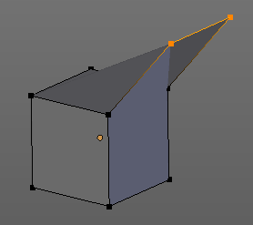
Extend vertices extrudes out the selected vertices. When you do this operation at an edge then you will create N-Gons that way.

Last Operator Extend Vertices
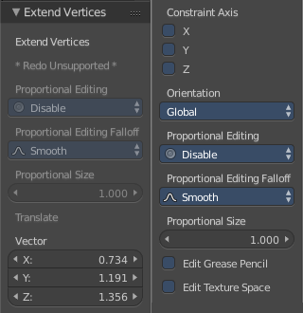
There are some greyed out parts. We will ignore them since it is most probably a bug, and we cannot edit them anyway.

Vector
Here you can adjust the position values for the three values

Constraint Axis
Here you can limit the position relative to the source object.

Orientation
Orientation is a drop-down box where you can choose the type of orientation for the mirroring action.

Proportional Editing
Proportional Editing is a drop-down box where you can choose to use proportional editing. When you choose one of the active methods then the neighbour geometry gets influenced by Shrink/Fatten too in a proportional way.

Proportional Editing Falloff
Proportional Editing Falloff is a drop-down box where you can choose a method for the falloff for the proportional editing.

Proportional Size
Proportional size is a edit box where you can adjust the strength of the Proportional falloff.

Edit Grease Pencil
Edit Grease Pencil edits the selected Grease Pencil strokes.

Edit Texture Space
With Confirm on Release checked the action gets performed when you release the mouse button.

Split
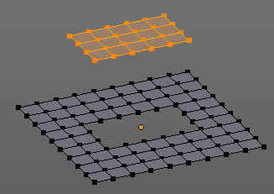
Split works similar to the Rip tool. It splits the edges between the selected vertices. It creates two edges out of one.
This tool works similar to the Edge Split tool. But with selected edges instead of selected vertices.

Connect Vertex Path
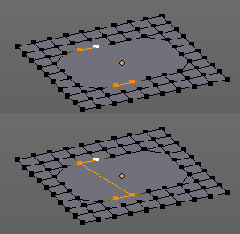
Connect Vertex path connects selected vertices, but takes the vertex order into account. It just creates edges between vertices that are not connected in this order.

Connect Vertices
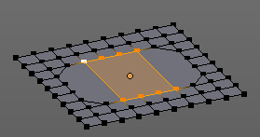
Connect Vertices connects the selected vertices. It does not fill the selection with edges though, but creates just the edges for the outside of a polygon.

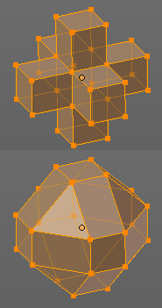
Convex Hull
Creates a convex hull around the selected vertices.

Last Operator Convex Hull

Delete Unused
Removes vertices that are not part of the convex geometry.

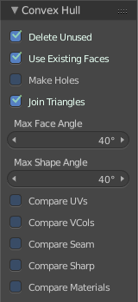
Use existing Faces
Use existing input faces that lies on the hull where possible. This option allows to have N-Gons in the convex hull.

Make Holes
Deletes edges and faces in the hull that were part of the input. This allows to delete faces between the existing mesh and the convex hull.

Join Triangles
Joins adjacent triangles into quads

Max Face Angle
Max Face Angle belongs to the Join Triangles setting. Here you can set the maximum face angle.

Max Shape Angle
Max Face Angle belongs to the Join Triangles setting. Here you can set the maximum shape angle.

Compare UV's
Takes existing UV patches for the calculation into account.

Compare Vcols
Takes existing Vertex colors for the calculation into account.

Compare Seam
Takes existing seams for the calculation into account.

Compare Sharp
Takes existing sharp edges for the calculation into account.

Compare Materials
Takes existing materials for the calculation into account.

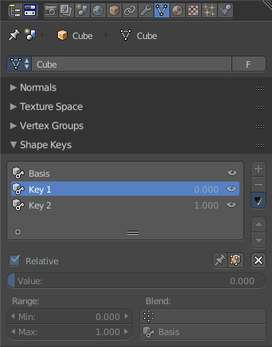
Blend from Shape
This tool requires to have a shape key at the mesh. It blends the selected shape key into the mesh.

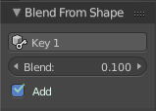
Last Operator Blend from Shape

Drop-down box
Here you can define which shape key should be used.

Blend edit box
Here you can adjust the blend factor

Add
Add to blend shape instead of blending in.

Shape Propagate
This tool requires to have a shape key at the mesh. It applies the current vertex locations to all other shape keys at the mesh.

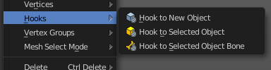
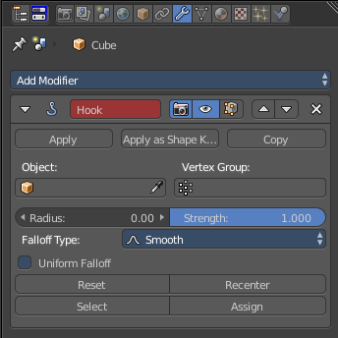
Hooks
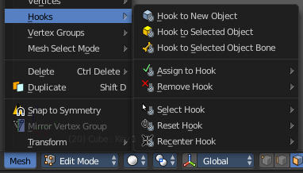
Hooks is a menu with tools around the hook modifier. You could also adjust the hook modifier from the Properties editor. But the menu items are more accessible.
When there is no hook modifier at the mesh then you just see three menu items. When there is minimum one hook modifier applied, then you will see an extended menu.

Hook to New Object
Creates a new Hook Modifier for the active object and assigns it to the selected vertices. It also creates an empty at the center of those vertices, which are hooked to it.

Hook to Selected Object
Does the same as Hook to New Object, but instead of hooking the vertices to a new empty, it hooks them to the selected object (if it exists). There should be only one selected object (besides the mesh being edited).

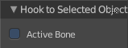
Last Operator Hook to Selected Object

Active Bone
Hook to the object(s) of the active bone.

Hook to Selected Object Bone
Does the same as Hook to New Object. But it sets the last selected bone in the also selected armature as a target.

Assign to Hook
Here you can assign the selected vertices to the chosen hook modifier. Existing hooks gets overwritten. One vertex can be assigned to more than one hook.

Remove Hook
Removes the chosen Hook Modifier from the object.

Select Hook
Selects all vertices assigned to the chosen Hook Modifier.

Reset Hook
Resets the chosen Hook Modifier.

Recenter Hook
Recenter the Hook Modifier.

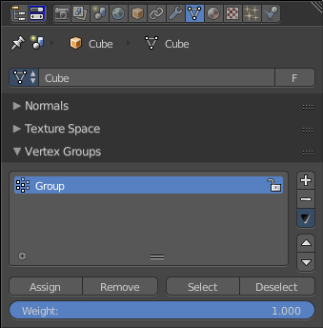
Vertex Groups
Vertex groups is a menu around vertex group functionality. The vertex groups can be found in the Object data tab in the Properties editor.

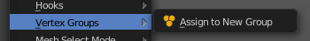
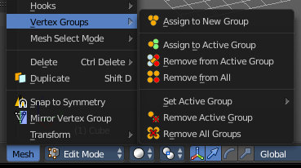
When there is no vertex group assigned yet then you can only see one menu item. The assign to new group button.
Once you have a vertex group assigned you will see the full functionality.

Assign to New Group
Assigns the mesh selection to a new vertex group.

Assign to active Group
Assigns the mesh selection to the currently active vertex group.

Remove from Active Group
Removes the mesh selection from the currently active vertex group.

Remove from All
Removes the mesh selection from all vertex groups.

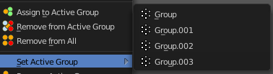
Set Active Group
Here you can select a vertex group to be the active one.

Remove Active Group
Removes the currently active vertex group.

Remove All Groups
Removes all vertex groups from the mesh.

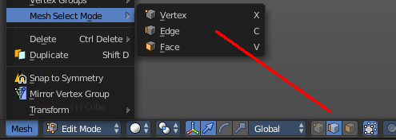
Mesh Select Mode
Mesh Select mode is a sub menu where you can set the current mesh select mode. Its functionality is equal to the mesh select mode buttons in the header. Just that you can't select more than one mode directly here. This menu exists to show and to edit the hotkeys. Not to work with it.
Interestingly the menu items have a last operator. Again, it is not meant to work this way. So this is just listed for documentation reasons.

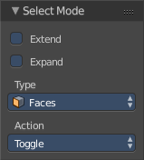
Last Operator Select Mode

Extend
Adds to the current selection mode

Expand
Not documented, not to find out, sorry.

Type
Here you can again adjust what select mode you want to activate

Action
How to work with the operator. Toggle means when you click at the button and it is disabled, then it enables. And vice versa. Enable and disable should be self explaining.

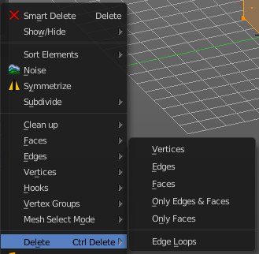
Delete
The smart delete works dependant of the selection and the mode. Which is fine for most cases. This delete menu gives you some more control over what exactly you want to delete. And how you want to delete it.#

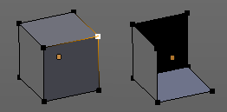
Vertices
Deletes the selected vertices, and all with it connected edges and faces.

Edges
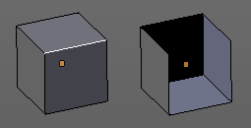
Deletes the selected edges and the connected faces.

Faces
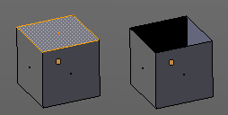
This one works similar to the smart delete. It deletes the selected faces.

Only Edges and Faces
This mode is of interest when you have more than one selection mode activated. It deletes then just the selected edges and faces. And not single vertices.

Only Faces
This mode is of interest when you have more than one selection mode activated. Just selected faces gets deleted. Not single edges or vertices.

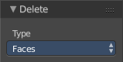
Last Operator Delete
The Last Operator Delete is the same for the above menu items.

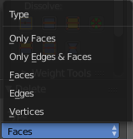
Type
Here you can choose the delete method again.

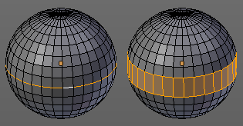
Edge Loops
This method works similar to the smart delete tool. It deletes the edge loop. But it selects the faces of the edge ring. And the Last operator offers you the option to split off face corners.

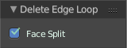

Last Operator Delete Edge Loop

Face Split
Split off face corners to maintain surrounding geometry.

Duplicate
Duplicates the current selection. The copy sticks to the mouse until you release it. A Right click while moving will reset the position of the duplicate. The duplicated part will be part of the same object.
When you drag the duplicate around you will see the position values in the header.

Last Operator Duplicate

Duplicate Objects

Linked
With this option ticked the duplication happens with linked data.

Translate
The Position of the duplicated object

Constraint Axis
Here you can limit the position relative to the source object.

Orientation
Orientation is a drop-down box where you can choose the type of orientation for the mirroring action.

Proportional Editing
Proportional Editing is a drop-down box where you can choose to use proportional editing. When you choose one of the active methods then the neighbour geometry gets influenced by Shrink/Fatten too in a proportional way.

Proportional Editing Falloff
Proportional Editing Falloff is a drop-down box where you can choose a method for the falloff for the proportional editing.

Proportional Size
Proportional size is a edit box where you can adjust the strength of the Proportional falloff.

Edit Grease Pencil
Edit Grease Pencil edits the selected Grease Pencil strokes.

Edit Texture Space
With Confirm on Release checked the action gets performed when you release the mouse button.

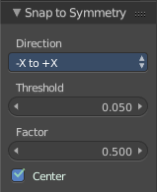
Snap to Symmetry
Tries to snap the selected vertices symmetrical along the chosen world orientation.

Last Operator Snap to Symmetry

Direction
The calculation direction.

Threshold
The threshold defines the radius in which matching vertices gets located. When you get a warning that snapping failed try increasing the threshold value.

Factor
The snapping factor. Blend mirrored locations from one side to the other. 0.5 is blending both sides equal.

Center
Snap vertices in the center axis to zero.

Mirror Vertex Group
This tool requires to have a vertex group assigned. It tries to mirror for example existing Weight Painting from one side to the other.
This tool works only with a perfectly symmetrical mesh along the local X axis. Vertices that have no corresponding vertex on the other side will not be affected.
Use case:
Let's say you have a rigged character, and do Weight Paint at one side of the mesh. Now you would have to repeat the Weight Painting at the other side. Instead, go to the vertex group panel in the Properties editor, and choose Copy Vertex Group (from the drop down menu) for each group you want to mirror. Then select the copy and choose Mirror Vertex Group.

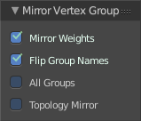
Last Operator Mirror Vertex Group

Mirror Weights
Mirrors the Weight Painting informations from the symmetrical counterpart. When both are selected it will become a group and weight information exchange. If only one is selected, then the information from the unselected vertice will go to the selected vertice.

Flip Group Names
Flip selected group names. This works with vertex groups with symmetrical name conventions. Like .L , .R, right, left.

All Groups
Pass information to all groups instead of the active one.

Topology Mirror
Use topology based mirroring.

Transform
Transform is a menu that contains some special transform functionality.
See chapter Edit Mode - Transform Menu

Edit Mode - Curve + Surface Object - Curve + Surface Menu
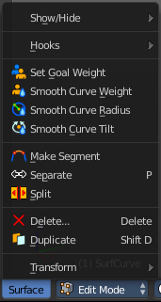
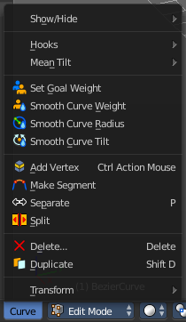
The Curve Menu in Edit Mode contains the tools to manipulate the curve geometry in Edit mode. It just exists for Curve Objects.

Same counts for the Surface Menu in Edit mode. The menus are identical since both object types are a curve type. So we handle both menus here.

There are two little differences. The Mean Tilt menu and the add vertex tool is missing for the Surface object. Surface objects doesn't have this functionality.

Show/Hide
Show/Hide is a menu. Here you can show or hide objects in the viewport. See chapter All Modes, all Object types - Show / Hide

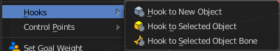
Hooks
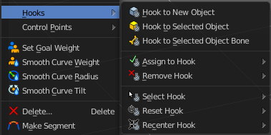
Hooks is a menu with tools around the hook modifier. You could also adjust the hook modifier from the Properties editor. But the menu items are more accessible.
When there is no hook modifier at the mesh then you just see three menu items. When there is minimum one hook modifier applied, then you will see an extended menu.

Hook to New Object
Creates a new Hook Modifier for the active object and assigns it to the selected vertices. It also creates an empty at the center of those vertices, which are hooked to it.

Hook to Selected Object
Does the same as Hook to New Object, but instead of hooking the vertices to a new empty, it hooks them to the selected object (if it exists). There should be only one selected object (besides the mesh being edited).

Last Operator Hook to Selected Object

Active Bone
Hook to the object(s) of the active bone.

Hook to Selected Object Bone
Does the same as Hook to New Object. But it sets the last selected bone in the also selected armature as a target.

Assign to Hook
Here you can assign the selected vertices to the chosen hook modifier. Existing hooks gets overwritten. One vertex can be assigned to more than one hook.

Remove Hook
Removes the chosen Hook Modifier from the object.

Select Hook
Selects all vertices assigned to the chosen Hook Modifier.

Reset Hook
Resets the chosen Hook Modifier.

Recenter Hook
Recenter the Hook Modifier.

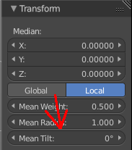
Mean Tilt
Mean Tilt only exists in the Curve menu!
The Mean Tilt menu contains two menu items to control the mean tilt in the Transform panel of the Properties sidebar. Here's the place to assign hotkeys to it.
The Mean Tilt menu is empty for the Surface object. The slider in the Transform panel has no effect at a Surface Object.
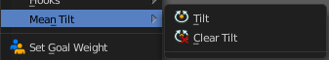

Tilt
Tilt tilts the selected curve.
While operating you will see the current tilt value in the header.

Clear Tilt
Resets the mean tilt to zero.

Set Goal Weight
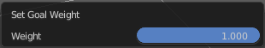
This tool requires to have a Soft Body physics applied to the curve. With this tool you can adjust the goal weight of the selected control points. A setting of zero allows to pin this control point vertice(s).
When you activate the tool then you will see a dialogue where you can adjust the weight.

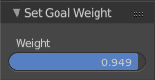
Last Operator Set Goal Weight

Weight
Here you can again adjust the weight strength.

Smooth Curve Weight
Interpolates the weight of the selected control point(s).

Smooth Curve Radius
Smooths the curve radius of the selected control point(s).

Smooth Curve Tilt
Smooths the curve tilt of the selected control point(s).

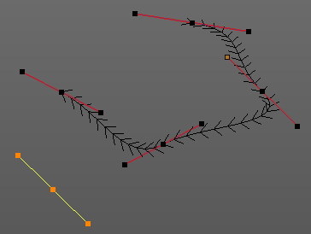
Add Vertex
Add Vertex adds a control point under the mouse, extruding from the selected endpoint(s). In case that you don't have an endpoint of your curve selected you will create a not connected control point.
The tool provides similar functionality to the extrude tool. But here you define the end point with the mouse position already.

Note!
Add Vertex is a hotkey only tool. Since it requires to have the mouse at the right position in the viewport.

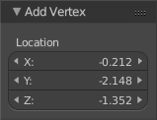
Last Operator Add Vertex

Location
Here you can change the position of the new created control point.

Make Segment
Joins two curves by adding a segment between the end of the one and the beginning of the other. You can also create a closed curve that way.

Separate
Separates the selected control points, and creates a new curve object out of it. You need to select two control points to select the segment between it.

Split
Splits the curve at the selected control point(s). You need to select two control points to select the segment between it.

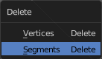
Delete
Delete calls a pop-up where you can choose if you want to delete vertices or segments.

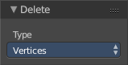
Last Operator Delete

Type
Here you can again choose if you want to delete vertices or segments.

Duplicate
Duplicates the current selection. The copy sticks to the mouse until you release it. A Right click while moving will reset the position of the duplicate. The duplicated part will be part of the same object.
When you drag the duplicate around you will see the position values in the header.

Last Operator Duplicate

Duplicate Objects

Linked
With this option ticked the duplication happens with linked data.

Translate
The Position of the duplicated object

Constraint Axis
Here you can limit the position relative to the source object.

Orientation
Orientation is a drop-down box where you can choose the type of orientation for the mirroring action.

Proportional Editing
Proportional Editing is a drop-down box where you can choose to use proportional editing. When you choose one of the active methods then the neighbour geometry gets influenced by Shrink/Fatten too in a proportional way.

Proportional Editing Falloff
Proportional Editing Falloff is a drop-down box where you can choose a method for the falloff for the proportional editing.

Proportional Size
Proportional size is a edit box where you can adjust the strength of the Proportional falloff.

Edit Grease Pencil
Edit Grease Pencil edits the selected Grease Pencil strokes.

Edit Texture Space
With Confirm on Release checked the action gets performed when you release the mouse button.

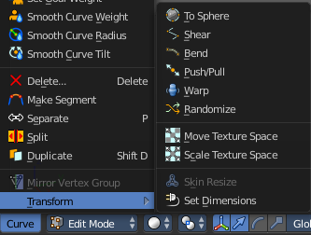
Transform
Transform is a menu that contains some special transform functionality.
See chapter Edit Mode - Transform Menu

Edit Mode - Metaball Object - Metaball Menu
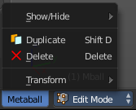
The Metaball menu in Edit mode contains the tools to work with Meta elements in Edit Mode.

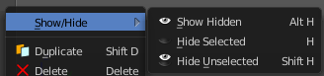
Show/Hide
Show/Hide is a menu. Here you can show or hide objects in the viewport. See chapter All Modes, all Object types - Show / Hide

Duplicate
Duplicates the current selection. The copy sticks to the mouse until you release it. A Right click while moving will reset the position of the duplicate. The duplicated part will be part of the same object.
When you drag the duplicate around you will see the position values in the header.

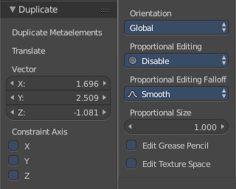
Last Operator Duplicate

Duplicate Meta elements
Just ignore this label.

Translate
The Position of the duplicated object.

Constraint Axis
Here you can limit the position relative to the source object.

Orientation
Orientation is a drop-down box where you can choose the type of orientation for the mirroring action.

Proportional Editing
Proportional Editing is a drop-down box where you can choose to use proportional editing. When you choose one of the active methods then the neighbour geometry gets influenced by Shrink/Fatten too in a proportional way.

Proportional Editing Falloff
Proportional Editing Falloff is a drop-down box where you can choose a method for the falloff for the proportional editing.

Proportional Size
Proportional size is a edit box where you can adjust the strength of the Proportional falloff.

Edit Grease Pencil
Edit Grease Pencil edits the selected Grease Pencil strokes.

Edit Texture Space
With Confirm on Release checked the action gets performed when you release the mouse button.

Delete
Deletes the selected element(s).

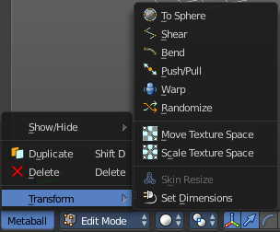
Transform
Transform is a menu that contains some special transform functionality. See chapter Edit Mode - Transform Menu

Edit Mode - Text Object - Text Menu
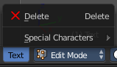
The Text menu contains the tools to work with text in edit mode.

Note that you have to use the Object mode box to escape the Edit mode with a text object. The hotkey to change the mode will be counted as text input for the text object.

Delete
Delete deletes the selected text.

To select parts of the text, move the cursor with the arrow buttons to the needed location, then hold down Shift, and select the letters by pressing the arrow buttons left or right. And then you can delete this selected text part.

Selecting text parts with the arrows brings up the Last Operator for Move Select.

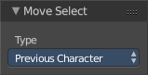
Last Operator Move Select

Type
Type is a drop-down box where you can change the selection method.

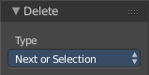
Last Operator Delete

Type
Type is a drop-down box where you can change the delete method.

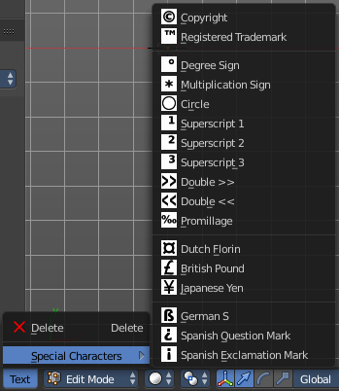
Special Characters
Special characters is a menu that contains some special text characters, like copyright, which you can insert into the text.

Edit Mode - Armature Object - Armature Menu

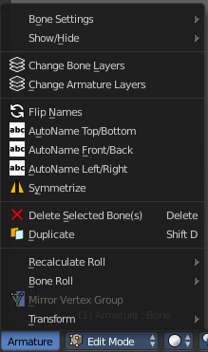
The armature menu provides you the tools to work with armatures and its bones in edit mode.

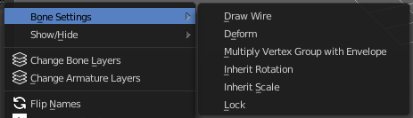
Bone Settings
Bone Settings is a menu with menu items to toggle special checkboxes in the Properties editor. But here you can do it for a selection too, and not just one object.

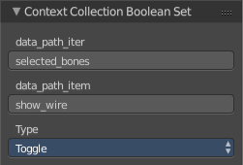
Last Operator Collection Boolean Set
Each of the menu items uses the same Last Operator. With different strings for the booleans.

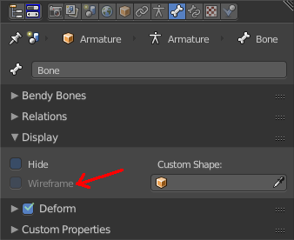
Draw Wire
Turns on or off the Wireframe checkbox, and so its functionality, in the Bones tab in the Display Panel Properties editor.
This checkbox requires to have a custom bone shape. It will not work at a normal bone shape. When you have a custom bone shape defined, then this custom bone object gets always displayed as Wireframe, regardless of viewport draw mode.

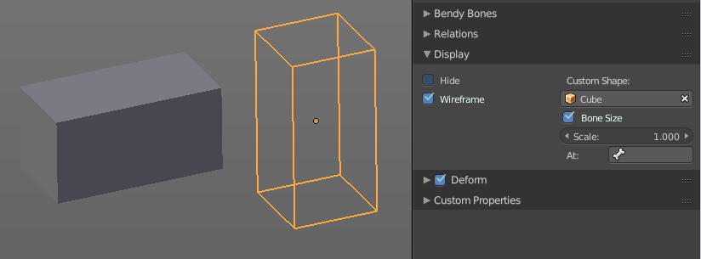

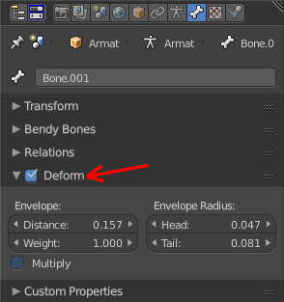
Deform
Turns on or off the Deform panel, and so its functionality, in the Bones tab in the Properties editor.
With Deform enabled the chosen bone deforms the connected mesh. The Deform panel also contains some Envelope settings.
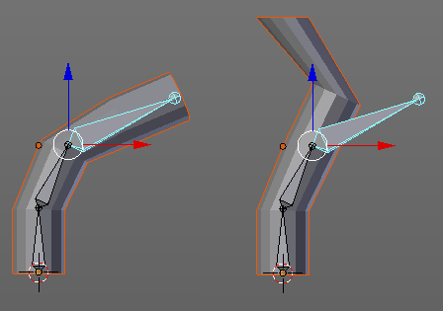

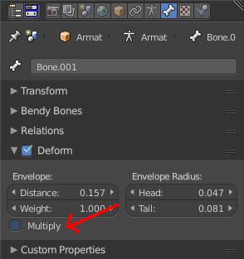
Multiply Vertex Group with Envelope
Turns on or off the Multiply checkbox in the Deform panel, and so its functionality, in the Bones tab in the Properties editor.
Multiply the effects of vertex group weights with envelope influence.

Inherit Rotation
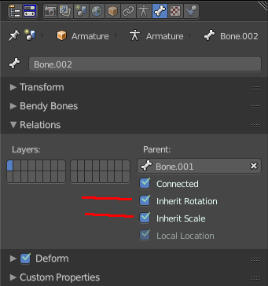
Turns on or off the Inherit Rotation checkbox in the Relations panel, and so its functionality, in the Bones tab in the Properties editor.
The bone inherits rotation from the parent bone.

Inherit Scale
Turns on or off the Inherit Scale checkbox in the Relations panel, and so its functionality, in the Bones tab in the Properties editor.
The bone inherits scale from the parent bone.

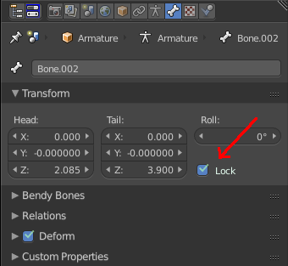
Lock
Turns on or off the Lock checkbox in the Transform panel, and so its functionality, in the Bones tab in the Properties editor.
Locked bones cannot be edited in edit mode anymore. They are locked.

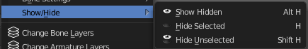
Show/Hide
Show/Hide is a menu. Here you can show or hide objects in the viewport. See chapter All Modes, all Object types - Show / Hide

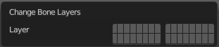
Change Bone Layers
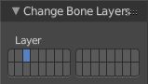
This menu item opens a popup where you can put single selected bone(s) onto another layer.

Last Operator Change Bone Layers

Layer
Here you can again put the selected bones onto another layer.

Change Armature Layers
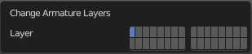
This menu item opens a popup where you can put the whole armature onto another layer.

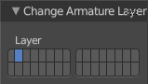
Last Operator Change Armature Layers

Layer
Here you can again put the armature onto another layer.

Flip Names
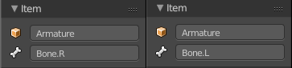
This tool requires to follow some name conventions. If there is a lower or upper case “L”, “R”, “left” or “right” with a separating dot in the bone name, then this tool renames the bones names to its counter part. Bone.L becomes Bone.R.
This tool is useful when you mirror parts of the armature, and don't want to rename all the bones one by one.

AutoName Top/Bottom
This tool automatically adds a suffix to all selected bones, based on their local position relative to the armature center.
Bones with a positive Z Coordinate will receive a .Top suffix. Bones with a negative Z coordinate will receive a .Bot suffix.

AutoName Front/Back
This tool automatically adds a suffix to all selected bones, based on their local position relative to the armature center.
Bones with a positive Y Coordinate will receive a .Fr suffix. Bones with a negative Y coordinate will receive a .Bk suffix.

AutoName Left/Right
This tool automatically adds a suffix to all selected bones, based on their local position relative to the armature center.
Bones with a positive X Coordinate will receive a .L suffix. Bones with a negative X coordinate will receive a .R suffix.

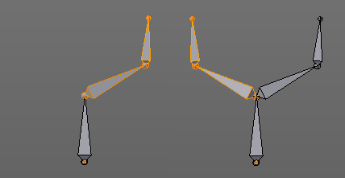
Symmetrize
Creates a symmetrical mirrored copy of the currently selected bones along the X axis. The mirror center is the pivot of the armature.
Symmetrize follows the name conventions for bones. If there is a lower or upper case “L”, “R”, “left” or “right” with a separating dot in the bone name, then this tool renames the bones names to its counter part. Bone.L becomes Bone.R.

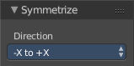
Last Operator Symmetrize

Direction
Here you can define the calculation direction. From -X to + X or from +X to -X

Delete Selected Bone(s)
Deletes the currently selected bones.

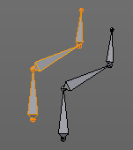
Duplicate
Duplicates selected bones. The duplicate is still part of the armature. The name number at the bones increases.
You are automatically in grab mode, and so you can easily move the object out of position. Which is sometimes wanted, since you can position the duplicate then. But sometimes this is unwanted. A right click after releasing the mouse lets the object snap back into its creation position.
When you drag the duplicate around you will see the position values in the header.

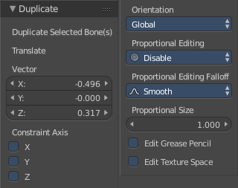
Last Operator Duplicate

Duplicate Selected Bone(s)
Just ignore this label.

Translate
Just ignore this label.

Constraint Axis
Here you can limit the position relative to the source object.

Orientation
Orientation is a drop-down box where you can choose the type of orientation for the mirroring action.

Proportional Editing
Proportional Editing is a drop-down box where you can choose to use proportional editing. When you choose one of the active methods then the neighbour geometry gets influenced by Shrink/Fatten too in a proportional way.

Proportional Editing Falloff
Proportional Editing Falloff is a drop-down box where you can choose a method for the falloff for the proportional editing.

Proportional Size
Proportional size is a edit box where you can adjust the strength of the Proportional falloff.

Edit Grease Pencil
Edit Grease Pencil edits the selected Grease Pencil strokes.

Edit Texture Space
With Confirm on Release checked the action gets performed when you release the mouse button.

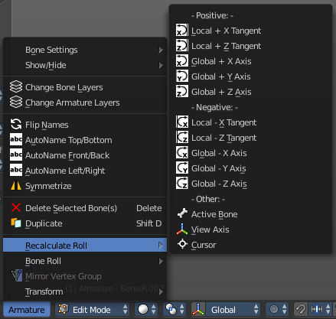
Recalculate Roll
Recalculate Roll is a menu where you can recalculate the bone roll in various ways.
The menu items are pretty self explaining. So we will not repeat the descriptions here.

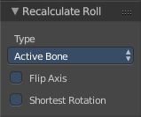
Last Operator Recalculate Roll

Type
Type is a drop-down box where you can choose the recalculation method again.

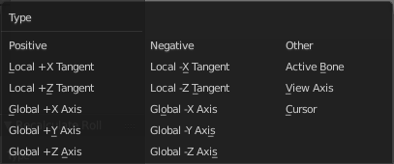
Flip Axis
Negates the alignment axis.

Shortest Rotation
Ignore the axis direction, and use the shortest rotation to align the bone(s)

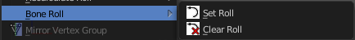
Bone Roll
Bone Roll is a menu where you can directly set the bone roll, or reset the bone roll to zero.

Set Roll
This operation is relative to the starting value, and starts always with zero. It does not display the Bone Roll value from the Transform panel. It adds or subtracts the amount of the operation to/from the Roll value then.
While operating you will see the current relative Roll value in the header.

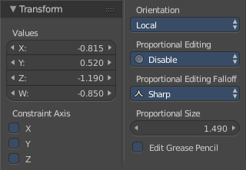
Last Operator Transform
The only interesting value is the X value right at the top. The other settings here are simply dysfunctional. You cannot turn on proportional editing, there is nothing to constraint, etc. . And so we will not go into detail here.
Unfortunately even the X value to display the amount of the roll is broken. It displays the amount in Radians, while the Bone roll is in degrees.

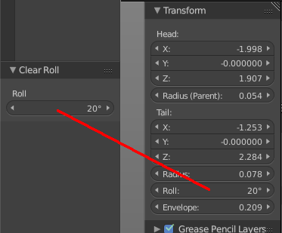
Clear Roll
Here you can set the bone roll value directly.

Last Operator Clear Roll

Roll
Here you can set the bone roll.

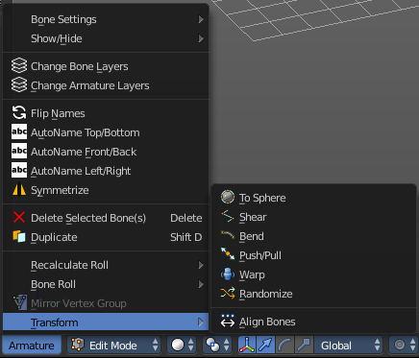
Transform
Transform is a menu that contains some special transform functionality. See chapter Edit Mode - Transform Menu.

Edit Mode - Lattice Object - Lattice Menu
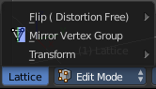
The Lattice menu provides you with tools to edit the Lattice object in edit mode.

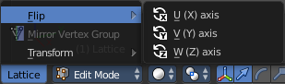
Flip
Flip is a menu where you can flip the lattice object along the world axis X, Y or Z

Mirror Vertex Group
This tool requires to have a vertex group assigned. It mirrors the selected vertex group.
This tool works only with a perfectly symmetrical mesh along the local X axis. Vertices that have no corresponding vertex on the other side will not be affected.

Last Operator Mirror Vertex Group

Mirror Weights
Mirrors the Weight Painting informations from the symmetrical counterpart. When both are selected it will become a group and weight information exchange. If only one is selected, then the information from the unselected vertice will go to the selected vertice.

Flip Group Names
Flip selected group names. This works with vertex groups with symmetrical name conventions. Like .L , .R, right, left.

All Groups
Pass information to all groups instead of the active one.

Topology Mirror
Use topology based mirroring.

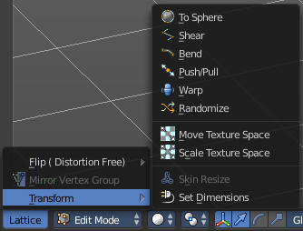
Transform
Transform is a menu that contains some special transform functionality. See chapter Edit Mode - Transform Menu.

Pose Mode - Armature Object - Pose Menu

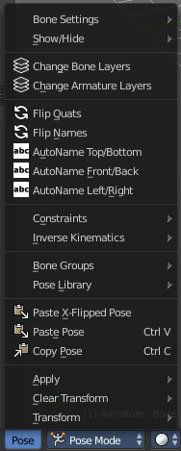
The Pose menu contains the tools to work with Armature objects in Pose mode. This means here you find all the tools that you need to pose and animate your armature.

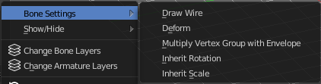
Bone Settings
Bone Settings is a menu with menu items to toggle special checkboxes in the Properties editor. But here you can do it for a selection too, and not just one object.

Last Operator Collection Boolean Set
Each of the menu items uses the same Last Operator. With different strings for the booleans.

Draw Wire
Turns on or off the Wireframe checkbox, and so its functionality, in the Bones tab in the Display Panel Properties editor.
This checkbox requires to have a custom bone shape. It will not work at a normal bone shape. When you have a custom bone shape defined, then this custom bone object gets always displayed as Wireframe, regardless of viewport draw mode.

Deform
Turns on or off the Deform panel, and so its functionality, in the Bones tab in the Properties editor.
With Deform enabled the chosen bone deforms the connected mesh. The Deform panel also contains some Envelope settings.

Multiply Vertex Group with Envelope
Turns on or off the Multiply checkbox in the Deform panel, and so its functionality, in the Bones tab in the Properties editor.
Multiply the effects of vertex group weights with envelope influence.

Inherit Rotation
Turns on or off the Inherit Rotation checkbox in the Relations panel, and so its functionality, in the Bones tab in the Properties editor.
The bone inherits rotation from the parent bone.

Inherit Scale
Turns on or off the Inherit Scale checkbox in the Relations panel, and so its functionality, in the Bones tab in the Properties editor.
The bone inherits scale from the parent bone.

Show/Hide
Show/Hide is a menu. Here you can show or hide objects in the viewport. See chapter All Modes, all Object types - Show / Hide

Change Bone Layers
This menu item opens a popup where you can put single selected bone(s) onto another layer.

Last Operator Change Bone Layers

Layer
Here you can again put the selected bones onto another layer.

Change Armature Layers
This menu item opens a popup where you can put the whole armature onto another layer.

Last Operator Change Armature Layers

Layer
Here you can again put the armature onto another layer.

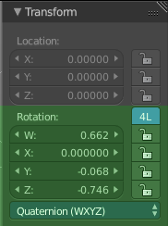
Flip Quats
This feature flips the quaternion rotation values of the currently selected bone(s). Positive values becomes negative, and negative values becomes positive.

Flip Names
This tool requires to follow some name conventions. If there is a lower or upper case “L”, “R”, “left” or “right” with a separating dot in the bone name, then this tool renames the bones names to its counter part. Bone.L becomes Bone.R.
This tool is useful when you mirror parts of the armature, and don't want to rename all the bones one by one.

AutoName Top/Bottom
This tool automatically adds a suffix to all selected bones, based on their local position relative to the armature center.
Bones with a positive Z Coordinate will receive a .Top suffix. Bones with a negative Z coordinate will receive a .Bot suffix.

AutoName Front/Back
This tool automatically adds a suffix to all selected bones, based on their local position relative to the armature center.
Bones with a positive Y Coordinate will receive a .Fr suffix. Bones with a negative Y coordinate will receive a .Bk suffix.

AutoName Left/Right
This tool automatically adds a suffix to all selected bones, based on their local position relative to the armature center.
Bones with a positive X Coordinate will receive a .L suffix. Bones with a negative X coordinate will receive a .R suffix.

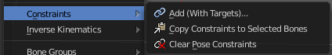
Constraints
Constraints is a menu that contains some tools around constraints.

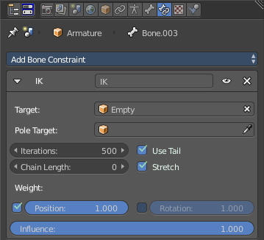
Add (With Targets)
Add (With Targets) calls the Constraints menu where you can choose the constraint that you want to add. When you add an IK constraints with just the bone selected, then it adds an empty as a handler too, and fills it in as a target.
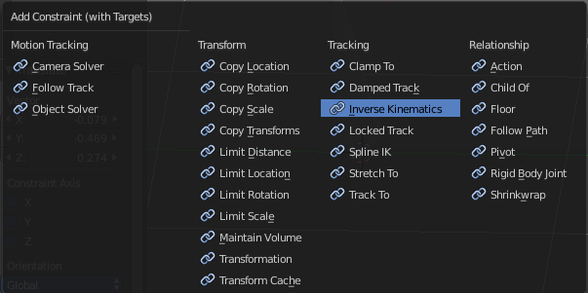
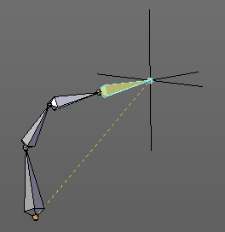

You can define a own target object too. The armature needs to be in pose mode. Let's create a cube or another primitive. Select it. Now hold down Shift, and click at the bone where you want to add the constraint too. Then choose Add (with Targets), and choose your constraint method. The cube will now be chosen as the target object.

Copy Constraints to selected Bones
Copies the constraints with all its settings to the selected bone.
Usage:
Select the bone where you want to copy the constraints to. Hold down shift, then select the bone that contains the constraints. Then perform the tool. The constraints will be copied.

Clear Pose Constraints
Removes all bone constraints modifiers from the bone.

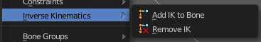
Inverse Kinematics
Inverse Kinematics is a menu with two isolated items from the whole bone constraints menu. The Inverse Kinematics. You could also add an Inverse Kinematics bone constraint by the Constraints / Add (With Targets) menu item from above. It is in the list. But this menu allows quick access without big search.

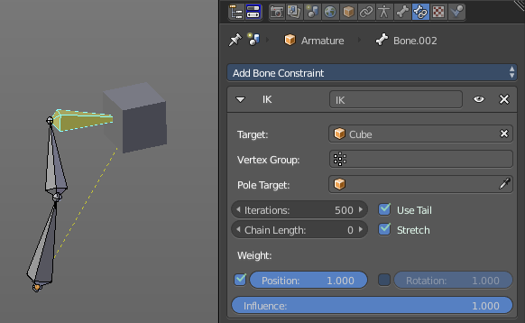
Add IK to Bone
Add IK to bone adds an IK bone constraint to the selected bone. When you add an IK constraints with just the bone selected, then it adds an empty as a handler too, and fills it in as a target.

You can define a own target object too. The armature needs to be in pose mode. Let's create a cube or another primitive. Select it. Now hold down Shift, and click at the bone where you want to add the constraint too. Then choose Add (with Targets), and choose your constraint method. The cube will now be chosen as the target object.

Last Operator Add IK to Bone

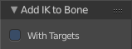
With Targets
Here you can define if you want to add the IK constraints with or without a target.

Remove IK
Removes all IK bone constraint(s) at the selected bone(s).

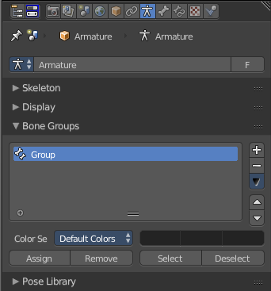
Bone Groups
Bone Groups is a menu to handle bone group functionality from within a menu in the 3D view. The bone groups themselves can be found in the Properties editor.

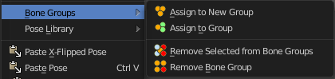

Assign to New Group
Assigns the selected bone(s) to a new group.

Assign to Group
Assigns the selected bone(s) to a existing group.

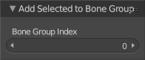
Last operator Add Selected to Bone Group
This last operator belongs to both tools. Assign to New Group, and Assign to Group.

Bone Group Index
Here you can adjust the Bone Group Index. An Index of 0 creates a new bone group. Higher values tries to assign the bone to existing bone groups instead.

Remove selected from Bone Groups
Removes the selected bone(s) from the assigned bone groups.

Remove Bone Group
Removes the currently active bone group.

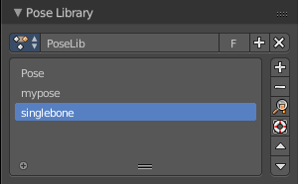
Pose Library
The content of this menu belongs to the Pose library. Which can be found in the Properties editor.
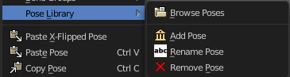

Browse Poses
With this feature you can browse through the available poses in the 3D view. While operation you will see informations in the header. It shows you what the current pose is, and how to navigate to the next or previous pose.
Note that you need to have the bones selected for which you want to display the poses. When in doubt, select all bones.

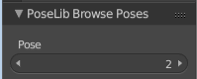
Last Operator Pose lib Browse Poses

Pose
Here you can scroll through the poses

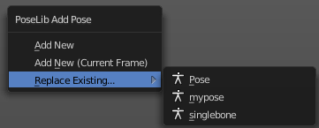
Add Pose
Here you can add a new pose for your armature to the pose library.
Note that you need to have the bones selected for which you want to add the pose. It just records the pose for the selected bones.
Calling the tool opens a popup where you can choose how you want to add the current pose.

Add New
Adds a new pose.

Add New (Current Frame)
Adds a new pose at the current frame. It does NOT record a keyframe.

Replace Existing
Here you can replace an existing pose.

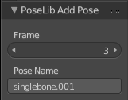
Last Operator Pose Lib Add Pose

Frame
The frame at which this pose should be created

Pose Name
Here you can rename the pose while creation.

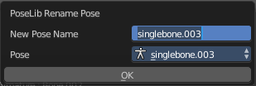
Rename Pose
Here you can rename a pose. It opens a popup menu where you can choose the pose to rename, and where you can rename it. One pose at a time.

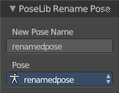
Last Operator Pose Lib Rename Pose

New Pose Name
Here you can enter the new pose name.

Pose
Here you can choose the pose that you want to rename.

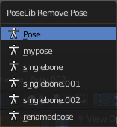
Remove Pose
Removes the currently active pose. The tool opens a popup where you can choose the pose to remove.

Last Operator Pose Lib Remove Pose

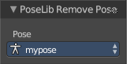
Pose
Here you can again choose which pose to remove.

Paste X-Flipped Pose
Pastes a formerly copied pose, and flips it around the X axis of the object. Local.

Paste Pose
Pastes a formerly copied pose.

Last Operator Paste Pose
This Last Operator belongs to both paste actions. Paste Pose and Paste X-Flipped Pose

Flipped on X-Axis
Flips the pasted pose around the X axis of the object.

On Selected Only
Pastes just to the currently selected bones. Not to the whole armature.

Copy Pose
Copies the current pose.

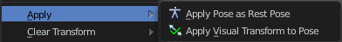
Apply
Apply is a menu with some Apply functionality.

Apply Pose as Rest Pose
You need a rest pose where you can reset the pose back to. With this tool you can set the current pose to be the new Rest pose.

Apply Visual Transform to Pose
Apply final constrained position of posed bones to their transform.

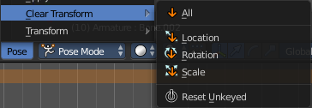
Clear Transform
Clear transform is a menu with some Clear functionality. You need to have the bones selected where you want to perform the operation. Unselected bones will not be calculated.

All
Resets location, rotation and scale back to the Rest pose.

Location
Resets location back to the Rest pose.

Rotation
Resets rotation back to the Rest pose.

Scale
Resets scale back to the Rest pose.

Reset Unkeyed
Resets the pose for the selected bones back to the state of the latest keyframe.

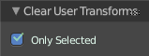
Last Operator Clear User Transforms

Only Selected
Clear User transform for selected armature part, or for the whole armature.

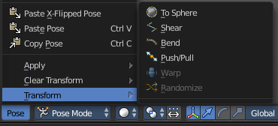
Transform
Transform is a menu that contains some special transform functionality. See chapter Edit Mode - Transform Menu.

Sculpt Mode - Sculpt Menu

The Sculpt menu contains just one menu item at the moment. Subdivide.

Subdivide
Subdivide is a menu where you can quickly set the subdivision level of the selection.
What it does is to add a SDS modifier in the Properties Editor if required. And set the SDS level to the needed value.
Crtrl 0 sets SDS to level 0. Ctrl 1 sets SDS level to 1 , and so on.
SDS happens at Object mode level. Even when you apply it in the Sculpt Mode! And it happens at the whole object.

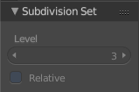
Last Operator Subdivision Set
The last operator Subdivision Set is greyed out in Sculpt mode.

Sculpt Mode - Brush Menu

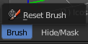
This menu contains brush related tools.

Reset Brush
Resets the current brush size to default size.

Sculpt Mode - Hide/Mask Menu
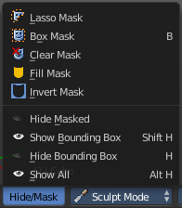
This menu contains some masking functionality.

Masking is a way to control which areas of the mesh are influenced by sculpting. To edit a mask manually, select the Mask Brush from the Brush panel.

Masked parts turns black.
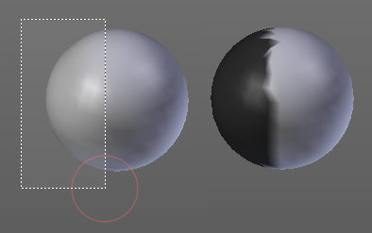
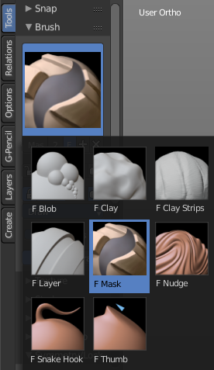

Lasso Mask
Select part of the mesh with a lasso tool.
Hotkey only tool, since the menu item is a bad starting point.

Box Mask
Select part of the mesh with a Rectangle tool.

Clear Mask
Clears the mask.

Fill Mask
Fills the mask with a given value, or inverts its values.

Invert Mask
Inverts the mask.

Hide Masked
Hides the masked mesh part.

Show Bounding Box
Lets you rectangle select a screen area to make hidden masked parts visible again.

Hide Bounding Box
Lets you rectangle select a screen area to hide mesh parts.

Show All
Makes all invisible mesh parts visible again.

Vertex paint Mode - Paint Menu

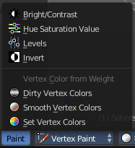
The Paint menu contains tools for vertex painting in Vertex paint mode.

Bright / Contrast
This tool allows you to adjust the brightness and the contrast of the vertex painting. You adjust the settings in the last operator.

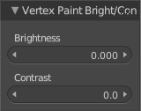
Last Operator Vertex Paint Bright/Contrast

Brightness
Adjust the brightness of the vertex colors.

Contrast
Adjust the contrast of the vertex colors.

Hue Saturation Value
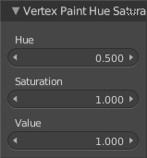
This tool allows you to adjust the hue, saturation and value values of the vertex painting. You adjust the settings in the last operator.

Last Operator Vertex Paint Hue Saturation Value

Hue
Adjust the Hue of the vertex colors.

Saturation
Adjust the Saturation of the vertex colors.

Value
Adjust the Value of the vertex colors.

Levels
This tool allows you to level the values of the vertex painting. You adjust the settings in the last operator.

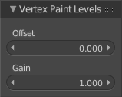
Last Operator Vertex Paint Levels

Offset
Adjust the Offset of the vertex colors.

Gain
Adjust the Gain of the vertex colors.

Invert
Inverts the vertex colors.

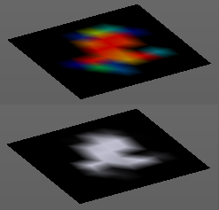
Vertex Color from Weight
This tool requires to have Weight Painting at the mesh. It converts the weight paint colors into greyscale vertex colors.

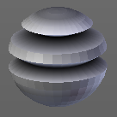
Dirty Vertex Colors
Dirty vertex colors is a special tool for ageing meshes. Let's for example imagine we have a relief. Edges that are outstanding are often touched, and tends to become brighter. While areas in the inner side of a relief are not so often touched. And here the relief collects dirt too. So this areas becomes darker.
And that's what the tool simulates. It makes the outer edges brighter, and the inner edges darker. This calculation is somehow similar to Ambient Occlusion. Ambient Occlusion makes corners darker. The dirty tool makes edges brighter too. And it calculates with the vertices. Not Texel positions like AO.
You need to convert this result to a texture to use it in your texturing, as a mask for example. This conversion can be done by baking.
The tessellation of the mesh should not be too high for this operation. Since it calculates the angles of the mesh edges.

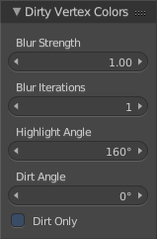
Last Operator Dirty Vertex Colors

Blur strength
How strong the result should be blurred

Blur Iterations
The number of iterations for the blur.

Highlight Angle
The angle for the bright areas. Angles higher as this value will not be recognized as a edge to highlight.

Dirt Angle
The angle for the dark areas. Angles lower as this value will not be recognized as a corner to darken.

Dirt only
Ignore the highlight areas, just calculate the dirt angles.

Smooth Vertex Colors
Smooths out the vertex colors.

Set Vertex Colors
Flood fills the vertex colors with the current vertex color value.

Weight Paint Mode - Select Menu

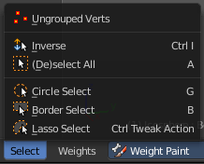
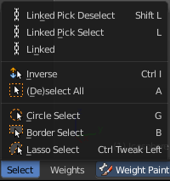
The Select menu in Weight Paint mode provides you with some selection tools for masking. This menu is just visible when you have either Face selection masking or vertex selection masking activated. The content differs between those two modes. Ungrouped Verts is just visible with Vertex Selection masking. The three "Linked" menu items just with Face Selection masking.

Linked
Just active with Face selection masking. Select linked faces.

Linked Pick Select
Just active with Face selection masking. Hotkey Only Functionality! This entry exists so that you know the tool is there and that you can edit the hotkey.
Linked Pick Select selects the linked faces under the cursor.

Linked Pick Deselect
Just active with Face selection masking. Hotkey Only Functionality! This entry exists so that you know the tool is there and that you can edit the hotkey.
Linked Pick Select deselects the linked faces under the cursor.

Ungrouped Verts
Just active with Vertex selection masking. Selects ungrouped Vertices.

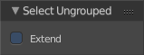
Last Operator Select Ungrouped

Extend
Extends the selection.

Inverse
Inverts the current selection.

(De)Select All
Toggles between select all and deselect all.

Last Operator (De)Select All

Action
Action is a drop-down box where you can choose between different methods.

Invert
Inverts the selection.

Deselect
Deselects all.

Select
Selects all.

Toggle
Toggles between select all and deselect all.

Circle Select
Circle select enters the Circle Select mode. This is a special select mode where you can select elements by moving with the mouse over it. It adds to selection by default.
To subtract from selection hold down Shift key. To exit the Circle select click with the right mouse button.
The pencil radius of the circle select tool can be adjusted with the scroll wheel.

Note
You cannot navigate while you are in Circle Select mode. You have to leave the Circle Select mode, do the navigation, then re enter the Circle Select mode.

Border Select
Border select enters the Border Select mode. This is a special select mode where you can select elements by dragging a rectangle. And what's inside of the rectangle gets selected then. It adds to selection by default.
To subtract from selection hold down Shift key.
The selection gets applied when you release the mouse. You leave the mode automatically when you release the mouse.

Lasso Select
Lasso select enters the Lasso Select mode. This is a special select mode where you can select elements by dragging a form around what you want to select. And what's inside of the rectangle gets selected then. It adds to selection by default.
To subtract from selection hold down Shift key.
The selection gets applied when you release the mouse. You leave the mode automatically when you release the mouse.

Note
You can of course also start with clicking at the menu item. But this tool is by design a hotkey only tool. Hold down Ctrl , and select with left mouse button.

Weight Paint Mode - Weights Menu
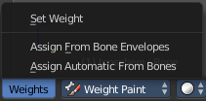
The weights menu contains some tools around Weight Painting.

Set Weight
This tool is just active when you have either Face selection masking or vertex selection masking activated.

The tool fills the selection with the current active Weight color that you have adjusted in the Brush panel in the Tools tab in the Tool shelf.

Assign from Bone Envelopes
Weights the vertices from the connected bone envelopes. And takes the distance to the bone envelope into account.

Assign Automatic from Bones
Weights the vertices connected with the bone. And takes the distance to the bone into account.

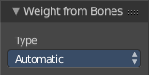
Last Operator Weight from Bones
This last operator is the same for both tools. Assign Automatic from Bones, and Assign from Bone Envelopes.

Type
Here you can choose if you want to Assign from Bone Envelopes, or from Bones.

Texture Paint Mode - Select Menu

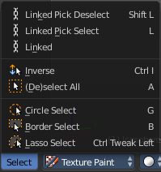
The Select menu in Weight Paint mode provides you with some selection tools for masking. This menu is just visible when you have either Face selection masking or vertex selection masking activated.

Linked
Select linked faces.

Linked Pick Select
Hotkey Only Functionality! This entry exists so that you know the tool is there and that you can edit the hotkey.
Linked Pick Select selects the linked faces under the cursor.

Linked Pick Deselect
Hotkey Only Functionality! This entry exists so that you know the tool is there and that you can edit the hotkey.
Linked Pick Select deselects the linked faces under the cursor.

Inverse
Inverts the current selection.

(De)Select All
Toggles between select all and deselect all.

Last Operator (De)Select All

Action
Action is a drop-down box where you can choose between different methods.

Invert
Inverts the selection.

Deselect
Deselects all.

Select
Selects all.

Toggle
Toggles between select all and deselect all.

Circle Select
Circle select enters the Circle Select mode. This is a special select mode where you can select elements by moving with the mouse over it. It adds to selection by default.
To subtract from selection hold down Shift key. To exit the Circle select click with the right mouse button.
The pencil radius of the circle select tool can be adjusted with the scroll wheel.

Note
You cannot navigate while you are in Circle Select mode. You have to leave the Circle Select mode, do the navigation, then re enter the Circle Select mode.

Border Select
Border select enters the Border Select mode. This is a special select mode where you can select elements by dragging a rectangle. And what's inside of the rectangle gets selected then. It adds to selection by default.
To subtract from selection hold down Shift key.
The selection gets applied when you release the mouse. You leave the mode automatically when you release the mouse.

Lasso Select
Lasso select enters the Lasso Select mode. This is a special select mode where you can select elements by dragging a form around what you want to select. And what's inside of the rectangle gets selected then. It adds to selection by default.
To subtract from selection hold down Shift key.
The selection gets applied when you release the mouse. You leave the mode automatically when you release the mouse.
Note
You can of course also start with clicking at the menu item. But this tool is by design a hotkey only tool. Hold down Ctrl , and select with left mouse button.

Particle Mode - Select Menu

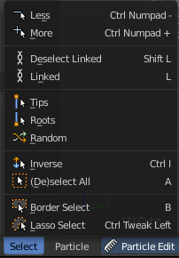
The Select menu in Particle mode provides you with some selection tools to edit the particles.

When you are in Emitter mode then most of the menu items are greyed out. This menu items are for Hair particles.

Less
Select less.

More
Select more.

Linked
Select linked geometry.

Deselect Linked
Deselect linked geometry.

Select Tips
Selects the end vertices of hair particles.

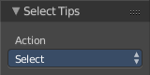
Last Operator Select Tips

Action
A dropdown box where you can choose what you want to do.

Select Roots
Selects the start vertices of hair particles.

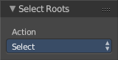
Last Operator Select Roots

Action
A dropdown box where you can choose what you want to do.

Random
Selects random objects.

Last Operator Select Random

Percent
The Percentage of objects that should be selected randomly.

Random Seed
The Seed for the random number generator.

Action
Action is a drop-down box where you can choose if you want to select or to deselect random.

Inverse
Inverts the current selection.

(De)Select All
Toggles between select all and deselect all.

Last Operator (De)Select All

Action
Action is a drop-down box where you can choose between different methods.

Invert
Inverts the selection.

Deselect
Deselects all.

Select
Selects all.

Toggle
Toggles between select all and deselect all.

Border Select
Border select enters the Border Select mode. This is a special select mode where you can select elements by dragging a rectangle. And what's inside of the rectangle gets selected then. It adds to selection by default.
To subtract from selection hold down Shift key.
The selection gets applied when you release the mouse. You leave the mode automatically when you release the mouse.

Lasso Select
Lasso select enters the Lasso Select mode. This is a special select mode where you can select elements by dragging a form around what you want to select. And what's inside of the rectangle gets selected then. It adds to selection by default.
To subtract from selection hold down Shift key.
The selection gets applied when you release the mouse. You leave the mode automatically when you release the mouse.

Note
You can of course also start with clicking at the menu item. But this tool is by design a hotkey only tool. Hold down Ctrl , and select with left mouse button.

Particle Mode - Particle Menu

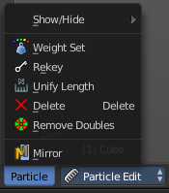
The Particle menu contains some tools to modify the particles.

Show/Hide
Show/Hide is a menu. Here you can show or hide objects in the viewport. See chapter All Modes, all Object types - Show / Hide

Weight Set
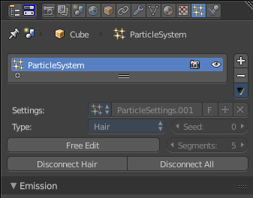
Here you can manually set a weight for the selected keys to interpolate between the current key weight and the brushes weight.
Using this tool activates and reveals Free Edit in the particle system settings.

Last Operator Weight Set

Factor
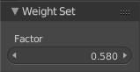
The strength of the keys weighting.

Rekey
You need to have some hair particles selected.
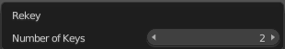
Rekey changes the number of keys for the selected particles, including root and tip keys. This tool brings up a popup where you can adjust the number of keys. Two means you have only a root and a tip key. Everything more subdivides the selected hair particle with more keys.

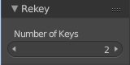
Last Operator Rekey

Number of keys
Here you can again adjust the number of keys.

Unify Length
Unifies the length of the selected hair particles. The length is calculated by the average length of the selection.

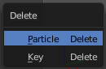
Delete
Brings up a popup where you can choose to delete either the selected particle(s) or the selected key(s).

Last Operator Delete

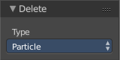
Type
Here you can again choose what type to delete. Particle or Key.


Remove Doubles
Remove double vertices that are very close to each other. This can for example happen when you mirror the particles.

Mirror
Mirrors the selected particles.
If you want a symmetrical haircut, first select all particles, then mirror the particles, then tick X Mirror in the Particle panel.

Header Tool - Mode Drop-down Box

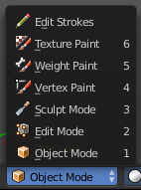
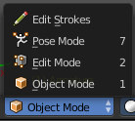
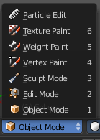
The Mode drop-down box allows you to switch between the different modes.

Modes are object states that allows you to edit and manipulate objects at different levels with different tool sets and goals. The sculpt mode for example allows you to sculpt a mesh object. Edit Mode allows to manipulate the mesh of the object, and so on.

The available modes can differ from object to object. A armature for example has an additional pose mode. And when you work with the grease pencil, then the Edit Strokes mode becomes available.

Object Mode
This mode allows to manipulate objects at Object level. Like move it around, rotate it, etc. This mode is available for all object types.

Edit Mode
The edit mode allows to edit the object. With a mesh object this means that you are able to modify and to change the geometry. With an armature you build your skeleton. And with a text object you can type in text, and choose the font etc.
Not all objects has an edit mode.

Sculpt Mode
Sculpt mode is a mesh object only mode. In this mode you can sculpt the mesh.

Vertex Paint
Vertex Paint is a mesh object only mode. In this mode you can paint vertices with colors.

Weight Paint
Weight Paint is a mesh object only mode. In this mode you can adjust weight painting for an armature for example. But Weight Painted mesh objects can also be used in conjunction with particles.

Texture Paint
Weight Paint is a mesh object only mode. In this mode you can paint at the texture of a mesh directly. This mode requires to have a working UV mapping and a texture at the mesh object.

Edit Strokes
Edit Strokes is a Grease Pencil only mode. It allows to manipulate the curves at a mesh level.

Particle Edit
Particle edit is a Particle System mode only. When you apply a particle system to a mesh object then this mode becomes available. It allows you to manipulate the particle system at a mesh level. You can comb hair particles for example.

Header Tool - 3D Manipulator Widget
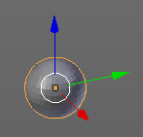
The 3D Manipulator widget tool allows you to enable and to disable a 3D Manipulator widget in the viewport. It is made of several sub elements.
This element exists in most modes. But in Sculpting mode for example the 3D Manipulator is not available.

3D Manipulator
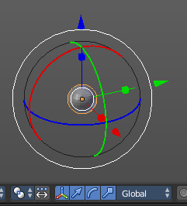
This button activates or deactivates the widget. Have a look at the shortcut here.

Transformation manipulator Translate, Rotate and Scale
Here you can activate or deactivate three different types of widgets. One for Translate, one for Rotate, one for Scale.
You can also activate more than one widget at a time. Hold down shift while clicking at one of the buttons adds to the selection.
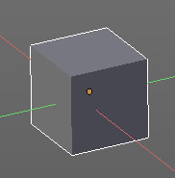
When you use the translate and scale widget, then you can transform in two directions by holding down shift. For example when you use translate widget and pull at the blue handler for upwards in Z direction, then you don't pull upwards, but sidewards in X and Y direction. The green and red line indicates the movement freedom.

When you use the Translate widget and hold down Ctrl, then you move the object with a snapping of one unit.

Last Operator Translate, Rotate and Resize
For the last Operator Translate, Rotate and Resize please have a look in the chapter Navigation Menu. They are identical.

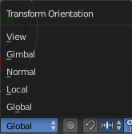
Transform Orientation
Transform Orientation is a drop-down box where you can choose between different orientation methods for the transform operation. The widget points into this direction then.

View
The transform orientation aligns to the current view.

Gimbal
Aligns each axis to the Euler rotation axis as used for input.

Normal
This is of interest for bones for example. Aligns the transformation axis to average normal of the selected elements. Bone Y axis for Pose mode.

Local
Uses the local orientation of the selected elements.

Global
Uses the global orientation for the selected elements.

Header Tool - Proportional Editing

Proportional editing is a way to transform selected elements with some kind of a falloff. So when you for example pull a vertice upwards in Edit mode, the neighbour vertices will also pull upwards, but not so strong. The neighbours gets influenced proportional.
Proportional Editing is not available in all modes.

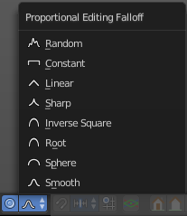
Proportional editing in Object mode is made of two elements. The on off switch. And a drop-down box where you can choose the falloff method.

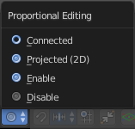
In Edit Mode with a mesh object you just have the on off switch. But here you can choose between three different falloff modes.
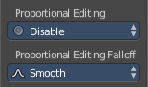
Both settings can be found in the Last Operator panel, when you for example move or scale an object or selection.

Changing the Proportional influence radius
You can change the influence radius for proportional editing with the mouse wheel or the Page up Page down arrows while keeping the mouse button pressed down for translate, rotate or scale. Or at the widget.

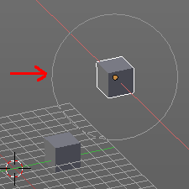
Usage:
Create for example two cubes. Now move one of it around. Enable proportional editing. Choose your favourite falloff method if you want.
When you click at the widget you will see a white circle around the Pivot point. That's the influence radius for the proportional editing.
Now increase the radius for falloff. So that the second cube is in the influence radius. You will see it moving at one point.
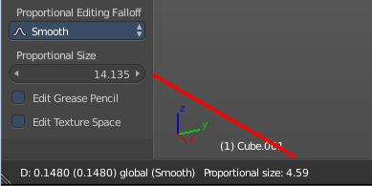
In the last operator Translate there is also a Proportional Size edit box that shows you the size of the radius. Here you can adjust the value too. But note that it will not update the visible influence radius in the 3D view. And when you change the radius in the viewport with the scroll wheel, then it will use the old value, and not the value that you have typed in here. So you better adjust the radius in the viewport. And use this edit box as a visual feedback.

Header Tool - Transform Snapping

Transform Snapping
This element is for snapping while transformation. Not to mix with the snapping tools in the Tools tab in the Tool Shelf. The Transform Snapping tool includes for example grid snapping.
Transform Snapping is not available in all modes.
The Transform Snapping tool is made of three elements.

Transform Snapping
Here you enable or disable snapping.

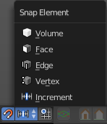
Snap Element
Snap Element is a drop-down box where you can choose between different snapping methods.

Volume
Snapping happens to the volume of another object.

Snapping
Snapping happens to the face of another object.

Edge
Snapping happens to the Edge of another object.

Vertex
Snapping happens to the Edge of another object.

Increment
Snapping happens relative to the ground grid.

Absolute Grid alignment while translating
With this feature on the selection snaps to the grid points. Without this feature it snaps increasing by unit size. When you have a grid snapping of 1, and an element at 0.56, then without absolute grid alignment it will snap at 1.56, 2.56 etc. With absolute grid snapping it will snap at 0, 1, 2 etc.

Header Tool - Viewport Shading

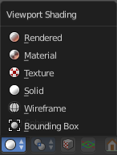
The Viewport shading drop-down box contains the different shading modes for the viewport. It exists in all modes.

Rendered
Displays the content in the viewport like you would have rendered it. This mode is dependant of what render engine you have currently active. And is available for Blender Render and Cycles.

Material
Displays the content in the viewport with all material settings and with OpenGL rendering.

Texture
Displays the content in the viewport textured. You need of course a working UV mapping and a texture at the mesh to see it.

Solid
Displays the content in the viewport with a solid white color.

Wireframe
Displays the content in the viewport as Wireframe.

Bounding Box
Displays the content in the viewport as Bounding box. The mesh content is not displayed.

Header Tool - Pivot Point

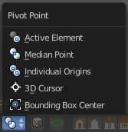
The Pivot Point is the point around which the object manipulation happens. Rotation, mirroring, and so on. Normally this happens around the pivot of the active object. In this menu you can set the pivot point to other locations. Like the position of the 3D cursor.

It exists in all modes.

Active Element
With this setting the manipulation happens relative to the center of the selected active elements. With more than one element is involved, then in Object mode this center gets calculated from the elements pivots. In edit mode the pivot is also the median point.

Median Point
With this setting the manipulation happens relative to the median point of the selected elements. This can be another point than calculating the center of the pivots. The median gets calculated from the geometry, not from the pivot point of the geometry.

Individual Origins
With this setting the manipulation happens relative to the origins of the selected elements. The origin is the little orange dot in every element.

3D Cursor
With this setting the manipulation happens relative to the 3D cursor.

Bounding Box Center
With this setting the manipulation happens relative to the Bounding Box Center.

Header Tool - Manipulate Center Points

This option is of interest when you have more than one object selected. With this option enabled a transformation will change the positions of the object’s origins, but will not affect the object itself.
For example, when you want to scale a group of selected cubes. Without the option enabled the cubes will scale also down when you scale the selection. With this option enabled, the cubes will keep their size. But they will scale closer together. The Pivot points gets scaled.

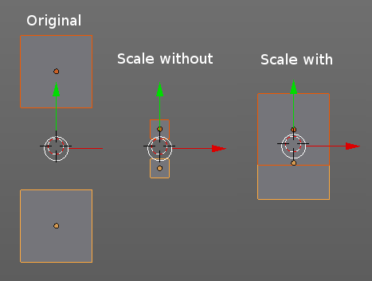

Header Tool - Mesh Object - Edit Mode - Mesh Select Mode

The mesh select mode in Edit Mode with a Mesh object allows you to switch between the three available selection modes Vertice select, Edge Select and Face Select.

You can have more than one mode active by shift clicking at the other mesh select modes.

Header Tool - Mesh Object - Edit Mode - Limit Selection to Visible

Limit selection to visible limits the view to what you can see from the front. By default the back geometry shines a bit through.
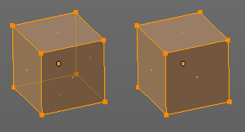

Header Tool - Mesh Object - Face selection masking for Painting

Painting at a Mesh object has two header tools that just belongs to the painting operations. One of it is Face selection masking for Painting. It is visible in Vertex Paint Weight Paint and Texture Paint.

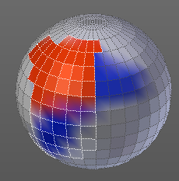
Face selection masking for Painting
When you activate this tool then you reveal a Select menu in the header. And you can select the mesh parts that you want to manipulate.
Note that you may first want to deselect all. By default everything is selected ...
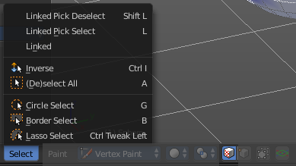

The select menu is explained in the chapter Vertex Painting - Select Menu.

Header Tool - Mesh Object - Vertex selection masking for Painting

Painting at a Mesh object has two header tools that just belongs to the painting operations. One of it is Face selection masking for Painting. It is visible in Vertex Paint and Weight Paint.

Vertex selection masking for Painting
When you activate this tool then you reveal a Select menu in the header. And you can select the mesh parts that you want to manipulate.
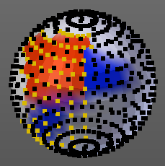
This tool is meant for Weight Painting. And so the mesh displays the vertices too.
Note that you may first want to deselect all. By default everything is selected ...
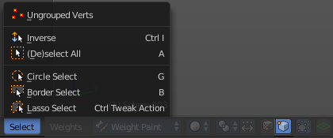

The select menu is explained in the chapter Vertex Painting - Select Menu.

Header Tool - Particle Edit - Select modes

The Select modes allows you to change the display and the editability of the particle vertices.

Path
No keypoints are visible. You can only select or deselect all keypoints at once.

Point
You see all keypoints. And all keypoints are editable

Tip
You can only see and edit the tip keypoints.

Header Tool - Reset 3D View

Reset 3D View is a navigation element. It resets the 3D view to a predefined setting.

It exists in all modes.

Reset 3D View is an add-on, and can be uninstalled when wanted. But note that the functionality is missing then.

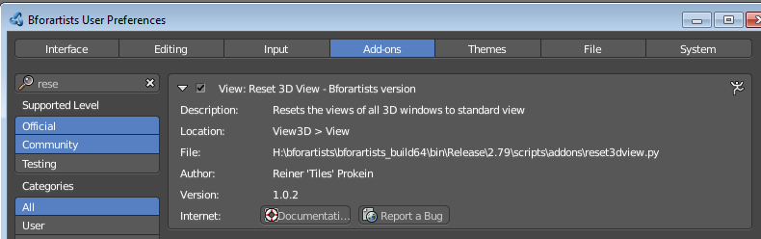

Header Tool - Align View Buttons
The Align View buttons contains some quick navigation elements to navigate in the viewport. You can switch between the different views, switch between orthographic and perspectivic view, switch to camera view and back to viewport view, and set the active camera.
It exists in all modes.
Align View Buttons is an add-on, and can be uninstalled when wanted. But note that the functionality is missing then.
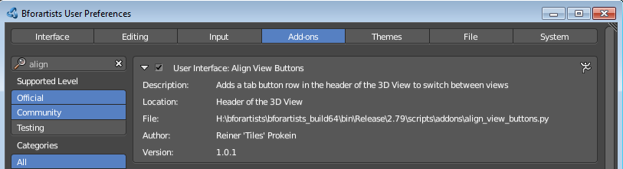

Top, Bottom, etc.
Switches to Top view, Bottom View, etc.

View Persp/Ortho
Toggles between perspectivic and orthographic view. Perspectivic view acts like a real camera with the perspectivic distortions. Orthographic view acts like a mathematical display of an object, without distortions.

Align View to active Camera
Switches to Camera view and back to Viewport Camera.

Set Active Camera
Sets the currently selected camera as the active camera. The active camera is the camera that gets used for rendering.
You need to have a camera object selected to activate the tool. Unlike the tool in the View menu, this tool here just works for camera objects.

